

Order by Product
VzON/EPL Firm Order New Connect and Disconnect User Guide

Effective Date: December 20, 2010
Revised Date: July 21, 2012

Notices

DISCLAIMER

This technical documentation is for general information purposes only. This documentation does not obligate Verizon to provide services in the manner described herein. Verizon reserves the right as its sole option to modify or revise the information contained in this technical documentation at any time without prior notice.

In addition to and without limitation of any other limitation of liability of Verizon or its affiliated companies set forth in an applicable contract or tariff, or elsewhere, in no event shall Verizon or its affiliated companies, or their agents, employees, directors, officers, representatives, or suppliers, be liable under contract, warranty, tort (including but not limited to the negligence of Verizon or its affiliates), or any other legal theory, for any incidental, consequential, special or indirect damages arising from or relating to this document or its contents, even if advised of the possibility of such damages.

© 2010 Verizon Corporation -All rights reserved.
Table of Contents
1 Overview 3
1.1 Benefits/Features 3
2 Getting Started with Order by Product 4
2.1 Order by Product Menu 6
2.2 Access Firm Order Activity Menu and associated Product Options 6
2.3 Ordering Menu – Routing, State, Network Assignment & Meet Point Options 10
3 Account Information 15
4 Billing and Contact Information 17
4.1 Billing Information Section 17
4.2 Contact Information Section 20
5 Order Information 21
5.1 VzON Firm Order ACTL to PREM Request 21
5.1.1 ACTL to PREM Request – New Activity 21
5.1.2 ACTL to PREM Request – Disconnect Activity 35
5.2 VzON Firm Order PREM to PREM Request 37
5.2.1 PREM to PREM Request – New Activity 37
5.2.2 PREM to PREM Request – Disconnect Activity 51
6 Adding and Removing Additional Circuits 52
6.1 Adding Additional Circuits – New Activity 52
6.2 Adding Additional Circuits – Disconnect Activity 54
6.3 Removing Additional Circuits – New and Disconnect Activity 56
6.3.1 Removing Additional Circuits – Prior to submitting the Original Request 56
6.3.2 Removing Additional Circuits – Previous Version has been Submitted & Accepted by Verizon 58
7 Service Address Section 60
8 Multi-Company Information Section 70
8.1 Enabling a Multi-Company Circuit Section 70
8.2 Populating the Multi-Company Information Section 70
8.3 Adding Additional Other Exchange Company Fields 71
8.4 Removing Additional Other Exchange Company Fields 72
9 Review and Submit Request 75
10 Order History and Status Section 79
11 Modify a Request (SUP) 83
11.1 Modify a Request (SUP) 83
11.2 Cancel a Request 85
12 View as ASR 86
12.1 “View as ASR” Prior to Submitting Request 86
12.2 “View as ASR” after Request has been Submitted 88
13 Billing/Account Profile 90
14 SOS Helpdesk 94

Overview

Order by Product is designed to simplify the ordering process on “New” and “Disconnect” activity for the most commonly ordered products. After populating the required fields and submitting the Request, Verizon will generate an ASR and send it to be processed. Certain ASR fields will be derived (ex: NC/NCI/SECNCI) based on selections made for the Routing, Configuration, and whether or not the Access Customer Terminating Location (ACTL) is collocated or not. Determining the appropriate Routing, Configuration, and ACTL considerations will be covered in greater detail in the sections below.

Benefits/Features
- Provides easy ordering of products for new and disconnect activity across Verizon's footprint.
- Determines the NC, NCI and SECNCI based on customer provided data and selections.
- Provides minimal number of fields to simplify ordering process; fields are displayed in full text rather than in ASOG Industry standard abbreviation.
- When the request is submitted, ASR is created and field values will be derived based on the entries and selections made by the User (ex. NC, NCI, SECNCI, REQTYP, PIU, SPEC etc).
- User Profile information containing Contact and Billing data is pre-populated on each request.
- Supports meet-point ordering.
- Ability to modify and submit subsequent versions of the request (SUP).
- Provides option to convert request to ASR format.
- Functionality includes the option to: Save, Close, Copy, Delete (Draft) or Review/Submit.

Getting Started with Order by Product

“Order by Product” can be selected from one of three ways:

- The initial “Landing Page”

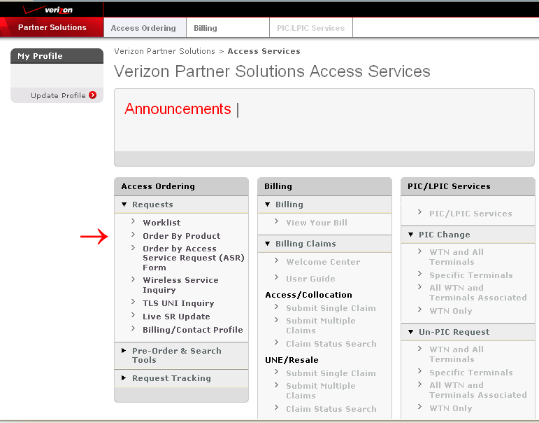

- The “Access Ordering” Tab

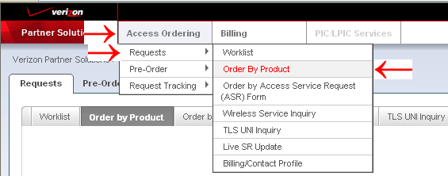

- The “Order by Product” Tab

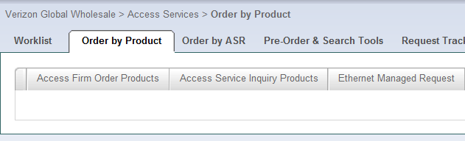

Order by Product Menu

After selecting “Order by Product”, product options are displayed in tab format and “Access Firm Order Products” should be selected:

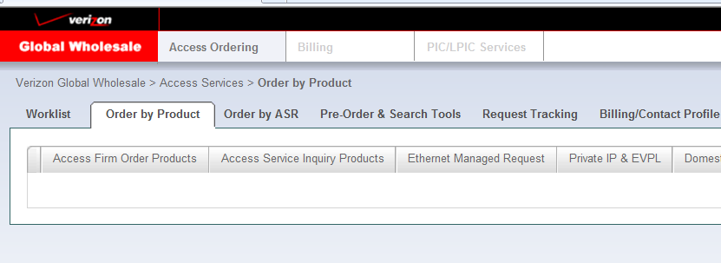

Access Firm Order Activity Menu and associated Product Options

After Selecting “Access Firm Order Products”, the Activity Menu is displayed:

Select the “New” or “Disconnect” Activity Type.
Note: Change Activity only applies to EVC requests

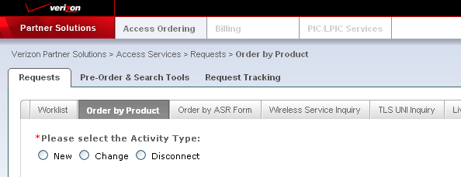

When “New” is selected, a product option must be selected, select “VzON/EPL Firm Order” and the “Next” Button:

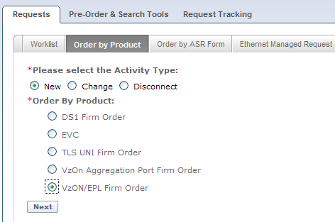

When “VzON/EPL Firm Order” is selected, additional menu fields are displayed:

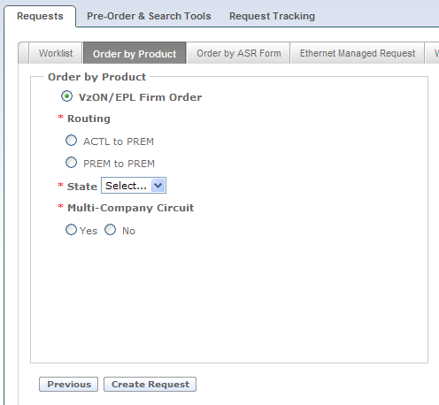

When “Disconnect” is selected, select the “Next” button to show disconnect product options:

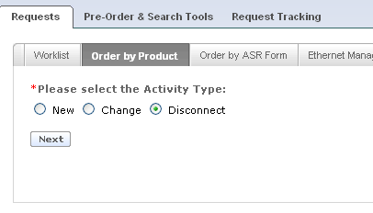

When “Disconnect” is selected, the product option must be selected, select “VzON/EPL Firm Order”:

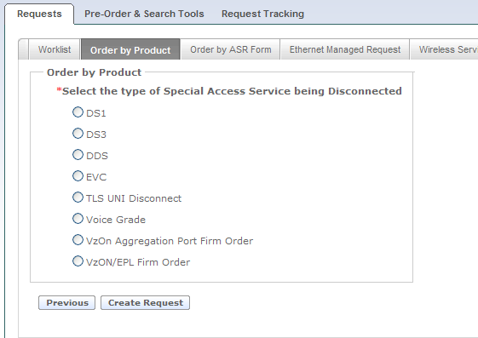

When “VzON/EPL Firm Order” is selected, additional menu fields are displayed:
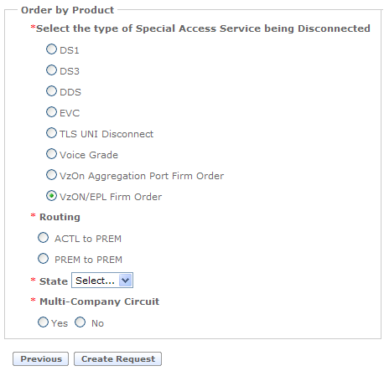

Ordering Menu – Routing, State & Meet Point Options
Regardless of Activity selected, the Routing, State, and Meet Point options need to be selected.

Verizon Optical Networking Service (VzON), also known as Ethernet Private Line (EPL), provides for managed optical transport of Ethernet data signals of various speeds over Verizon’s shared network.

Select a Routing Option for VzON/EPL Firm Order:

- ACTL to PREM
Select this option when ordering the following type of service:
- POP location or collocation arrangement to End User location
- REQTYP derived as “SD”
- Serial Circuit ID format

- PREM to PREM
Select this option when ordering the following type of service:
- End user to End user
- REQTYP derived as “ED”
- Serial Circuit ID format

Select the State:
Choose the appropriate geographical state from the “State” drop-down option for the request.

Select Multi-Company Circuit Option for VzON Firm Order:
Select “Yes” when the route of the request is meet-point between Local Exchange Companies (LEC), otherwise select “No”.

Select “Create Request” button

After completing the “Order by Product” menu, select the “Create Request” button to continue.

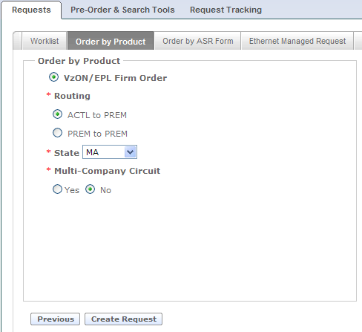

After the “Create Request” is selected, the order request form is presented:
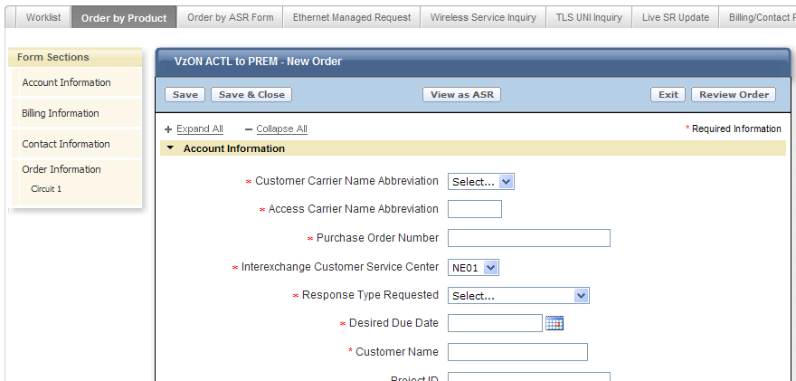

The layout of the form displayed is the same regardless of the “Routing Option” selected on the previous menu and includes:

Form Sections: A check mark “” will be displayed and indicate when the required fields of a section are complete.

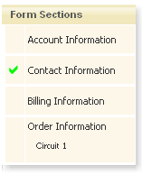

The Header will indicate the type of “Routing” and “Activity” selected from the menu:

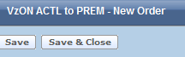

The Function Buttons are “Save”, “Save & Close”, “View as ASR”, “Exit” and “Review Order”:

The buttons perform the following functionality when selected:

- Save – Saves all the populated entries and remains on the current screen.
- Save & Close – Saves all the populated entries, closes the current screen, and returns to the “Worklist” page.

NOTE: The Customer Carrier Name (CCNA), Purchase Order Number (PON), Interexchange Customer Service Center (ICSC), and Response Type Requested (RTR) fields must be populated for the “Save” or the “Save & Close” option to engage.

- View as ASR – Permanently changes the request to ASR format. Review Section 11.1 for additional information.
- Exit – CHANGES WILL NOT BE SAVED, closes the current screen, and returns to the “Worklist” page.
- Review Order – Select this button once the request is completed. The completed request is displayed for final review prior to submitting.

Expand All and Collapse All Buttons will Open or Close the different sections contained within the request.

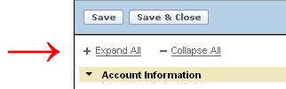

The next sections will provide the details for completing each Section of a request.

Account Information

The details provided in this section apply for creating a “New” or “Disconnect” request. The required fields will be designated with a red asterisk (*) on each type of request.

Populate the appropriate fields:
  - Customer Carrier Name Abbreviation (CCNA)
  - Access Carrier Name Abbreviation (ACNA)
  - Purchase Order Number (PON)
  - Interexchange Customer Service Center (ICSC) default value will be determined based on the geographical state selected on “Order by Product” Menu. Value can be changed if needed.
  - Response Type Requested (RTR)
  - Desired Due Date (DDD)
  - Early Date Acceptance (EDA)
  - Customer Name – displays for new activity only
  - Circuit ID (ECCKT) – This field is populated by Verizon on new activity. For new activity, this field displays after confirmation notice is received and field value cannot be changed.
  - Project ID – optional/displays for new activity only
  - Related Purchase Order Number (RPON) – optional/displays for new activity only
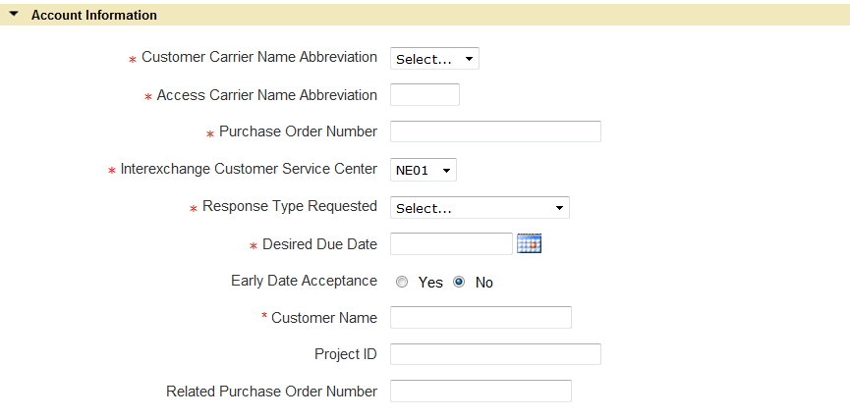

Additional Desired Due Date (DDD) Information:
When the calendar icon is selected the current month is displayed.

The coloring key is as follows:
- Dark Gray indicates weekends, holidays, or past date and is not available for selection.
- Blue indicates current date.
- Light Gray indicates the date is available for selection.
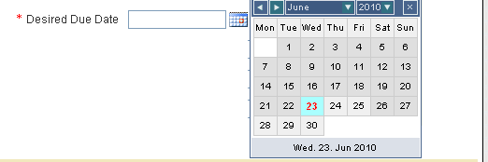

Select the Desired Date by “clicking” on it and the value will auto-populate in the Desired Due Date field.

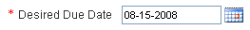

NOTE: When the Desired Due Date is in a future month/year, navigate to the desired month/year by using the navigation bar along the top of the calendar.

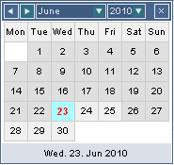

Billing and Contact Information

Billing Information Section
The details provided in this section apply for creating a “New” or “Disconnect” request. The required fields will be designated with a red asterisk (*) on each type of request.

Populate the appropriate fields:

  - Billing Account Number Type

Note: When request is for “New” activity, the required/optional field requirements and Term Agreement field names for the Billing Information Section vary depending on the selection of “Use Existing BAN” or “Establish New BAN” in the Billing Account Number Type field.

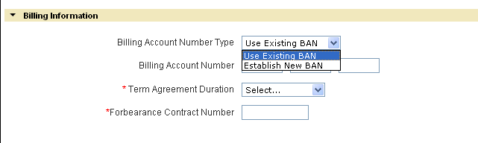

When “Use Existing BAN” or “Establish New BAN” is selected for Billing Account Number Type, the following fields will be displayed:

  - Billing Account Number (BAN) – Populate with a valid account number or leave blank. When left blank, Verizon will assign to an existing account.
  - Term Agreement Duration (VTA) – Select the desired billing term options for the circuit being ordered. The appropriate options will be displayed based on the ICSC value populated in the Account Information Section. (New activity only)
      - Variable Month – Displays as open text box and allows up to 3 numeric characters when Variable Month is chosen for Term Agreement Duration. Enter the number of months applicable.
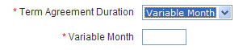
  - Forbearance Contract Number (PNUM) - (New activity only)

When “Establish New BAN” is selected for Billing Account Number Type (“Establish New BAN” should only be selected for New Activity!), the following fields will also be displayed:

  - Billing Account Name (BILLNM)
  - Floor (BILL FLOOR)
  - Room (BILL ROOM)
  - Address (BILL STREET)
  - City (BILL CITY)
  - State (BILL STATE)
  - Zip Code (BILL ZIP CODE)
  - Contact Name (BILLCON)
  - Contact Phone (BILL TEL NO)
  - Tax Exempt Status (TE)

Select the appropriate Tax Exemption Status from the Drop Down:

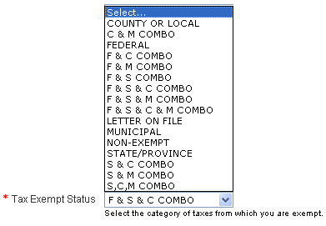

Verizon will convert the Tax Exempt Status selection made to the proper ASOG value as follows:

Selection | = | ASOG Value
County or Local | = | C
C & M Combo | = | J
Federal | = | F
F & C Combo | = | B
F & M Combo | = | K
F & S Combo | = | A
F, S, & C Combo | = | D
F, S, & M Combo | = | E
F, S, M, & C Combo | = | G
Letter on File | = | L
Municipal | = | M
Non-Exempt | = | N
State/Province | = | S
S & C Combo | = | H
S & M Combo | = | I
S, C, & M Combo | = | P

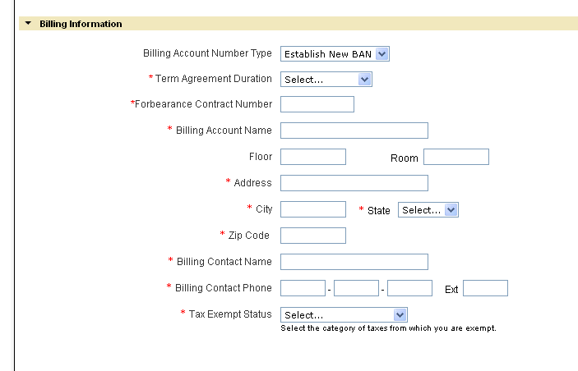

NOTE: The data for the Billing Section of each request can be system populated by completing and saving the Billing/Contact Profile. (See Section 13)

Contact Information Section
The details provided in this section apply for creating a “New” or “Disconnect” request. The required fields will be designated with a red asterisk (*) on each type of request.

Populate the appropriate fields:
  - Request by Name (INIT)
  - Request by Telephone (INIT TEL NO)
  - Request by E-mail (INIT EMAIL)
  - Design Contact Name (DSGCON)
  - Design Contact Telephone (DSGCON TEL NO)
  - Design Contact Fax (DSG FAX NO) – optional
  - Design Contact E-mail (DSG EMAIL) – optional
  - Design Routing Code (DRC) – optional- displays only when requesting a DLR in the Response Type Requested field.
  - Implementation Contact Name (IMPCON)
  - Implementation Contact Telephone (IMPCON TEL NO)

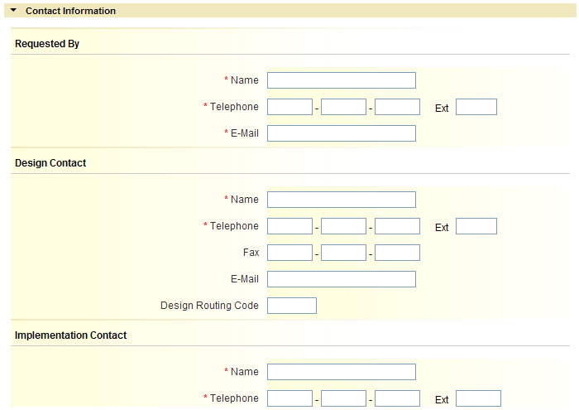

NOTE: The data for the Contact Section of each request can be system populated by completing and saving the Billing/Contact Profile. (See Section 13)

Order Information

VzON Firm Order ACTL to PREM Request
The details provided in this section apply for creating a request with “New” or “Disconnect” Activity. This section is broken down by Activity Type.

ACTL to PREM Request – New Activity
The details provided in this section apply for creating a request with “New” Activity. The required fields will be designated with a red asterisk (*). This section is broken down into subsections and contains the information needed for indentifying the connecting facility assignment (CFA/CCEA), the Primary location details, and the Secondary location details including the terminating service address fields.

    - Circuit 1 Section

Populate the following Required Fields:
  - Are you collocated at the primary or secondary location? - the value selected for this field is part of the necessary information needed for determining the NCI/SECNCI values as well as determining allowable bandwidth options in the ‘What is the requested bandwidth?’ field.
      - Select “Primary Location”, “Secondary Location”, or “Collocation at both ends” only when the specific location is collocated within a Verizon Central Office otherwise select “No”.

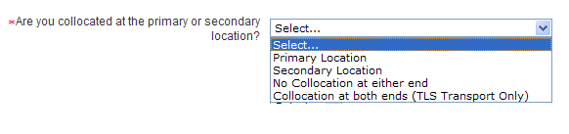
  - Are you riding a Connecting Facility Assignment (Aggregation Port)? – the value selected for this field is part of the necessary information needed for determining the NCI/SECNCI values as well as determining allowable bandwidth options in the ‘What is the requested bandwidth?’ field. Drop down options in this field will vary based on selection to field “Are you collocated at the primary or secondary location?” Note: If the requested circuit is riding another CFA type (such as a Ring) that is not an Aggregation Port Facility, you cannot use Order by Product for this request.
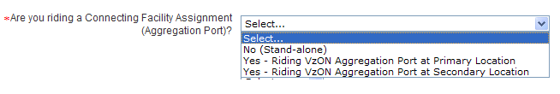
  - Do you want to be SONET Mapped at the primary location? – field is displayed when ‘No (stand-alone)’ is selected for “Are you riding a Connecting Facility Assignment (Aggregation Port)?” and ‘Secondary Location” is selected for “Are you collocated at the primary or secondary location?”. The value selected for this field is part of the necessary information needed for determining the NCI/SECNCI values as well as determining allowable bandwidth options in the ‘What is the requested bandwidth?’ field.
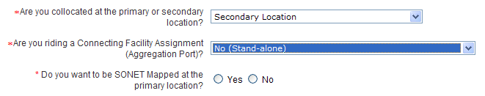
  - Do you want to be SONET Mapped at the secondary location? – field is displayed when ‘No (stand-alone)’ is selected for “Are you riding a Connecting Facility Assignment (Aggregation Port)?” and ‘Primary Location” is selected for “Are you collocated at the primary or secondary location?”. The value selected for this field is part of the necessary information needed for determining the NCI/SECNCI values as well as determining allowable bandwidth options in the ‘What is the requested bandwidth?’ field.
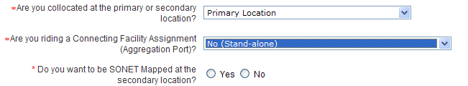
  - Do you want to be SONET Mapped at either the primary or secondary location? – field is displayed when ‘No (stand-alone)’ is selected for “Are you riding a Connecting Facility Assignment (Aggregation Port)?” and ‘No collocation at either end” is selected for “Are you collocated at the primary or secondary location”. The value selected for this field is part of the necessary information needed for determining the NCI/SECNCI values as well as determining allowable bandwidth options in the ‘What is the requested bandwidth?’ field.
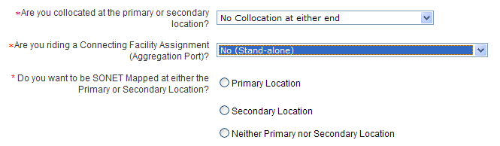
  - What is the requested bandwidth? – the value selected for this field is part of the necessary information needed for determining the NC/NCI/SECNCI values. Values displayed in the drop down will vary based on previously answered questions.

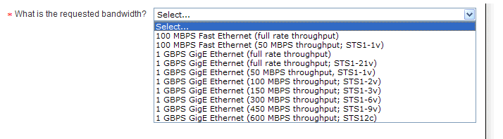

Conditional and Optional Field(s):

  - Do you require the Verizon Inter-Office Facility route to be protected? – the value selected for this field is part of the necessary information needed for determining the correct NC value. This field shall be displayed and required based upon specific bandwidth selections for field “What is the requested bandwidth?” Available options are ‘Yes’ and ‘No’. Certain collocation and bandwidth selections will cause this field to default to ‘Yes’.
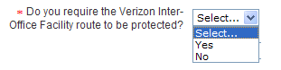
  - Fiber Network Identification (FNI) – this field is displayed and required when you are riding a connecting facility assignment at either the primary or secondary location.
  - Wireless Site Indicator (WSI) – select existing site if applicable to the request. Used to indicate the request is to an existing cell site location. Note: For new site option, see the user guide for Wireless VzON/EPL Service Inquiry.
  - Telecommunications Service Priority (TSP) – field is optional
  - Customer Circuit ID (CKR) – field is optional
  - Cross Connect Equipment Assignment (CCEA) – Required when ‘No (Stand-alone)’ is selected to field “Are you riding a Connecting Facility Assignment (Aggregation Port)?” and “Primary Location” or “Collocation at both ends (TLS Transport Only)” is selected to field “Are you collocated at the primary or secondary location?”
  - Secondary Cross Connect Equipment Assignment (SCCEA) – Required when ‘No (Stand-alone)’ is selected to field “Are you riding a Connecting Facility Assignment (Aggregation Port)?” and “Secondary Location” or “Collocation at both ends (TLS Transport Only)” is selected to field “Are you collocated at the primary or secondary location?”
  - Remarks – field is optional

Example of Circuit 1 section for ACTL to PREM:

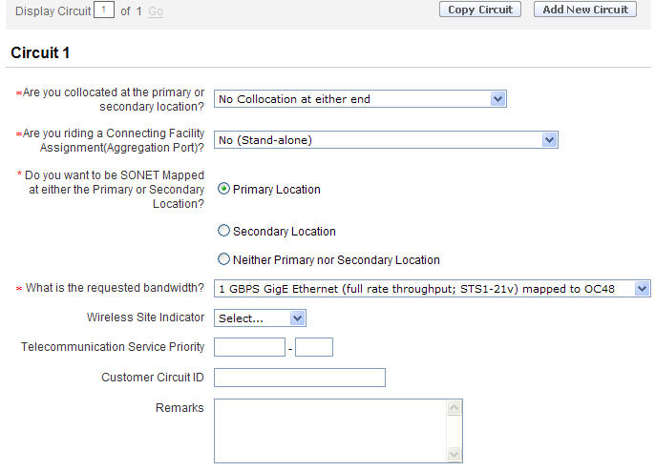

    - Primary Location Connecting Facility Assignment (CFA) Section
This Section is required when the circuit being ordered is to ride a higher level facility.
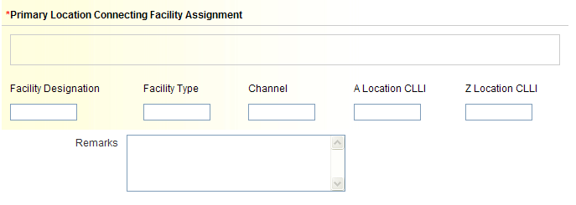

Available Fields:

  - Connecting Facility Assignment (CFA) – required when ‘Yes - Riding VzON Aggregation Port at Primary Location” is selected for field “Are you riding a Connecting Facility Assignment (Aggregation Port)?” and consists of the following elements:
      - Facility Designation
      - Facility Type
      - Channel
      - A Location CLLI
      - Z Location CLLI

Note: Must meet CFA format requirements and all elements must be populated.

- What is multiplexing location CLLI code for the CFA? (MUXLOC)– displayed and required when “Interexchange Customer Service Center” in Account Section is GT10 or GT11.
  - Does a lease arrangement apply to this CFA? Used to indicate if your Company is the owner of the facility named or if a lease arrangement applies.

- When “No” is selected, no further action is needed.

- When “Yes” is selected, population of additional fields is required:

Lease Authorization Name (LANM)
Date of Lease Arrangement (LADATED) Use the format of MM-DD-YYYY

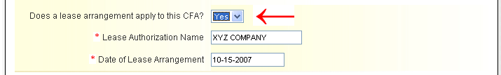

- Remarks - optional

    - Secondary Location Connecting Facility Assignment (SCFA) Section
This Section is required when the circuit being ordered is to ride a higher level facility.
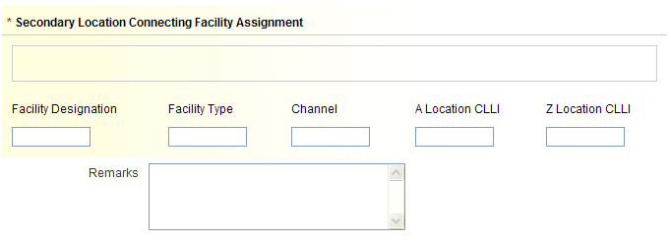

Available Fields:

  - Secondary Connecting Facility Assignment (SCFA) – required when ‘Yes - Riding VzON Aggregation Port at Secondary Location” is selected to field “Are you riding a Connecting Facility Assignment (Aggregation Port)?” and consists of the following elements:
      - Facility Designation
      - Facility Type
      - Channel
      - A Location CLLI
      - Z Location CLLI

Note: Must meet CFA format requirements and all elements must be populated.

- Remarks - optional

    - Service Installation – From
This Section provides information for population of the primary location of the service requested (ACTL).

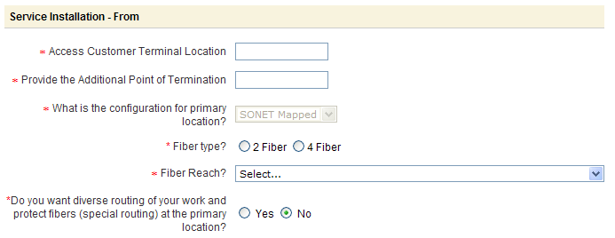

  - Access Customer Terminal Location (ACTL) – this field is required and must contain a valid 11 character CLLI code
  - Provide the Additional Point of Termination (APOT) – this field is required
  - What is the configuration for primary location? – required when displayed. Field will not be displayed when Primary Location is collocated or bandwidth is one of the following:

      - 1 GBPS Fibre Channel (full rate throughput; STS1-19v)
      - 1 GBPS FICON (full rate throughput; STS1-19v)

Note: This field may be defaulted to “SONET Mapped” or ‘Native Ethernet” based upon previous selections for SONET Mapped and/or riding a connecting facility assignment. If field is not defaulted, a selection will be required.

    - When Native Ethernet is selected or bandwidth is 1 GBPS Fibre Channel (full rate throughput; STS1-19v) or 1 GBPS FICON (full rate throughput; STS1-19v), the following additional fields may be displayed based upon previous selections:
      - What is the type of Ethernet Hand-off at primary location? –required when displayed and Native Ethernet is selected for configuration for primary location.
        - Select Electrical or Optical from drop down menu.
          - Some bandwidth selections will cause a default to either “Optical” or “Electrical” for this field.
      - Type? – required when displayed. This field will display when “Optical” is selected to “What is the type of Ethernet Hand-off at primary location?” or bandwidth is 1 GBPS Fibre Channel (full rate throughput; STS1-19v) or 1 GBPS FICON (full rate throughput; STS1-19v).

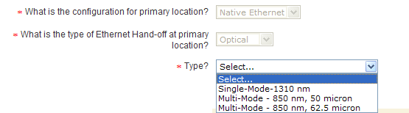

    - When SONET Mapped is selected, the following additional fields may be displayed based upon previous selections:

      - Fiber type? – required when displayed and SONET Mapped is selected for configuration at the primary location.
        - When riding a connecting facility assignment at the primary location, this field will default to “4 Fiber”.
      - Fiber Reach? – required when displayed and SONET Mapped is selected for configuration at the primary location.

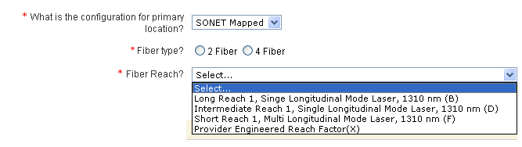

  - Is the circuit(s) being mapped to a standalone STS1 Facility? – this field may be displayed and required based upon previous configuration selections when location is ‘SONET Mapped’ and bandwidth selection is ‘100 MBPS Fast Ethernet (50 MBPS throughput) mapped to STS1 (STS1-1v)’. The value selected for this field is part of the necessary information needed for determining the NCI value.
  - Is Primary location Near-Out-Of-Franchise (NOOF)? - displayed and required when Interexchange Customer Service Center (ICSC) is GT10 or GT11. The value selected for this field is part of the necessary information needed for determining if a SPEC value is required.
  - Near-Out-Of-Franchise (NOOF) Contract Number (CNO) – displayed and required when “Yes” is selected for field “Is Primary location Near-Out-Of-Franchise”.
  - Does Near-Out-Of-Franchise (NOOF) have an ICB? – displayed and required when “Yes” is selected for field “Is Primary location Near-Out-Of-Franchise”. The value selected for this field is part of the necessary information needed for determining the correct SPEC value.
  - Near-Out-Of-Franchise (NOOF) ICB Number – displayed and required when “Yes” is selected for field “Does Near-Out-Of-Franchise (NOOF) have an ICB?”
  - Near-Out-Of-Franchise (NOOF) USOC(s) – displayed and required when “Yes” is selected for field “Does Near-Out-Of-Franchise (NOOF) have an ICB?” Note: This field is displayed with 5 instances to allow up to 5 USOCs to be input.
  - Do you want diverse routing of your work and protect fibers (special routing) at the primary location? (SR) – required for selection when displayed. Field is only displayed when primary location is not collocated.

    - Service Installation – To
This Section provides information for population of the secondary location of the service requested (SECLOC).

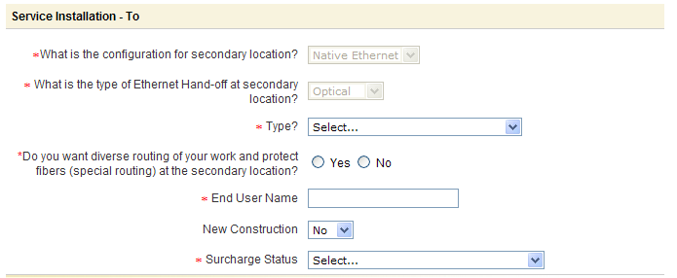

  - What is the configuration for secondary location? – required when displayed. Field will not be displayed when Secondary Location is collocated or bandwidth is one of the following:

      - 1 GBPS Fibre Channel (full rate throughput; STS1-19v)
      - 1 GBPS FICON (full rate throughput; STS1-19v)

Note: This field may be defaulted to “SONET Mapped” or ‘Native Ethernet” based upon previous selections for SONET Mapped and/or riding a connecting facility assignment. If field is not defaulted, a selection will be required.

    - When Native Ethernet is selected or bandwidth is 1 GBPS Fibre Channel (full rate throughput; STS1-19v) or 1 GBPS FICON (full rate throughput; STS1-19v), the following additional fields may be displayed based upon previous selections:
      - What is the type of Ethernet Hand-off at secondary location? –required when displayed and Native Ethernet is selected for configuration at secondary location.
        - Select Electrical or Optical from drop down menu.
          - Some bandwidth selections will cause a default to either “Optical” or “Electrical” for this field.
      - Type? – required when displayed. This field will display when “Optical” is selected to “What is the type of Ethernet Hand-off at secondary location?” or bandwidth is 1 GBPS Fibre Channel (full rate throughput; STS1-19v) or 1 GBPS FICON (full rate throughput; STS1-19v).
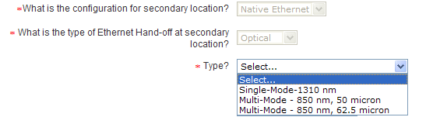

    - When SONET Mapped is selected, the following additional fields may be displayed based upon previous selections:

      - Fiber type? – required when displayed and SONET Mapped is selected for configuration at the secondary location.
        - When riding a connecting facility assignment at the secondary location, this field will default to “4 Fiber”.
      - Fiber Reach? – required when displayed and SONET Mapped is selected for configuration at the secondary location.

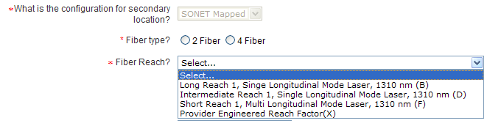
  - Is the circuit(s) being mapped to a standalone STS1 Facility? – this field may be displayed and required based upon previous configuration selections when location is ‘SONET Mapped’ and bandwidth selection is ‘100 MBPS Fast Ethernet (50 MBPS throughput) mapped to STS1 (STS1-1v)’. The value selected for this field is part of the necessary information needed for determining the SECNCI value.
  - Is Secondary location Near-Out-Of-Franchise (NOOF)? - displayed and required when Interexchange Customer Service Center (ICSC) is GT10 or GT11. The value selected for this field is part of the necessary information needed for determining if a SPEC value is required.
  - Near-Out-Of-Franchise (NOOF) Contract Number (CNO) – displayed and required when “No” is selected for field “Is Primary location Near-Out-Of-Franchise” and “Yes” is selected to “Is Secondary location Near-Out-Of-Franchise (NOOF).
  - Does Near-Out-Of-Franchise (NOOF) have an ICB? – displayed and required when “No” is selected for field “Is Secondary location Near-Out-Of-Franchise” and “Yes” is selected to “Is Secondary location Near-Out-Of-Franchise (NOOF). The value selected for this field is part of the necessary information needed for determining the correct SPEC value.
  - Near-Out-Of-Franchise (NOOF) ICB Number – displayed and required when “Yes” is selected for field “Does Near-Out-Of-Franchise (NOOF) have an ICB?”
  - Near-Out-Of-Franchise (NOOF) USOC(s) – displayed and required when “Yes” is selected for field “Does Near-Out-Of-Franchise (NOOF) have an ICB?” Note: This field is displayed with 5 instances to allow up to 5 USOCs to be input.

  - Do you want diverse routing of your work and protect fibers (special routing) at the secondary location? (SR) – required for selection when displayed. Field is only displayed when secondary location is not collocated.
  - End User Name (EUNAME) – field is required
  - New Construction (NCON) – field is optional. Value is set to default to “No”, change value to “Yes” when terminating address is new construction.
  - Surcharge Status (S25) – field is required. Select the appropriate value to determine if surcharge applies to the request.

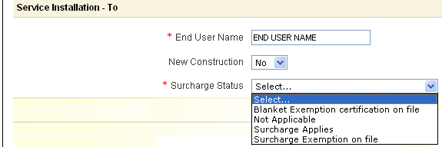

Verizon will convert the Surcharge Status selection made to the proper ASOG value as follows:

Selection | = | ASOG Value
Blanket Exemption certification on file | = | B
Not Applicable | = | NA
Surcharge Applies | = | C
Surcharge Exemption on file | = | A

Note: When ordering meet-point, please refer to Section 7 for additional meet-point (Multi Company) field requirements.

    - Service Address

Section 7 in this user guide provides information for population of the terminating service address and the local contact information.

    - Circuit 2 Section

After all required fields are populated as noted above in the Order Information Section, you may now add an additional circuit(s) if you need a quantity greater than 1.

Minimal information is needed for Circuit 2 and greater since the majority of information was provided at Circuit 1.

Once you add the new circuit, the Delete Circuit option becomes available at Circuit 2 or greater.

Populate the following Required Fields:

  - Surcharge Status (S25C) - this field is displayed and required at Circuit 2 and greater.

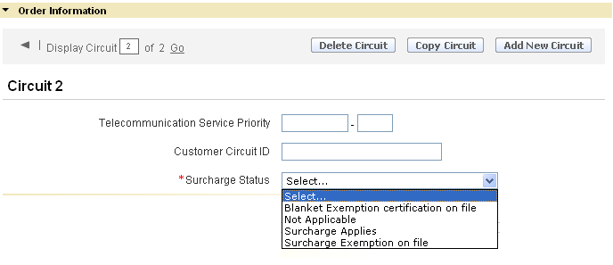

Conditional Field(s):

  - Cross Connect Equipment Assignment (CCEA) – Required when ‘No (Stand-alone)’ is selected to field “Are you riding a Connecting Facility Assignment (Aggregation Port)?” and “Primary Location” or “Collocation at both ends (TLS Transport Only)” is selected to field “Are you collocated at the primary or secondary location?”
  - Secondary Cross Connect Equipment Assignment (SCCEA) – Required when ‘No (Stand-alone)’ is selected to field “Are you riding a Connecting Facility Assignment (Aggregation Port)?” and “Secondary Location” or “Collocation at both ends (TLS Transport Only)” is selected to field “Are you collocated at the primary or secondary location?”

Optional Field(s):

  - Telecommunications Service Priority (TSP)
  - Customer Circuit ID (CKR)

    - Primary Location Connecting Facility Assignment (CFA) Section

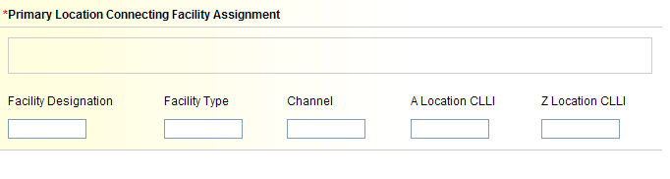

Available Fields:

  - Connecting Facility Assignment (CFA) – required when ‘Yes - Riding VzON Aggregation Port at Primary Location” is selected to field “Are you riding a Connecting Facility Assignment (Aggregation Port)?” and consists of the following elements::
      - Facility Designation
      - Facility Type
      - Channel
      - A Location CLLI
      - Z Location CLLI

Note: Must meet CFA format requirements and all elements must be populated.

    - Secondary Location Connecting Facility Assignment (SCFA) Section

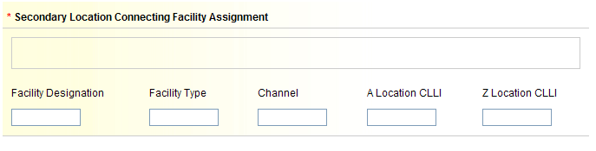

Available Fields:

  - Secondary Connecting Facility Assignment (SCFA) – required when ‘Yes - Riding VzON Aggregation Port at Secondary Location” is selected to field “Are you riding a Connecting Facility Assignment (Aggregation Port)?” and consists of the following elements:
      - Facility Designation
      - Facility Type
      - Channel
      - A Location CLLI
      - Z Location CLLI

Note: Must meet CFA format requirements and all elements must be populated.

For more information on adding more than one (1) circuit, go to Section 6.1 (Adding Additional Circuits – New Activity), otherwise go to Section 9 (Review & Submit Request).

ACTL to PREM Request – Disconnect Activity
The details provided in this section apply for creating a request with “Disconnect” Activity. The required fields will be designated with a red asterisk (*).

    - Circuit 1 Section

Populate the following Required Fields:
  - Circuit ID (ECCKT) – Select the appropriate type of circuit being disconnected (Facility or Serial) and populate the circuit ID.
  - Access Customer Terminal Location (ACTL) – Populate the ACTL associated with the circuit being disconnected.

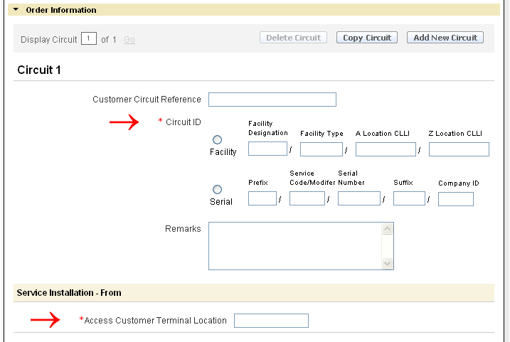

Optional Fields:
  - Customer Circuit Reference (CKR) - is an optional field used to provide the Circuit ID as named by the customer.
  - Remarks - is an optional field used to provide additional detail associated with the request.

Example of a populated request:

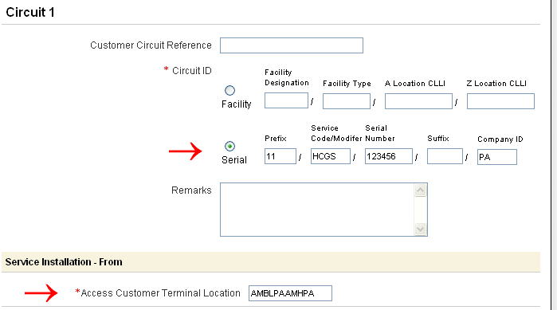

When disconnecting more than one (1) circuit, go to Section 6.2 (Adding Additional Circuits – Disconnect Activity), otherwise go to Section 9 (Review & Submit Request)

VzON Firm Order PREM to PREM Request
The details provided in this section apply for creating a request with “New” or “Disconnect” Activity. This section is broken down by Activity Type.

PREM to PREM Request – New Activity
The details provided in this section apply for creating a request with “New” Activity. The required fields will be designated with a red asterisk (*). This section is broken down into subsections and contains the information needed for indentifying the connecting facility assignment (CFA/CCEA), the Primary locations details, and the Secondary location details including the originating and terminating service address fields.

    - Circuit 1 Section

Populate the following Required Fields:
  - Are you collocated at the primary or secondary location? - the value selected for this field is part of the necessary information needed for determining the NCI/SECNCI values as well as determining allowable bandwidth options in the ‘What is the requested bandwidth?’ field.
  - Are you riding a Connecting Facility Assignment (Aggregation Port)? - the value selected for this field is part of the necessary information needed for determining the NCI/SECNCI values as well as determining allowable bandwidth options in the ‘What is the requested bandwidth?’ field. Drop down options in this field will vary based on selection to field “Are you collocated at the primary or secondary location?” Note: If the requested circuit is riding another CFA type (such as a Ring) that is not an Aggregation Port Facility, you cannot use Order by Product for this request.
  - Do you want to be SONET Mapped at the primary location? – this field is displayed when ‘No (stand-alone)’ is selected for “Are you riding a Connecting Facility Assignment (Aggregation Port)?” and ‘Secondary Location” is selected for “Are you collocated at the primary or secondary location?”. The value selected for this field is part of the necessary information needed for determining the NCI/SECNCI values as well as determining allowable bandwidth options in the ‘What is the requested bandwidth?’ field.

  - Do you want to be SONET Mapped at the secondary location? – this field is displayed when ‘No (stand-alone)’ is selected for “Are you riding a Connecting Facility Assignment (Aggregation Port)?” and ‘Primary Location” is selected for “Are you collocated at the primary or secondary location?”. The value selected for this field is part of the necessary information needed for determining the NCI/SECNCI values as well as determining allowable bandwidth options in the ‘What is the requested bandwidth?’ field.
  - Do you want to be SONET Mapped at either the primary or secondary location? – this field is displayed when ‘No (stand-alone)’ is selected for “Are you riding a Connecting Facility Assignment (Aggregation Port)?” and ‘No collocation at either end” is selected for “Are you collocated at the primary or secondary location”. The value selected for this field is part of the necessary information needed for determining the NCI/SECNCI values as well as determining allowable bandwidth options in the ‘What is the requested bandwidth?’ field.
  - What is the requested bandwidth? – the value selected for this field is part of the necessary information needed for determining the NC/NCI/SECNCI values. Values displayed in the drop down will vary based on previously answered questions.

Conditional and Optional Field(s):

  - Do you require the Verizon Inter-Office Facility route to be protected? – the value selected for this field is part of the necessary information needed for determining the correct NC value. This field shall be displayed and required based upon specific bandwidth selections for field “What is the requested bandwidth?” Available options are ‘Yes’ and ‘No’. Certain collocation and bandwidth selections will cause this field to default to ‘Yes’.
  - Fiber Network Identification (FNI) – this field is displayed and required when you are riding a connecting facility assignment at either the primary or secondary location.
  - Wireless Site Indicator (WSI) – select existing site if applicable to the request. Used to indicate the request is to an existing cell site location. Note: For new site option, see the user guide for Wireless VzON/EPL Service Inquiry.
  - Telecommunications Service Priority (TSP)
  - Customer Circuit ID (CKR)
  - Cross Connect Equipment Assignment (CCEA) – Required when ‘No (Stand-alone)’ is selected to field “Are you riding a Connecting Facility Assignment (Aggregation Port)?” and “Primary Location” or “Collocation at both ends (TLS Transport Only)” is selected to field “Are you collocated at the primary or secondary location?”
  - Secondary Cross Connect Equipment Assignment (SCCEA) – Required when ‘No (Stand-alone)’ is selected to field “Are you riding a Connecting Facility Assignment (Aggregation Port)?” and “Secondary Location” or “Collocation at both ends (TLS Transport Only)” is selected to field “Are you collocated at the primary or secondary location?”
  - Remarks - optional

Example of circuit 1 section for Prem to Prem:
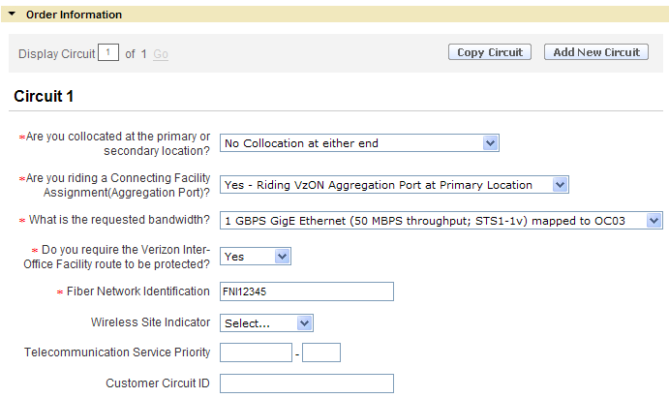

    - Primary Location Connecting Facility Assignment (CFA) Section

This Section is required when the circuit being ordered is to ride a higher level facility at the primary location.
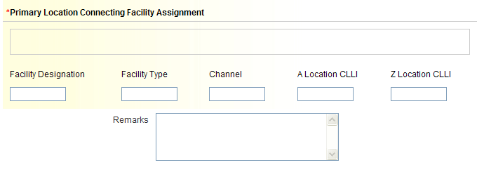

Available Fields:

  - Connecting Facility Assignment (CFA) – required when ‘Yes - Riding VzON Aggregation Port at Primary Location” is selected to field “Are you riding a Connecting Facility Assignment (Aggregation Port)?” and consists of the following elements:
      - Facility Designation
      - Facility Type
      - Channel
      - A Location CLLI
      - Z Location CLLI

Note: Must meet CFA format requirements and all elements must be populated.

- What is multiplexing location CLLI code for the CFA? (MUXLOC)– displayed and required when “Interexchange Customer Service Center” in Account Section is GT10 or GT11.
  - Does a lease arrangement apply to this CFA? Used to indicate if your Company is the owner of the facility named or if a lease arrangement applies.

- When “No” is selected, no further action is needed.

- When “Yes” is selected, population of additional fields is required:

Lease Authorization Name (LANM)
Date of Lease Arrangement (LADATED) Use the format of MM-DD-YYYY

    - Secondary Location Connecting Facility Assignment (SCFA) Section
This Section is required when the circuit being ordered is to ride a higher level facility at the secondary location.

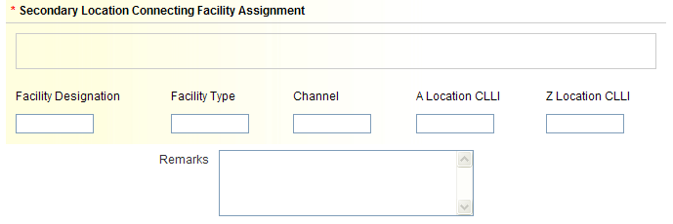

Available Fields:

  - Secondary Connecting Facility Assignment (SCFA) – required when ‘Yes - Riding VzON Aggregation Port at Secondary Location” is selected to field “Are you riding a Connecting Facility Assignment (Aggregation Port)?” and consists of the following elements:
      - Facility Designation
      - Facility Type
      - Channel
      - A Location CLLI
      - Z Location CLLI

Note: Must meet CFA format requirements and all elements must be populated.

- Remarks - optional

    - Service Installation – From
This Section provides information for population of the primary location of the service requested.
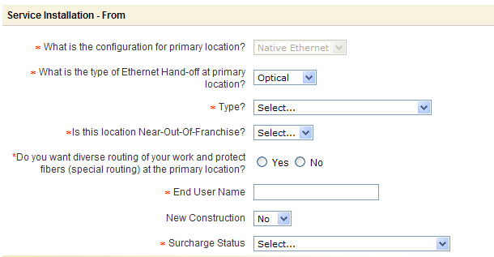

  - What is the configuration for primary location? – required when displayed. Field will not be displayed when Primary Location is collocated or bandwidth is one of the following:

      - 1 GBPS Fibre Channel (full rate throughput; STS1-19v)
      - 1 GBPS FICON (full rate throughput; STS1-19v)

Note: This field may be defaulted to “SONET Mapped” or ‘Native Ethernet” based upon previous selections for SONET Mapped and/or riding a connecting facility assignment. If field is not defaulted, a selection will be required.

    - When Native Ethernet is selected or bandwidth is 1 GBPS Fibre Channel (full rate throughput; STS1-19v) or 1 GBPS FICON (full rate throughput; STS1-19v), the following additional fields may be displayed based upon previous selections:
      - What is the type of Ethernet Hand-off at primary location? –required when displayed and Native Ethernet is selected for configuration at primary location.
        - Select Electrical or Optical from drop down menu.
          - Some bandwidth selections will cause a default to either “Optical” or “Electrical” for this field.
      - Type? – required when displayed. This field will display when “Optical” is selected to “What is the type of Ethernet Hand-off at primary location?” or bandwidth is 1 GBPS Fibre Channel (full rate throughput; STS1-19v) or 1 GBPS FICON (full rate throughput; STS1-19v).

    - When SONET Mapped is selected, the following additional fields may be displayed based upon previous selections:

      - Fiber type? – required when displayed and SONET Mapped is selected for configuration at the primary location.
        - When riding a connecting facility assignment at the primary location, this field will default to “4 Fiber”.
      - Fiber Reach? – required when displayed and SONET Mapped is selected for configuration at the primary location.

  - Is the circuit(s) being mapped to a standalone STS1 Facility? – this field may be displayed and required based upon previous configuration selections when location is ‘SONET Mapped’ and bandwidth selection is ‘100 MBPS Fast Ethernet (50 MBPS throughput) mapped to STS1 (STS1-1v)’. The value selected for this field is part of the necessary information needed for determining the NCI value.
  - Is Primary location Near-Out-Of-Franchise (NOOF)? - displayed and required when Interexchange Customer Service Center (ICSC) is GT10 or GT11. The value selected for this field is part of the necessary information needed for determining if a SPEC value is required.
  - Near-Out-Of-Franchise (NOOF) Contract Number (CNO) – displayed and required when “Yes” is selected for field “Is Primary location Near-Out-Of-Franchise”.
  - Does Near-Out-Of-Franchise (NOOF) have an ICB? – displayed and required when “Yes” is selected for field “Is Primary location Near-Out-Of-Franchise”. The value selected for this field is part of the necessary information needed for determining the correct SPEC value.
  - Near-Out-Of-Franchise (NOOF) ICB Number – displayed and required when “Yes” is selected for field “Does Near-Out-Of-Franchise (NOOF) have an ICB?”
  - Near-Out-Of-Franchise (NOOF) USOC(s) – displayed and required when “Yes” is selected for field “Does Near-Out-Of-Franchise (NOOF) have an ICB?” Note: This field is displayed with 5 instances to allow up to 5 USOCs to be input.
  - Do you want diverse routing of your work and protect fibers (special routing) at the primary location? (SR) – required for selection when displayed. Field is only displayed when primary location is not collocated.
  - End User Name (EUNAME) – field is required
  - New Construction (NCON) – field is optional
  - Surcharge Status (S25) – field is required

Verizon will convert the Surcharge Status selection made to the proper ASOG value as follows:

Selection | = | ASOG Value
Blanket Exemption certification on file | = | B
Not Applicable | = | NA
Surcharge Applies | = | C
Surcharge Exemption on file | = | A

Note: When ordering meet-point, please refer to Section 7 for additional meet-point (Multi Company) field requirements.

    - Service Address

Go to Section 7 for information on population of the originating service address and the local contact information.

    - Service Installation – To
This Section provides information for population of the secondary location of the service requested (SECLOC).

  - What is the configuration for secondary location? – required when displayed. Field will not be displayed when Secondary Location is collocated or bandwidth is one of the following:

      - 1 GBPS Fibre Channel (full rate throughput; STS1-19v)
      - 1 GBPS FICON (full rate throughput; STS1-19v)

Note: This field may be defaulted to “SONET Mapped” or ‘Native Ethernet” based upon previous selections for SONET Mapped and/or riding a connecting facility assignment. If field is not defaulted, a selection will be required.

    - When Native Ethernet is selected or bandwidth is 1 GBPS Fibre Channel (full rate throughput; STS1-19v) or 1 GBPS FICON (full rate throughput; STS1-19v), the following additional fields may be displayed based upon previous selections:
      - What is the type of Ethernet Hand-off at secondary location? –required when displayed and Native Ethernet is selected for configuration at secondary location.
        - Select Electrical or Optical from drop down menu.
          - Some bandwidth selections will cause a default to either “Optical” or “Electrical” for this field.
      - Type? – required when displayed. This field will display when “Optical” is selected to “What is the type of Ethernet Hand-off at secondary location?” or bandwidth is 1 GBPS Fibre Channel (full rate throughput; STS1-19v) or 1 GBPS FICON (full rate throughput; STS1-19v).

    - When SONET Mapped is selected, the following additional fields may be displayed based upon previous selections:

      - Fiber type? – required when displayed and SONET Mapped is selected for configuration at the secondary location.
        - When riding a connecting facility assignment at the secondary location, this field will default to “4 Fiber”.
      - Fiber Reach? – required when displayed and SONET Mapped is selected for configuration at the secondary location.

  - Is the circuit(s) being mapped to a standalone STS1 Facility? – this field may be displayed and required based upon previous configuration selections when location is ‘SONET Mapped’ and bandwidth selection is ‘100 MBPS Fast Ethernet (50 MBPS throughput) mapped to STS1 (STS1-1v)’. The value selected for this field is part of the necessary information needed for determining the SECNCI value.
  - Is Secondary location Near-Out-Of-Franchise (NOOF)? - displayed and required when Interexchange Customer Service Center (ICSC) is GT10 or GT11. The value selected for this field is part of the necessary information needed for determining if a SPEC value is required.
  - Near-Out-Of-Franchise (NOOF) Contract Number (CNO) – displayed and required when “No” is selected for field “Is Primary location Near-Out-Of-Franchise” and “Yes” is selected to “Is Secondary location Near-Out-Of-Franchise (NOOF).
  - Does Near-Out-Of-Franchise (NOOF) have an ICB? – displayed and required when “No” is selected for field “Is Secondary location Near-Out-Of-Franchise” and “Yes” is selected to “Is Secondary location Near-Out-Of-Franchise (NOOF). The value selected for this field is part of the necessary information needed for determining the correct SPEC value.
  - Near-Out-Of-Franchise (NOOF) ICB Number – displayed and required when “Yes” is selected for field “Does Near-Out-Of-Franchise (NOOF) have an ICB?”
  - Near-Out-Of-Franchise (NOOF) USOC(s) – displayed and required when “Yes” is selected for field “Does Near-Out-Of-Franchise (NOOF) have an ICB?” Note: This field is displayed with 5 instances to allow up to 5 USOCs to be input.
  - Do you want diverse routing of your work and protect fibers (special routing) at the secondary location? (SR) – required for selection when displayed. Field is only displayed when secondary location is not collocated.
  - End User Name (EUNAME)
  - New Construction (NCON) – Value is set to default to “No”, change value to “Yes” when terminating address is new construction.
  - Surcharge Status (S25) – Select the appropriate value to determine if surcharge applies to the request.

Verizon will convert the Surcharge Status selection made to the proper ASOG value as follows:

Selection | = | ASOG Value
Blanket Exemption certification on file | = | B
Not Applicable | = | NA
Surcharge Applies | = | C
Surcharge Exemption on file | = | A

Note: When ordering meet-point, please refer to Section 7 for additional meet-point (Multi Company) field requirements.

    - Service Address

Go to Section 7 for information on population of the terminating service address and the local contact information.

    - Circuit 2 Section

After all required fields are populated as noted above in the Order Information Section, you may now add an additional circuit(s) if you need a quantity greater than 1.

Minimal information is needed for Circuit 2 and greater since the majority of information was provided at Circuit 1.

Once you add the new circuit, the Delete Circuit option becomes available at Circuit 2 or greater.

Populate the following Required Fields:

  - Surcharge Status (S25C) - this field is displayed and required at Circuit 2 and greater.

Conditional Field(s):

  - Cross Connect Equipment Assignment (CCEA) – Required when ‘No (Stand-alone)’ is selected to field “Are you riding a Connecting Facility Assignment (Aggregation Port)?” and “Primary Location” or “Collocation at both ends (TLS Transport Only)” is selected to field “Are you collocated at the primary or secondary location?”
  - Secondary Cross Connect Equipment Assignment (SCCEA) – Required when ‘No (Stand-alone)’ is selected to field “Are you riding a Connecting Facility Assignment (Aggregation Port)?” and “Secondary Location” or “Collocation at both ends (TLS Transport Only)” is selected to field “Are you collocated at the primary or secondary location?”

Optional Field(s):

  - Telecommunications Service Priority (TSP)
  - Customer Circuit ID (CKR)

    - Primary Location Connecting Facility Assignment (CFA) Section

Available Fields:

  - Connecting Facility Assignment (CFA) – required when ‘Yes - Riding VzON Aggregation Port at Primary Location” is selected to field “Are you riding a Connecting Facility Assignment (Aggregation Port)?” and consists of the following elements:
      - Facility Designation
      - Facility Type
      - Channel
      - A Location CLLI
      - Z Location CLLI

Note: Must meet CFA format requirements and all elements must be populated.

    - Secondary Location Connecting Facility Assignment (SCFA) Section

Available Fields:

  - Secondary Connecting Facility Assignment (SCFA) – required when ‘Yes - Riding VzON Aggregation Port at Secondary Location” is selected to field “Are you riding a Connecting Facility Assignment (Aggregation Port)?” and consists of the following elements:
      - Facility Designation
      - Facility Type
      - Channel
      - A Location CLLI
      - Z Location CLLI

Note: Must meet CFA format requirements and all elements must be populated.

For more information on adding more than one (1) circuit, go to Section 6.1 (Adding Additional Circuits – New Activity), otherwise go to Section 9 (Review & Submit Request).

PREM to PREM Request – Disconnect Activity
The details provided in this section apply for creating a request with “Disconnect” Activity. The required fields will be designated with a red asterisk (*).

    - Circuit 1 Section

Populate the following Required Fields:
  - Circuit ID (ECCKT) – Select the appropriate type of circuit being disconnected (Facility or Serial) and populate the circuit ID.

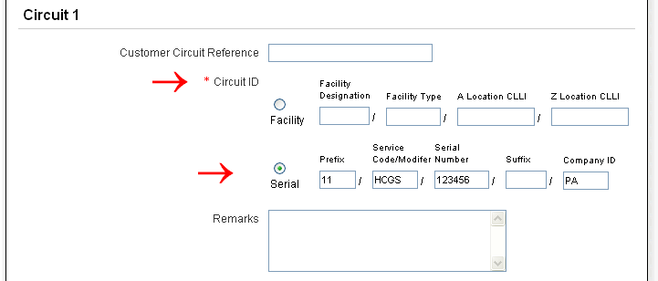

Optional Fields:
  - Customer Circuit Reference (CKR) - is an optional field used to provide the Circuit ID as named by the customer.
  - Remarks - is an optional field used to provide additional detail associated with the request.

When disconnecting more than one (1) circuit, go to Section 6.2 (Adding Additional Circuits – Disconnect Activity), otherwise go to Section 9 (Review & Submit Request)

Adding and Removing Additional Circuits
This functionality is not available for VzON Aggregration Port requests for new or disconnect activity.

Adding Additional Circuits – New Activity
The details provided in this section are for creating requests for multiple circuits for VzON FIRM requests only.

Populate the entire “Order Information” Section for Circuit 1:

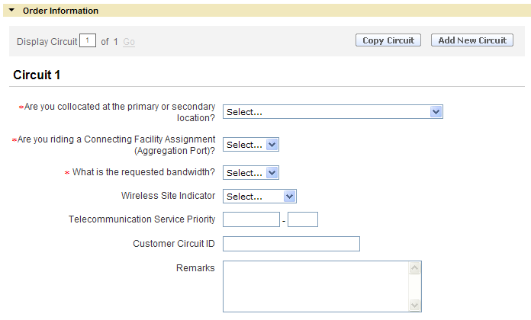

Select “Copy Circuit” or “Add New Circuit” Button:

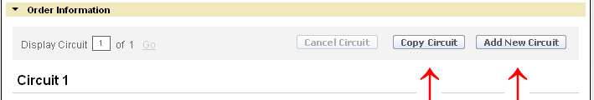

The “Copy Circuit” Button will duplicate the information already provided for Circuit 1, saving time and reducing the number of entries requiring population. Just name the Surcharge Status (S25A) if different from the previous circuit and update the necessary information such as the Customer Circuit Reference (CKR) and channel assignment on the CFA.

If more circuits are desired for the request, select the “Copy Circuit” or “Add New Circuit” buttons as appropriate.

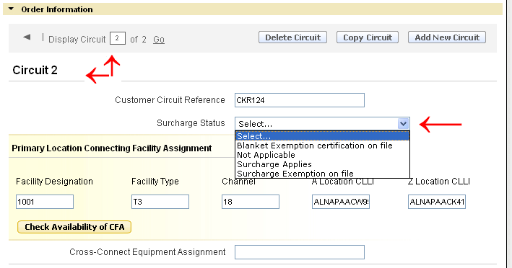

When the “Add New Circuit” button is selected, the circuit detail section will be returned “blank” requiring full population of the desired fields for the additional circuits:

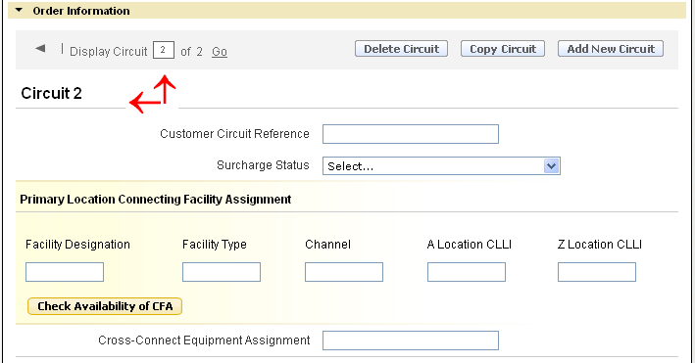

Adding Additional Circuits – Disconnect Activity

Populate the entire “Order Information” Section for Circuit 1:

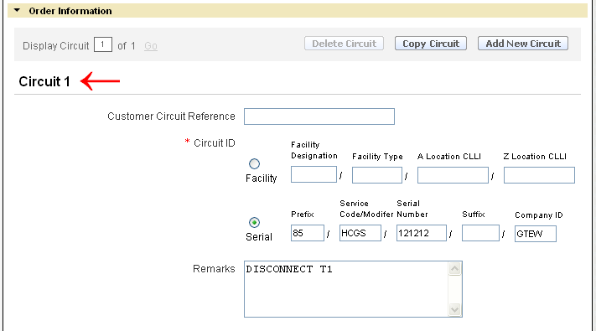

Select “Copy Circuit” or “Add New Circuit” Button:

The “Copy Circuit” Button will duplicate the information already provided for Circuit 1, saving time and reducing the number of entries requiring population. Just rename the Circuit ID.

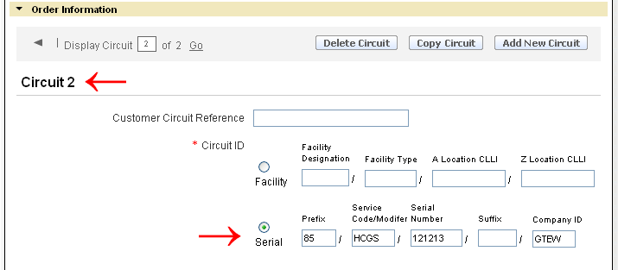

When the “Add New Circuit” button is selected, the circuit detail section will be returned “blank” requiring full population of the Circuit ID field.

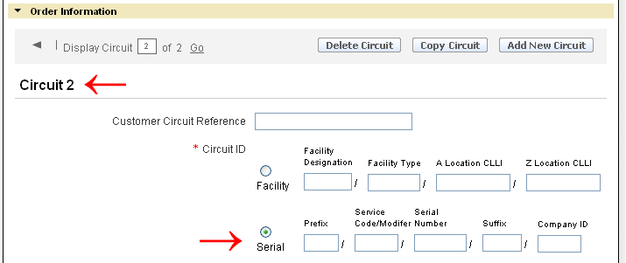:

Removing Additional Circuits – New and Disconnect Activity
This section will provide the necessary steps to remove a circuit from a request prior to submitting the original version as well as the proper steps to remove a circuit from a request that has already been received and ACCEPTED by Verizon.

Removing Additional Circuits – Prior to submitting the Original Request

Enter the circuit number to be removed in the open box (1st red arrow) and select “Go” or select the dark gray arrow (2nd red arrow) to advance sequentially to each additional circuit.

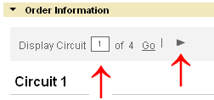

Once the desired Circuit detail screen is obtained select the “Delete Circuit” button.
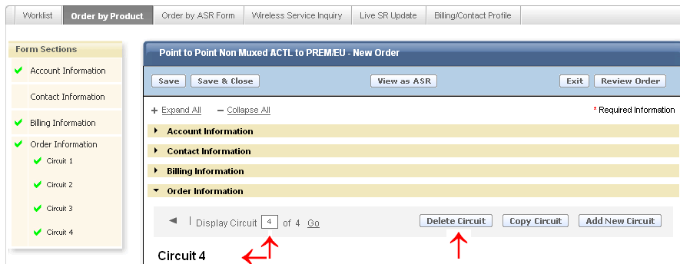

A Warning message will display. Select “OK” to delete the circuit or “Cancel” to stop the deletion process.
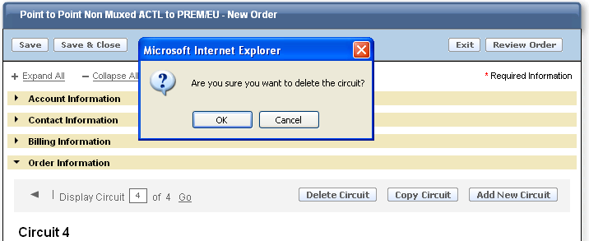

After selecting “OK”, the “Display Circuit” quantity value will update to reflect the change.

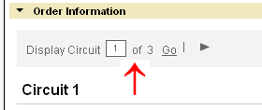

Removing Additional Circuits – Previous Version has been Submitted & Accepted by Verizon
A Supplement (SUP) needs to be submitted when removing additional circuits named on a previous version of the Request. Following the steps named below will obtain a “cancelation” to a specific circuit(s).

Enter the circuit number to be “canceled” in the open box (1st red arrow) and select “Go”, or select the dark gray arrow (2nd red arrow) to advance sequentially until the circuit to be “canceled” is displayed.

Once the desired Circuit detail screen is obtained select the “Cancel Circuit” button.

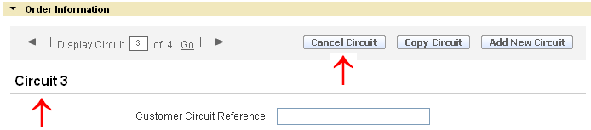

A Warning message will display. Select “OK” to cancel the circuit or “Cancel” to stop the cancelation process.

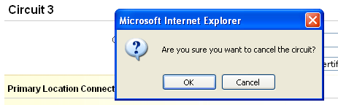

Select “Review Order” button:

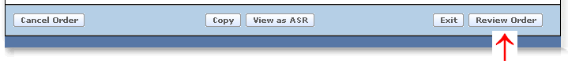

Name the Circuit that was canceled to review the status:

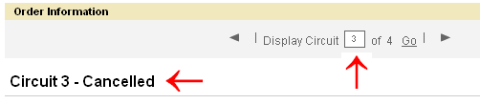

Then Select “Submit”.

Service Address Section
This section provides information for population of the originating and terminating service address and the local contact information. The required conditional and optional fields vary depending on the Verizon Region and address type (AFT) selected.

  - Select Address Type (AFT) – Value is set to default at “Official Numbered Address”. When desired value is not “Official Numbered Address”, the supported values to choose from will vary depending on the Verizon Region.

Verizon North and South Regions allowable entries:

Official Numbered Address (AFT = “blank”)
Rural Route & Box (AFT = “A”)
Assigned House Number (AFT = “C”)
Remote Location with Assigned CLLI (AFT = “E”)

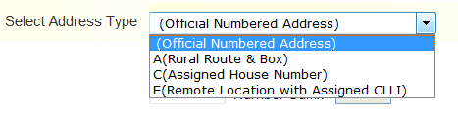
Note: Remote Location with assigned CLLI is not applicable when the associated Location is collocated.

Verizon West Region allowable entries:

Official Numbered Address (AFT = “blank”)
Rural Route & Box (AFT = A)
Unnumbered Address (AFT = B)
Remote Location with Assigned CLLI (AFT = “E”)

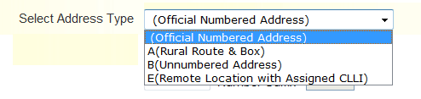

Note: Remote Location with assigned CLLI is not applicable when the associated Location is collocated.

Required Fields for “Official Number Address” (all Verizon regions) and “Assigned House” Number (Verizon East Only):

  - Select Address Type – “Official Numbered Address” or
“C (Assigned House Number)”
  - Address Number (SANO)
  - Street Name (SASN)
  - City (CITY)
  - State (STATE)
  - Zip Code (ZIP CODE)

Note: The fields named above are the minimal required fields. However, additional service address fields may be required to receive a successful address validation.

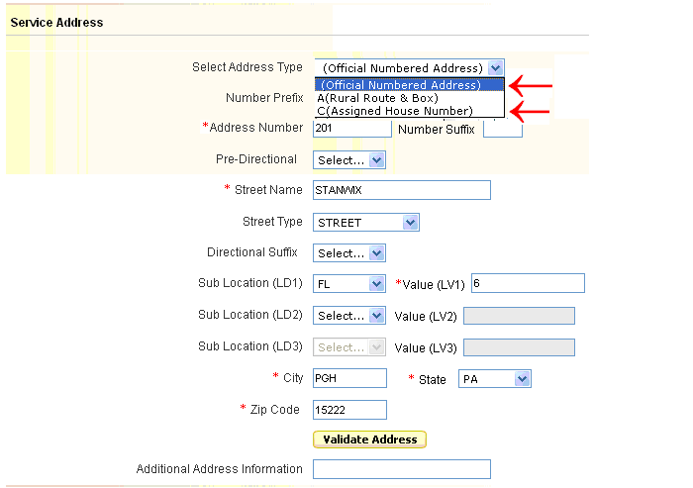

Optional Fields:
  - Number Prefix (SAPR)
  - Number Suffix (SASF)
  - Pre-Directional (SASD)
  - Street Type (SATH)
  - Directional Suffix (SASS)
  - Sub Location (LD1)
  - Value (LV1)
  - Sub Location (LD2)
  - Value (LV2)
  - Sub Location (LD3)
  - Value (LV3)

Populate the address where service is to terminate and select the “Validate Address” button.

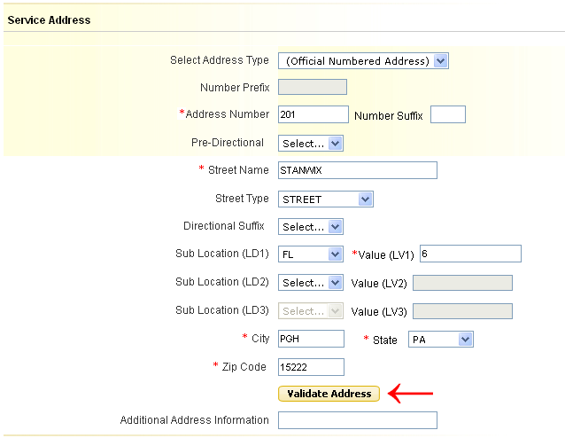

A “Pop Up” box will display the result of the Search. Slide the Scroll bar on the bottom of the box to see all the information returned:

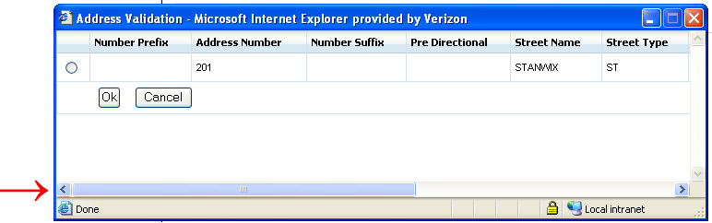

Select the radio button next to the address, and then select “OK”.

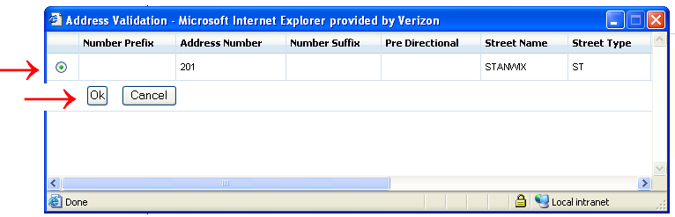

Required Fields for “Rural Route and Box”:

  - Select Address Type – A (Rural Route & Box)
  - Address Number – Verizon East Only (SANO)
  - Rural Route (SASN) – Select the appropriate entry
  - Route # (SASN)
  - City (CITY)
  - State (STATE)
  - Zip Code (ZIP CODE)

Note: The fields named above are the minimal required fields. However, additional service address fields may be required to receive a successful address validation.

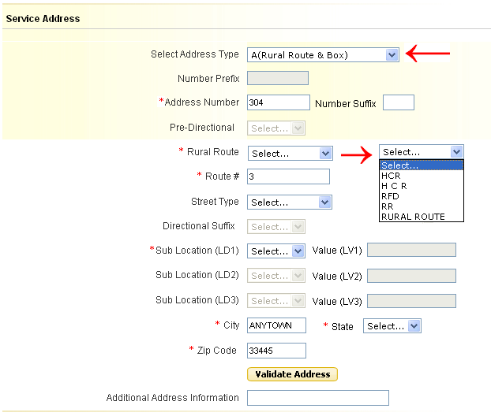

Optional Fields:
  - Number Suffix (SASF)
  - Street Type (SATH)
  - Sub Location (LD1)
  - Value (LV1)
  - Sub Location (LD2)
  - Value (LV2)
  - Sub Location (LD3)
  - Value (LV3)

Populate the address where service is to terminate and select the “Validate Address” button.

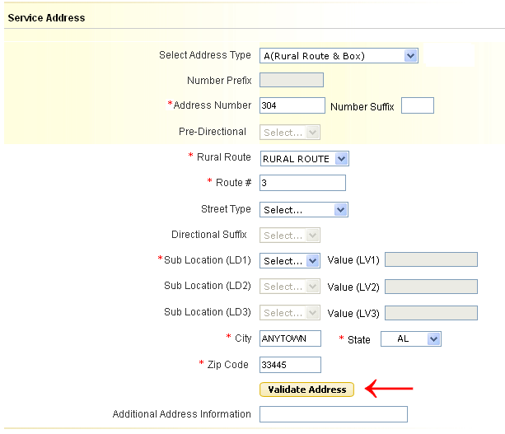

Required Fields for “Unnumbered Address” (Verizon West Only):
  - Street Name (SASN)
  - City (CITY)
  - State (STATE)
  - Zip Code (ZIP CODE)

Note: The fields named above are the minimal required fields. However, additional service address fields may be required to receive a successful address validation.
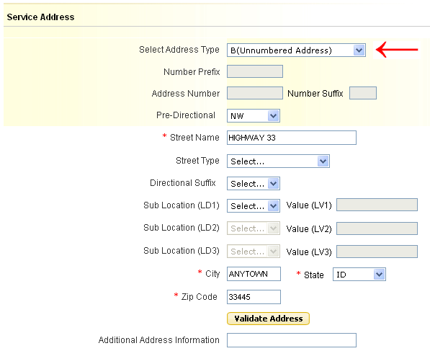

Optional Fields:
  - Pre-Directional (SASD)
  - Street Type (SATH)
  - Directional Suffix (SASS)
  - Sub Location (LD1)
  - Value (LV1)
  - Sub Location (LD2)
  - Value (LV2)
  - Sub Location (LD3)
  - Value (LV3)

Populate the address where service is to terminate and select the “Validate Address” button.

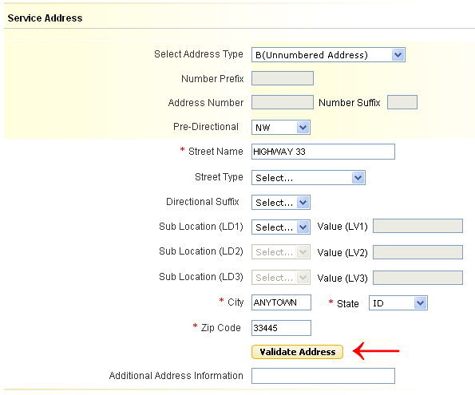

Required Fields for “Remote Location with Assigned CLLI”:

  - Remote Location CLLI – 8 or 11 character CLLI code
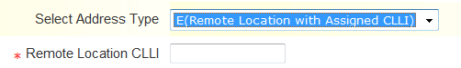

    - Local Contact Information

Populate the following Required Fields:

- Local Contact Name (LCON)
- Local Contact Telephone (ACTEL)
- Local Contact E-Mail (LCON EMAIL)
- Alternate Local Contact Name (ALCON) – must be different than the Local Contact Name
- Alternate Local Contact Telephone (ALCON TEL) – must be different than the Local Contact Telephone
- Alternate Local Contact E-Mail (ALCON EMAIL) – must be different than the Local Contact E-Mail

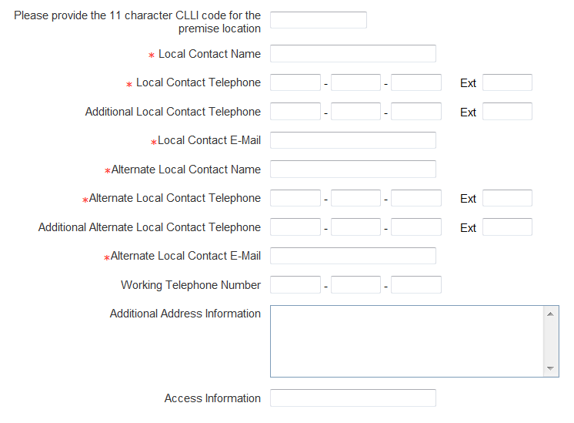

Optional Fields:

  - Please provide the 11 character CLLI code for the premise location (SPOT) – required when Interexchange Customer Service Center field 1st two positions are GT, else optional.
  - Additional Local Contact Telephone (AACTEL)
  - Additional Alternate Local Contact Telephone (AALCON TEL)
  - Working Telephone Number (WKTEL) - Required for population when 'Existing Site' is selected for field "Wireless Site Indicator", else optional.
  - Additional Address Information (AAI) – required only when “Remote Location with assigned CLLI” is selected in the “Select Address Type” field otherwise optional.
  - Access Information (ACC)

Multi-Company Information Section
This section provides the necessary detail to complete the “Multi-Company Information” Section. The details provided in this section apply for creating a “New” or “Disconnect” request. The required fields will be designated with a red asterisk (*) on each type of request.

Enabling a Multi-Company Circuit Section
By selecting ‘Yes’ to the Multi-Company Circuit field on the product menu, a Multi-Company Information Section shall appear on the order form in Order by Product.

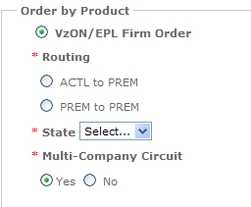

Populating the Multi-Company Information Section

Populate the following fields for ALL Routings:
  - ASC-EC Interexchange Customer Service Center (ASC-EC ICSC) – Populate the ICSC of the Access Service Controlling Company.
  - ASC-EC Billing Account Number (ASC-EC BAN) – Populate the full Billing Account Number (BAN) or “E” (existing BAN) of the Access Service Controlling Company.
  - Other Exchange Company ICSC (OEC ICSC) – Populate the ICSC of the Other Exchange Company.
  - Other Exchange Company BAN (OEC BAN) – Populate the full Billing Account Number (BAN) or “E” (existing BAN) of the Other Exchange Company.

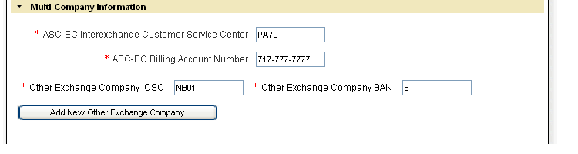

Adding Additional Other Exchange Company Fields
When more than one (1) Other Exchange Companies (OEC) are involved in the meet-point route, additional “Other Exchange Company ICSC and “Other Exchange Company BAN” fields are required to be populated.

The following Steps will add additional Other Exchange Company Fields:

When the Multi-Company Information Section is NOT populated the “Add New Other Exchange Company” button is not accessible.

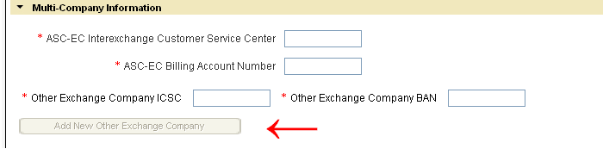

Upon completion of the initial four (4) required fields listed in the Multi-Company Information Section the “Add New Other Exchange Company” button will become accessible.

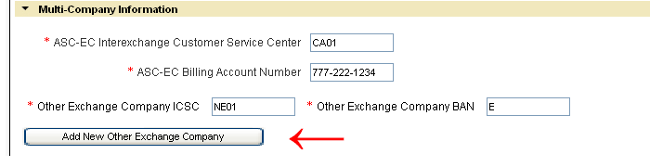

Select the “Add New Other Exchange Company” button to add the additional Other Exchange Company ICSC (OEC-ICSC) and Other Exchange Company BAN (OEC-BAN) combination(s). A maximum of seven (7) can be provided on a request.

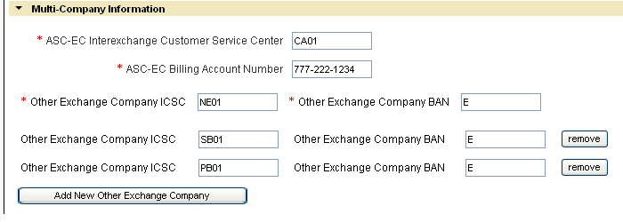

Removing Additional Other Exchange Company Fields

- Removing additional Other Exchange Company Fields prior to submitting the original request:

Select the “Remove” button located to the right of the Other Exchange Company BAN field you wish to delete.

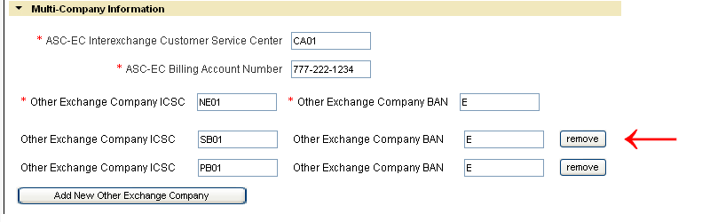

A Warning message will display. Select “OK” to delete the Other Exchange Company fields or “Cancel” to stop the deletion process.

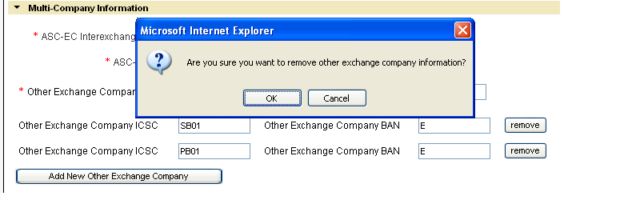

After selecting “OK”, the Other Exchange Company ICSC and Other Exchange Company BAN field combination will be removed from the request.

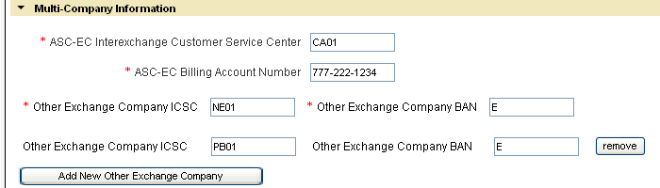

- Removing additional Other Exchange Company Fields on Request that has been submitted and ACCEPTED by Verizon:

A Supplement (SUP) needs to be submitted when removing the additional Other Exchange Company ICSC and BAN combination named on a previous version of the request. Following the steps named below will obtain a “cancelation” to the specific Other Exchange Company ICSC and BAN combination.

Note: Once an Other Exchange Company ICSC and BAN field combination is cancelled, as stated in the ASOG it cannot be reused for the life of the request.

Select the “Cancel” button located to the right of the Other Exchange Company ICSC and BAN combination to be cancelled.

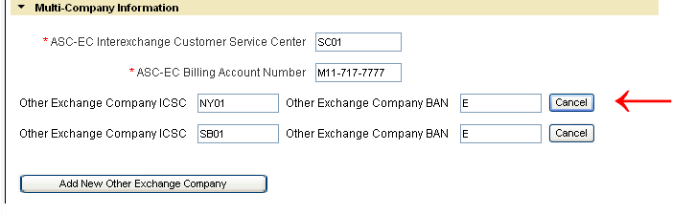

A Warning message will display. Select “OK” to cancel the Other Exchange Company ICSC and BAN combination, or “Cancel” to stop the cancellation process.

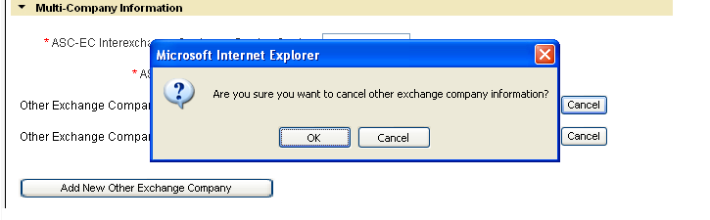

After selecting “OK”, the word “Cancelled” will display to the right of the line containing the Other Exchange Company ICSC and Other Exchange Company BAN combination to be cancelled.

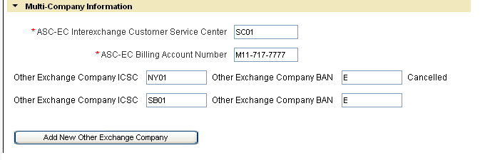

Select “Review Order” button:

The cancelled Other Exchange Company ICSC and BAN field combination is displayed as “Cancelled” on Review screen.

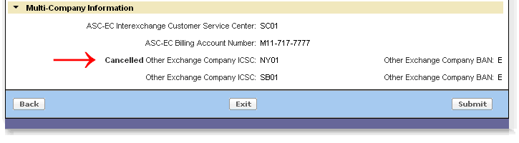

Then Select “Submit”.

Review and Submit Request
The details provided in this section provide the necessary steps for reviewing and submitting a completed request.

Select “Review Order” button:

Select “Submit” after reviewing the order details:

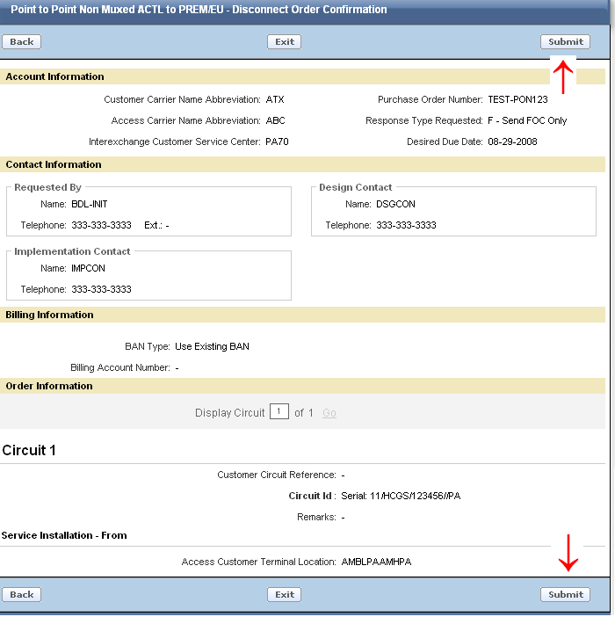

Select the “Back” button to return to the order entry screen.
Select the “EXIT” button to return to the Worklist page. The current request will not be “Saved” or “Submitted” when “EXIT” is selected.

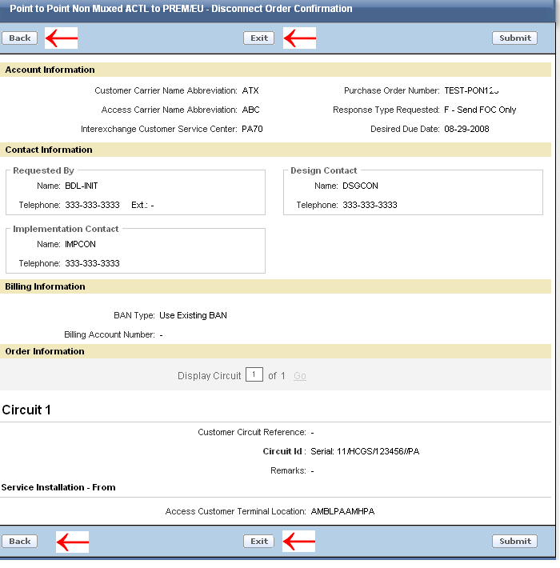

After Submit is selected, you will receive a pop up message asking “Are you sure you want to submit the request?”

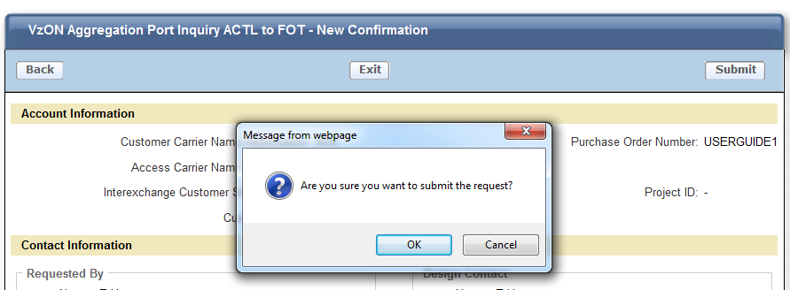

Click “OK” to submit
Click “Cancel” to return to the Review Order Page.

After “OK” is selected, you will receive a confirmation that your order has been submitted successfully:

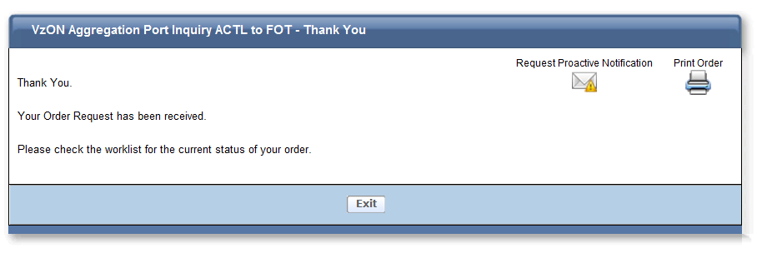

If you would like to receive proactive email notification of status changes on your order, then select “Request Proactive Notifications” otherwise you may print and/or exit the order.

If “Request Proactive Notifications” was selected, you will see the following screen and you can then select which notifications you would like to receive and hit the “Subscribe” button:
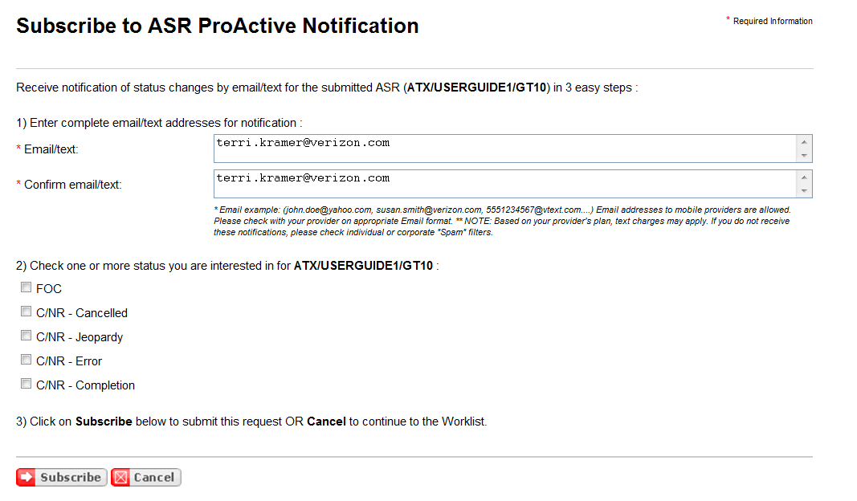

Order History and Status Section
To check the history and/or Status, select the PON from the Worklist.

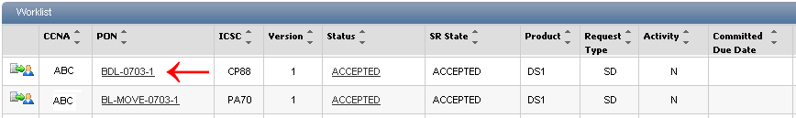

The Order History and Status section provides the history of a PON from submission to completion.

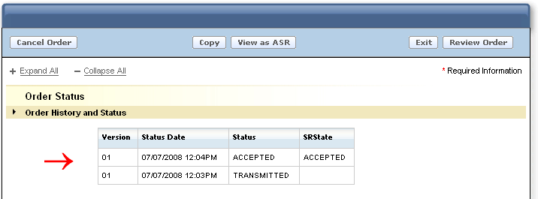

When the Status column indicates “Rejected”, the word “Rejected” is displayed as a link. Select the link to view the rejection response:

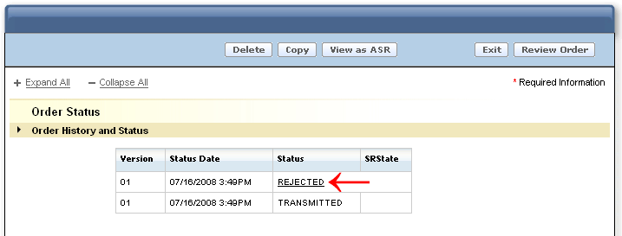

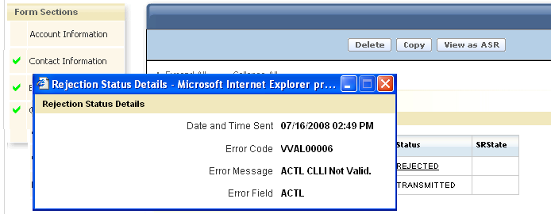

When the SRState column indicates “Error C/NR Pending”, the words “Error C/NR Pending” are displayed as a link. Select the link to view the C/NR response:

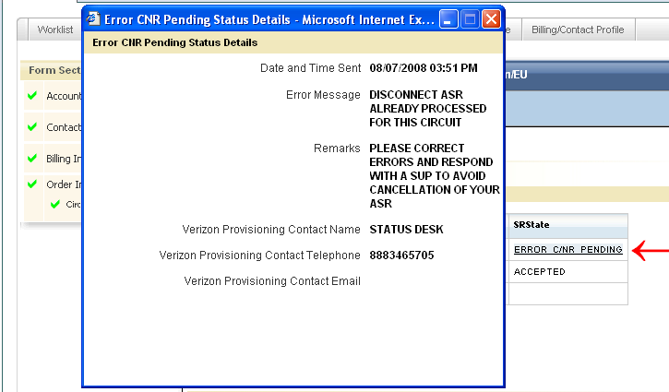

When the SRState column indicates “Confirmed”, the word “Confirmed” is displayed as a link. Select the link to view the Confirmation response:

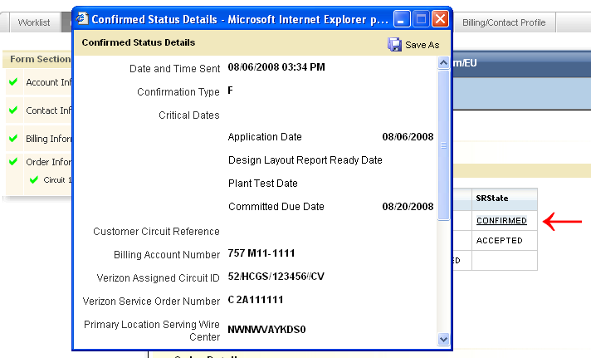

The SRSTATE column will also indicate “Complete” once the Request has been completed by the Verizon Provisioning teams. The entire history is displayed:

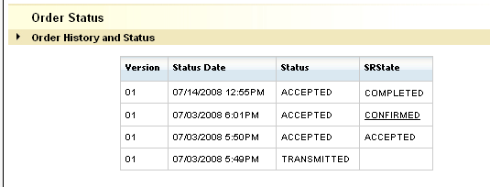

Modify a Request (SUP)
This section will provide the necessary steps to submit a supplement (SUP) version of a PON previously submitted and Accepted by Verizon.

Modify a Request (SUP)
There are several situations that may occur which require the submission of a supplement (SUP) on a previously Accepted PON. A few examples are: Change the original Desired Due Date (DDD), update entries previously provided on specific fields, or to respond to a Clarification (C/NR).

To issue a supplement, retrieve the PON from your Worklist. Note: The PON must be associated with your own worklist in order to issue a supplement.

If you need to move a PON to your worklist in order to issue a supplement, you must search for the PON in another user’s worklist. Once PON is located:

- To the left of the CCNA column on the list of PONs displayed will be the following icon:

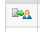

- Press the icon to assume responsibility of the order. The following text box will appear:
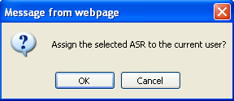
- Select ‘OK’ to transfer the PON to your own worklist or ‘Cancel’ to leave the PON on the current worklist.

To change the Desired Due Date, Select the Calendar Icon and select the appropriate date:

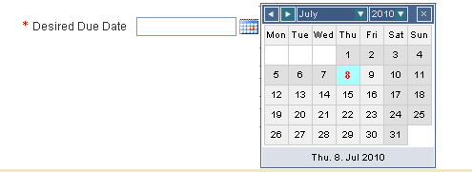

Select “Review Order” button:

Then Select “Submit”.

Verizon will compare the new version to the previous version. If the Desired Due Date is the only change, the SUP value of “2” will be named on the ASR created and submitted to the provisioning center.

When making other changes (ex: updating the Service Address, or renaming the ACTL), make the appropriate update, then…

Select “Review Order” button:

Then Select “Submit”.

Verizon will compare the new version to the previous version and assign a SUP value of “3” or “4” depending on whether or not a Confirmation has been issued for the PON.

Cancel a Request
This section will provide the necessary steps to cancel (SUP 1) a PON previously submitted and Accepted by Verizon.

To submit a cancellation, retrieve the PON from the Worklist.

Select “Cancel Order” button

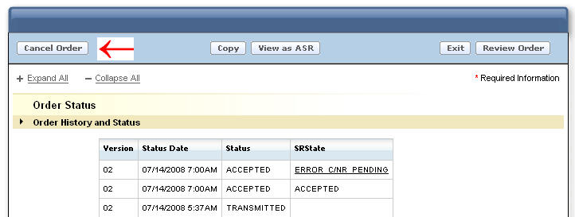

The display will automatically change to a “review” status and the description in the Header will show “Request Cancellation”.

Select “Submit”
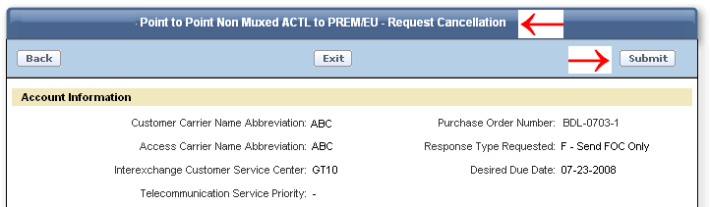

Verizon will assign the SUP value of “1” on the ASR created and submitted to the provisioning center.

View as ASR

When the “View as ASR” button is selected, the request is permanently moved to ASR format. All entries populated prior to moving the request to ASR format will be retained. When using “Order by Product”, there are several fields that are derived by Verizon (ex: REQTYP, PIU, NC, NCI, SECNCI). Determination of what “derived” fields are populated on the ASR will depend upon when the “View as ASR” button is selected during the process.

“View as ASR” Prior to Submitting Request

All required fields must be populated before the “View as ASR” button may be selected. All entered data will be retained and populated on the ASR formatted request, as well as the following “derived” fields”:

ASR field | = | Derived Value
REQTYP | = | SD or ED (Assigned based on original Routing selected from the ordering menu
ACT | = | N or D (Based on selection from Activity Menu)
QTY | = | Calculated based on number of named Circuits

NOTE: Because the request was not “submitted” through the “Order by Product” feature, additional derived fields are not available to be calculated (ex: PIU, NC, NCI, SECNCI) and will NOT be present on the ASR request when the “View as ASR” button is selected.

To view a request in ASR format, select “View as ASR” button.

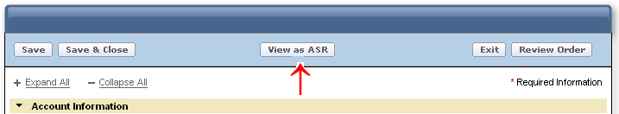

A warning message will display stating the action will permanently convert the request to ASR format.

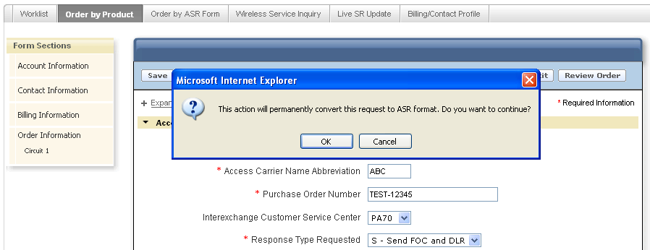

Select “OK” to continue or “Cancel” to stop the process. A selection of “OK’ will move this request to Order by ASR. A selection of “Cancel” will retain the request in Order by Product.

NOTE: When “View as ASR” button is selected, the action may take a few moments to process.

When “OK” is selected, the request will convert to ASR format.

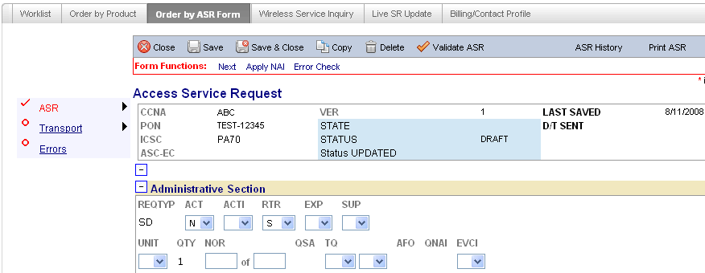

Complete, validate, and submit the request.

“View as ASR” after Request has been Submitted
“View as ASR” can be selected at anytime after a request has been submitted except when the current status is “Transmitted”.

All entries entered by the user and the entries derived by Verizon will be populated on the ASR formatted request.

To view the request in ASR format:

Retrieve the desired PON from the Worklist:

Select the “View as ASR” button:

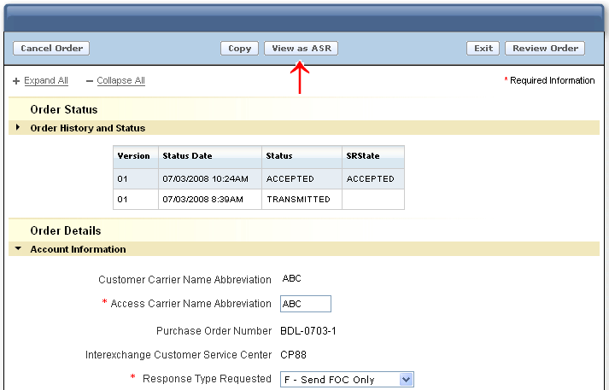

A warning message will display stating the action will permanently convert the request to ASR format.

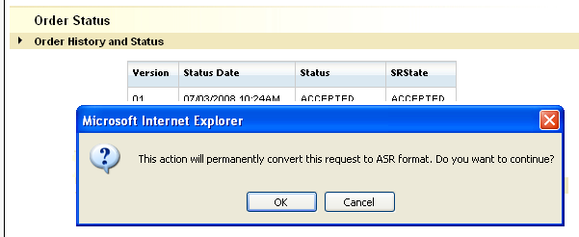

Select “OK” to continue or “Cancel” to stop the process.

When “OK” is selected, the process will begin to convert the request to ASR format. While the conversion is taking place the following screen will display. The process may take a few moments:

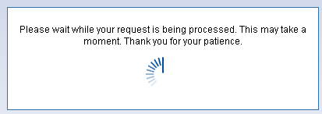

Once the conversion process is completed, the PON will display in ASR format. All fields and forms (entered by user or derived by Verizon) will be included.

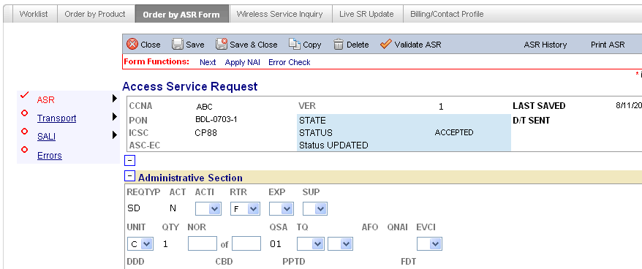

Billing/Account Profile

The Billing and Contact Profile provides a Default Profile for pre-population of the Billing and Contact Information Sections when the request is created.

The Billing and Contact Profile can be selected from:

The initial “Landing Page”
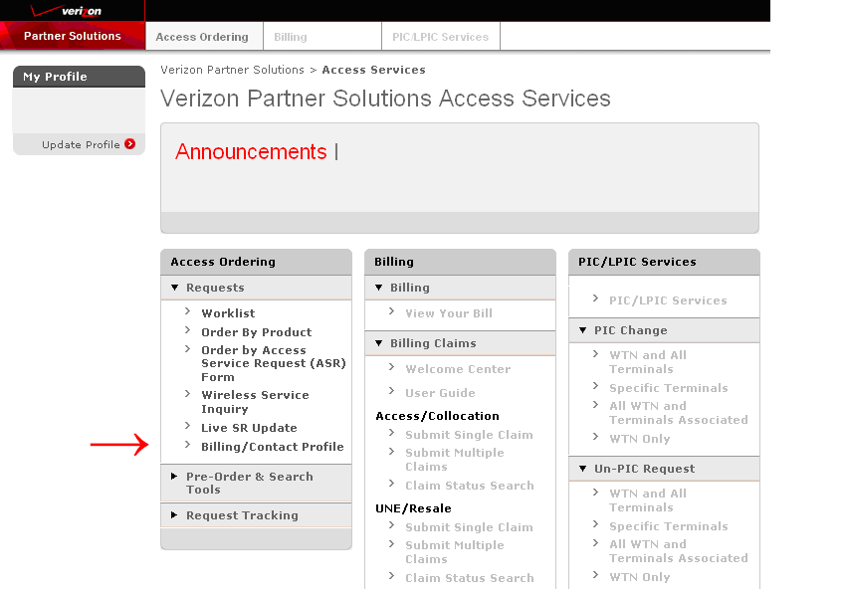

The “Access Ordering” Tab

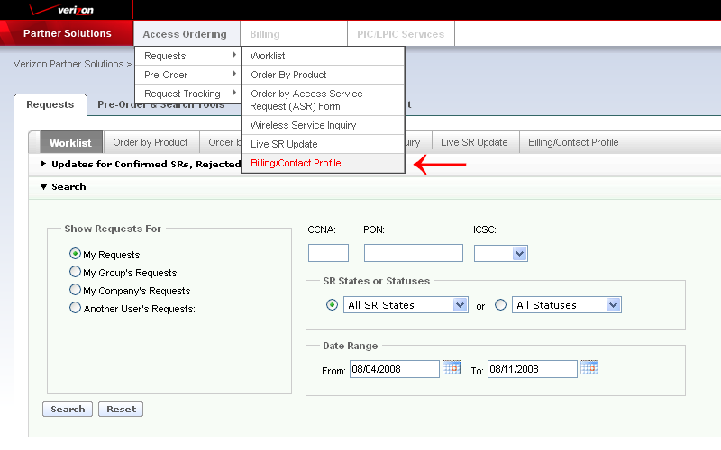

Or…The “Billing/Contact Profile” Tab

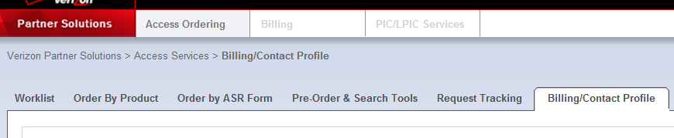

Create a default profile by populating the appropriate fields:

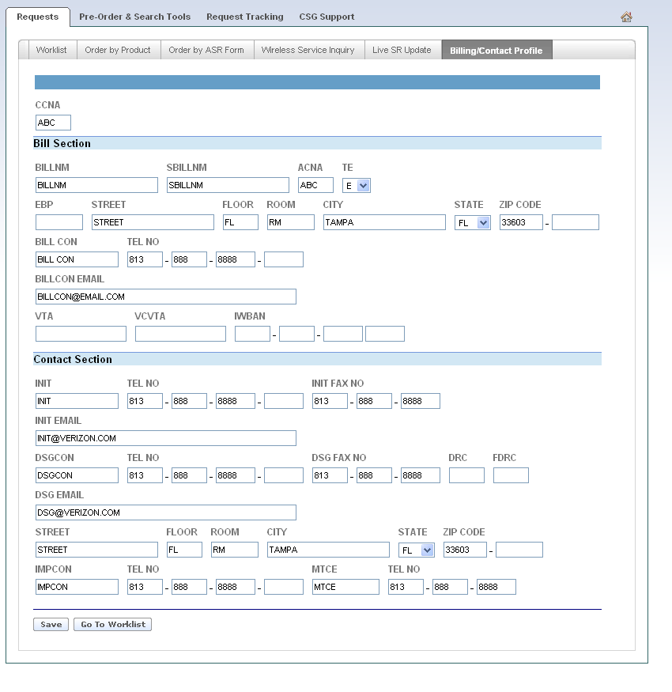

Select “Save” to save the Profile:

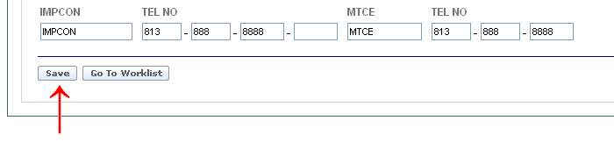

Select “Go to Worklist” to return to Worklist:

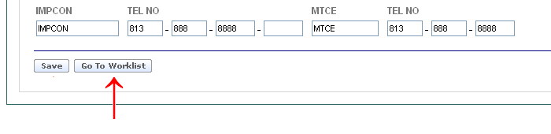

SOS Helpdesk
Each provisioning center within Verizon contains an Access Ordering Helpdesk. To obtain the correct telephone number go to the following url:

http://www22.verizon.com/wholesale/

Select “Contact Us”

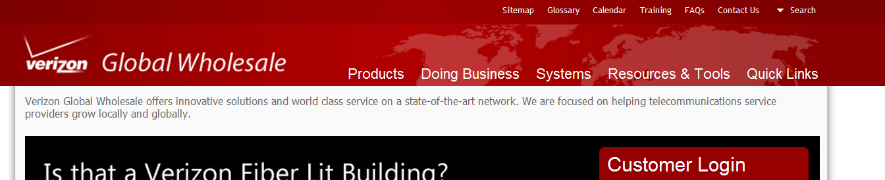

Select “Local and Access Services” and the “Next” Icon:

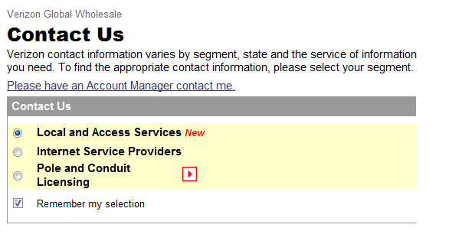

Select “Access Services” under Segment drop down:
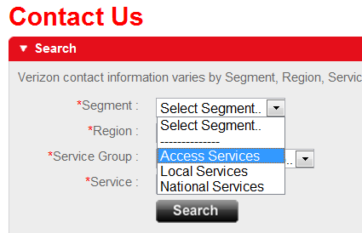

Select the appropriate “Region” using the drop down:
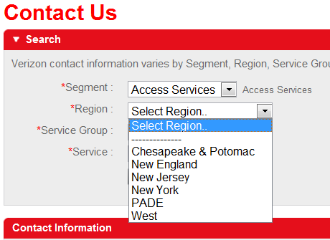

Select “Help Desk” from the “Service Group” menu drop down:
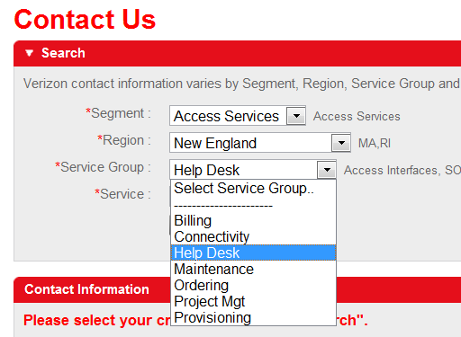

Select “SOS Help Desk” from the “Service” menu drop down:

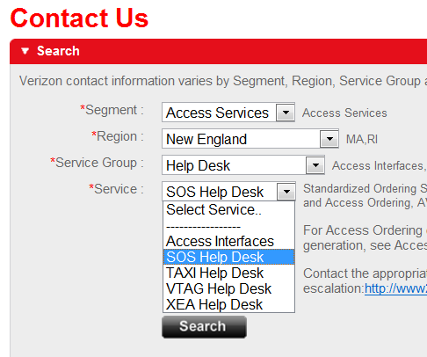

Select “Search”:

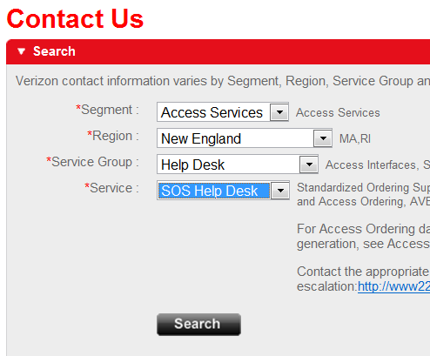

The Contact Information is displayed:



