3.8.15.34.1 Wholesale Billing Claims Web Portal User Guide

Submitted by:
Wholesale Systems Support

Table of Contents

1 Document Control 4
1.1 Change Record 4
1.2 Reviewer for Desktop Procedure Alignment to KM Standards 4
1.3 Business Unit Approvers 4
1.4 SOX Controls 4
1.5 Key Terms 4
1.6 System Access Requirements 4
2 Introduction 5
2.1 Purpose 5
2.2 Overview 5
3 Wholesale Billing Claims Web Portal 5
3.1 Getting an Account – Apply for Access: 5
4 Wholesale Billing Claims Screen 8
4.1 Welcome Center Tab 8
4.2 Access/Collocation Claims Tab 8
4.3 UNE/Resale Billing Claims Tab 9
4.4 Customer Notification Tab 10
4.5 Contact List Tab 10
5 Spreadsheet Columns - Claim Type Codes 12
5.1 Spreadsheet Field Requirements and Validations 12
6 Filling OUT AND UPLOADING Claim Spreadsheet 15
6.1 Spreadsheet Field Entry (Correct): 15
6.2 Spreadsheet Field Entry (Incorrect): 15
6.3 How to attach Supporting Documents to Claims Spreadsheet: 15
6.4 How to Upload the Billing Claims Spreadsheet: 17
7 Online Acknowledgement Display 20
7.1 Spreadsheet Splash Acknowledgement – Access/Collocation: 20
7.2 Spreadsheet Splash Acknowledgement – UNE/Resale: 20
8 Online View OF CLAIM Status 21
8.1 Existing Billing Claims - Search 22
8.2 Existing Billing Claim - Advanced search options 23
8.3 Existing Billing Claims - Export to Excel Spreadsheet 24
8.4 Retrieve Claims Status Spreadsheet –Using Batch ID 26
8.5 Claim Status Screen Sections: 27
9 Inquiries – If you have a zero-dollar claim or general questions about: 29
10 Troubleshooting 29

Document Control

Change Record
Date | Author | Version | Change Reference
08-13-2015 | Joe Faulkner | 1.0 | Initial version - Transition from M&P to DTP format (Supersedes Wholesale Billing Claims Web Portal User Guide)

Reviewer for Desktop Procedure Alignment to KM Standards
Name | Reviewed Version | Position
Jennifer Thompson | 1.0 | Manager – Fin Ops-Credit/Coll

Business Unit Approvers
Name | Approved Version | Position
Erin Stead | 1.0 | Director – Resource Management

SOX Controls
Control ID/  Process ID | Control Name | Control Activity
N/A | N/A | N/A

Key Terms
Key Terms | Definitions

System Access Requirements
System | Role | System Custodian  Contact | Notes

Introduction

Purpose
.

Overview
.

Wholesale Billing Claims Web Portal

Getting an Account – Apply for Access:

To obtain access to Wholesale Billing Claims, please go to the following site: http://www22.verizon.com/wholesale/billingclaim/apphome/Verizon-Customer-Financial-Services-Wholesale-Billing-Claims.html
Contact your Company User Administrator (CUA). They will provide you with the Authorization Code needed to submit your Access Request form. If your company currently does not have a Company User Administrator (CUA), please fill out the Authorization Code Request form on-line. (See Getting an Account section for on-line Authorization form)

Once you receive your Authorization Code you will complete the Access Request Form on-line and register as a Company User Administrator (CUA). (See Getting an Account section for on-line Access Request form)

Or, if an individual access is needed then fill out the Access Request form for new user access; then your CUA will need to approve and submit.

After submission of the Access Request Form you will be sent an email with a secure link to retrieve your User ID and Password to Wholesale Billing Claims.

If you are registered as a CUA you will be responsible for approving, creating and managing users within your company that will apply for Wholesale Billing Claims access.
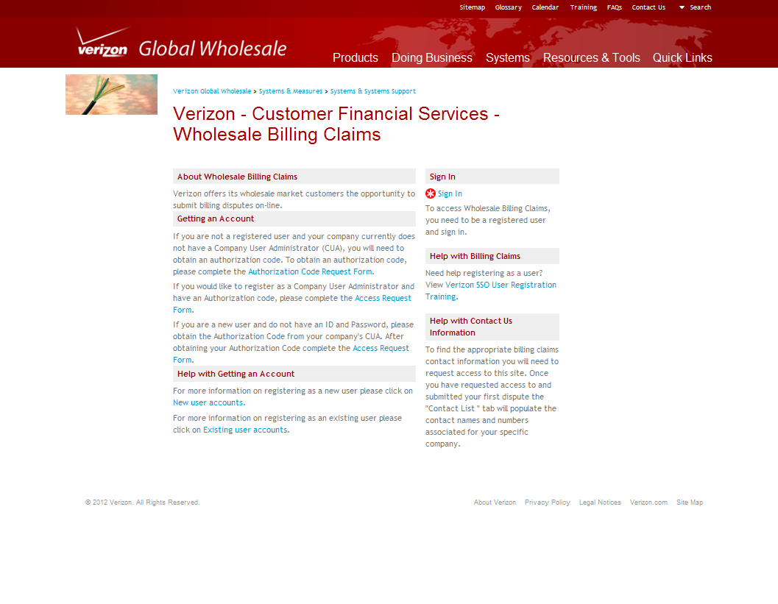
From home page select *Sign In, enter User ID and Password.

Note: If you have access to other Verizon applications, those user ids and passwords will not allow you to sign in to Billing Claims. You will need to gain access to Wholesale Billing Claims to sign in.

If you need a password reset, please email wholesale.claims.access@verizon.com or connectivity.management.team@verizon.com

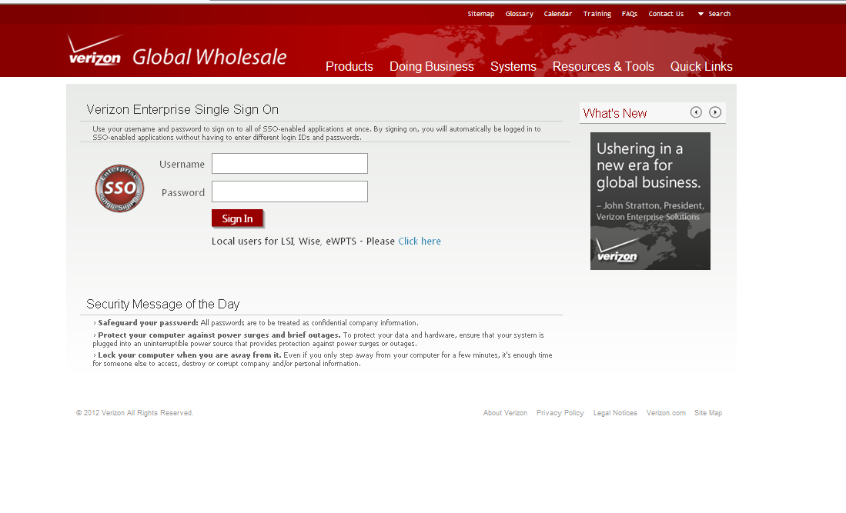

Common Errors and Issues
There are no applicable common errors and issues to the processes documented in this procedure.

SOX Control
There are no applicable SOX controls to the processes documented in this procedure.

Wholesale Billing Claims Screen
The Wholesale Billing Claims Screen is sectioned into six tabs for ease of navigation to each screen.
- Welcome Center
- Access/Collocation Claims
- UNE/Resale Claims
- Customer Notification
- Customer Feedback
- Contact List

Welcome Center Tab
Includes definitions of Access/Collocation and UNE/Resale customer types. Definitions will appear by positioning the cursor over the customer type and clicking each link. To enter a claim, Click red arrow next to Access/Collocation or UNE/Resale Billing Claims or select the specific Access/Collocation or UNE/Resale tab.

Access/Collocation Claims Tab
Spreadsheet upload will be the method used to submit a single or multiple claims. Please use the “Verizon – Customer Financial Services Claims Spreadsheet” for claim submission. The user should download the spreadsheet from this site; fill out spreadsheet, save file to your PC and Upload Spreadsheet.

Note: Application now accepts the use of Microsoft 2007 Offices and will accept (.xlsx,) file.

UNE/Resale Billing Claims Tab
Select the UNE/Resale Claims tab to enter a single billing claim or multiple claims.
Spreadsheet upload will be the method used to submit a single or multiple claims. Please use the “Verizon – Customer Financial Services Claims Spreadsheet” for claim submission. The user should download the spreadsheet from this site; fill out spreadsheet, save file to your PC and Upload Spreadsheet
Note: Application now accepts the use of Microsoft 2007 Offices and will accept (.xlsx,) file.

Customer Notification Tab
The red blinking exclamation mark will alert customers that an important message has been sent. Clicking the Customer Notification tab will generate a list of Current Notifications and Previous Notifications by date and title of message.
Customer Notifications will display customer information such as:
  - New System Releases to Web Portal
  - Alerts on System Outages and Down Time
  - General Information
  - View Current and Previous Notifications
  - Indicator to alert that messages should be read

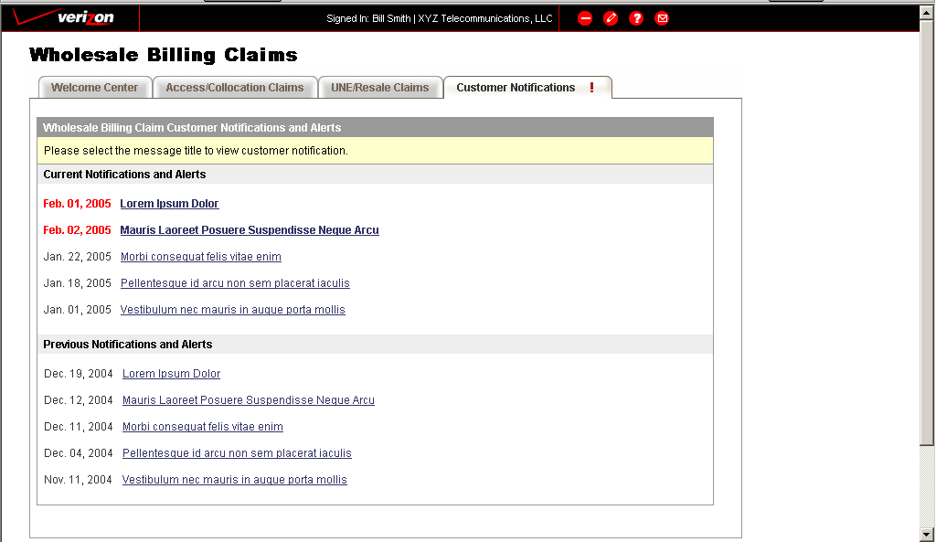

Contact List Tab
The customer contact list will display the latest Verizon contact name and telephone number information to help you with your billing questions and dispute resolution. If you do not see a contact list, please send an email to wholesale.claims.access@verizon.com with your user id and ACNA. This information will be used to link the display for your contact list.

Common Errors and Issues
There are no applicable common errors and issues to the processes documented in this procedure.

SOX Control
There are no applicable SOX controls to the processes documented in this procedure.

Spreadsheet Columns - Claim Type Codes

Spreadsheet Field Requirements and Validations
The chart below lists the field names description. User should verify if the fields are required and which fields will be subject to validation for processing. This information is obtained from the Claims Submission Instructions worksheet tab on the Claims Spreadsheet.

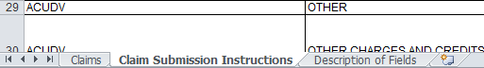

Verizon Partner Solutions Receivables Management Billing Claims
Name of field | Description
Contact Name | Name of customer contact authorized to answer inquiries regarding the wholesale claim.
Contact Phone | Telephone number of customer contact authorized to answer inquiries regarding the wholesale claim.
Ext. | Telephone extension
Contact Email Address | Email address of customer contact authorized to answer inquiries regarding the wholesale claim.
Billing Account Number (BAN) | The primary BAN used for billing or Summary Bill Number (SBN) that is associated with the wholesale claim.
Circuit ID /TSC/OCL/TN | The identification of the physical connection of equipment between two given paths. Correct entries include Circuit ID, Common Language Location Identifier (CLLI), Trunk Group Number, or Subordinate/Component/Working Telephone Number (WTN).
Bill Date in Dispute | The Verizon Bill Date in which disputed charges appeared on the customer bill. The system will accept bill dates in the following date formats: MMDDYYYY, MM/DD/YY, MM/DD/YYYY, MM-DD-YY, or MM-DD-YYYY.  Valid Format: MM/DD/YYYY  Example: 03/01/2011
Claim Type | The appropriate Claim Type pertaining to the wholesale claim. See Chart of Claim Type Code List.
Claim Amount | Dollar amount the customer is disputing in the wholesale claim. Valid Format: $1.11
Description of Claim | Detail claim explanation.
Customer Claim Number | Claim number entered by the customer pertaining to the wholesale claim. If none is provided, the customer claim number will be the same as the Verizon assigned claim number, e.g. Verizon assigned Claim Number is C050229000001.
Customer Audit # | When the disputed charge appears on the Other Charges and Credits or Detail of Adjustments section of the bill, the Customer Audit Number may be populated. Enter the information from the invoice in this field when required. The Customer Audit number will be validated for accuracy. Missing or incorrect entries, when required, will cause the claim to be denied for invalid/missing information.
Adjustment Serial # | When the disputed charge appears on the Other Charges and Credits or Detail of Adjustments section of the bill, the Adjustment Serial Number may be populated. Enter the information from the invoice in this field when required. The Adjustment Serial Number will be validated for accuracy. Missing or incorrect entries, when required, will cause the claim to be denied for invalid/missing information.
Contract # | When the disputed charge is related to a specific contract provision, enter the contract number in this field. (ex: FB1N011111)
PON/ASR/LSR | Purchase Order Number will be required on all Disconnect “DIS” claims.  Access Service Request or Local Service Request assigned to the customer account and associated with the wholesale claim.
Verizon Service Order Number | For certain claim types, the Verizon Service Order number is required. See the Claim Submission Instructions tab to determine when this field is required. The field will be validated when it is required. The field may be populated with correct information when it is listed as Optional.
Verizon Trouble Ticket Number | For certain claim types, the Verizon Trouble Ticket Number is required. See the Claim Submission Instructions tab to determine when this field is required. The field will be validated when it is required. The field may be populated with correct information when it is listed as Optional.
USOC/ISOC | USOC or ISOC associated you’re your dispute. The USOC/ISOC must be separated by commas. Valid Format: 1FLXX,1YTCS,TNT8X  Invalid Format: 1FLXX/1YTCS/TNT8X  N/A is not acceptable
Phrase Code | When the disputed charge is related to a specific Phrase Code appearing on the invoice, enter the Phrase Code in this field. (ex: 750)
Factor Type | The factor type is required for Monthly Recurring Charge disputes related to Jurisdictional Factors (MRC06). It is optional for Non-Recurring Charges related to Factors (NRC09). (ex: PIU or PLU)
Amount Withheld
Verizon Tracking Number | This is the Verizon Claim Tracking number assigned to the corresponding line for your dispute.
Verizon Contact Name | This field will be populated with the name of the Verizon Representative assigned to investigate and respond to your claim.
Status | This field will be populated with the status of the investigation for the dispute on responses.
Notes | This field will contain notes from the Verizon Representative related to the dispute
Pay By Date | This field will contain the last date to remit payment before being referred to collections treatment for denied claims.
Denied Amount | This field will contain the denied portion of the claim.
Approved Amount | This field will contain the approved portion of the claim, credit may appear via adjustment or service order on a future bill.

Note: When inputting values into the claims submission spreadsheet, do not change the formatting of the cells. Changing the formatting or inclusion of the “$” in the Claim Amount or the Amount Withheld fields will cause the claim submission to be rejected.
Note: Please verify your use of proper claim type code by reviewing the Claims Submission Instructions tab located at the bottom of the spreadsheet.

Common Errors and Issues
There are no applicable common errors and issues to the processes documented in this procedure.

SOX Control
There are no applicable SOX controls to the processes documented in this procedure.

Filling OUT AND UPLOADING Claim Spreadsheet
The Verizon – Customer Financial Services Claims Spreadsheet will be the appropriate spreadsheet for submitting your claims.

To obtain a blank spreadsheet click the Wholesale Billing Claim spreadsheet hyperlink to download a blank copy. Enter the required claim data on the spreadsheet, rename the file, save the spreadsheet to your computer and close the file.

Spreadsheet Field Entry (Correct):
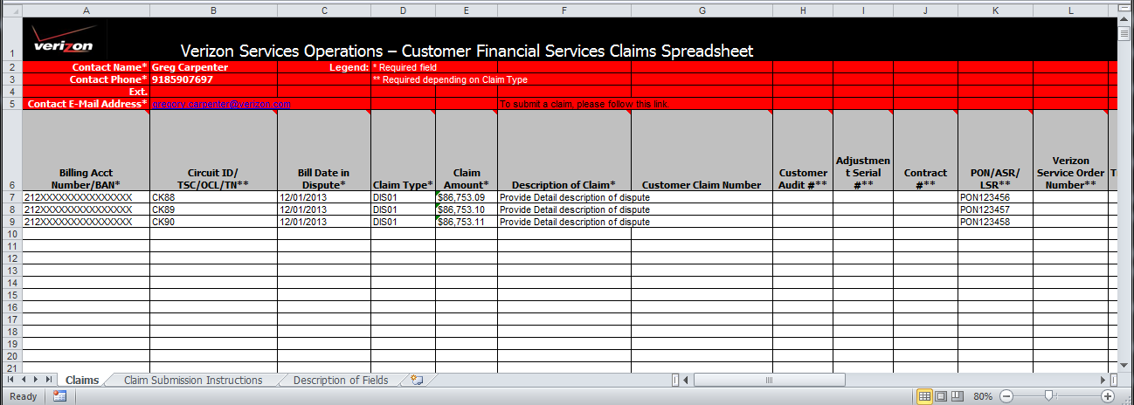

Spreadsheet Field Entry (Incorrect):
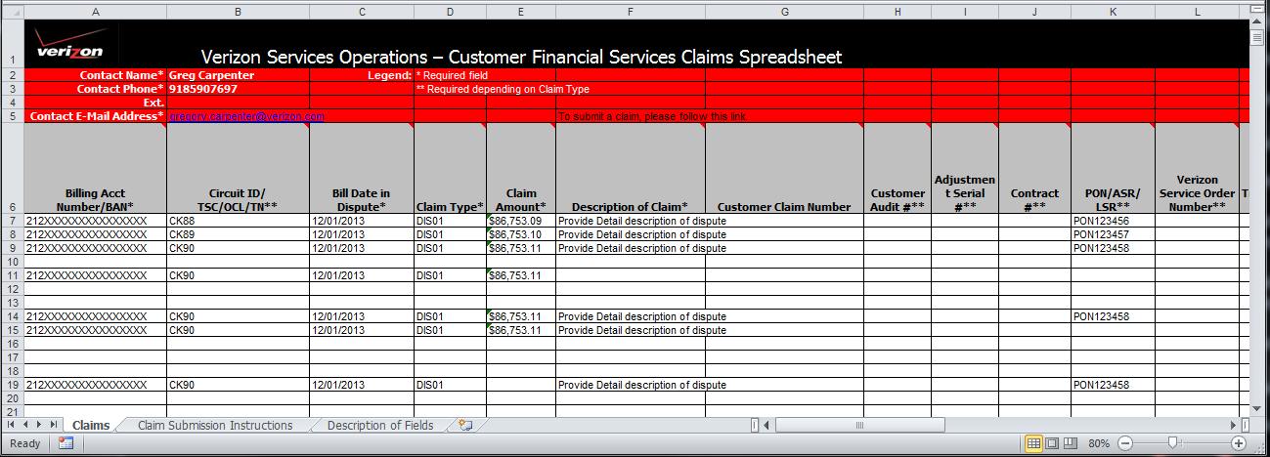

How to attach Supporting Documents to Claims Spreadsheet:
On the claims spreadsheet, add a worksheet and rename it as “Attachment”. Leave the “Claims” tab sheet alone, since the system validates the data only within the spreadsheet marked as “Claims”. Also, for your records, do not delete or alter the “Claim Submission Instructions” or “Description of Fields” spreadsheet tabs. The additional tabs are tag alongs and will be part of the claim. The billing representative will be able to retrieve the additional details as part of the claim investigation.
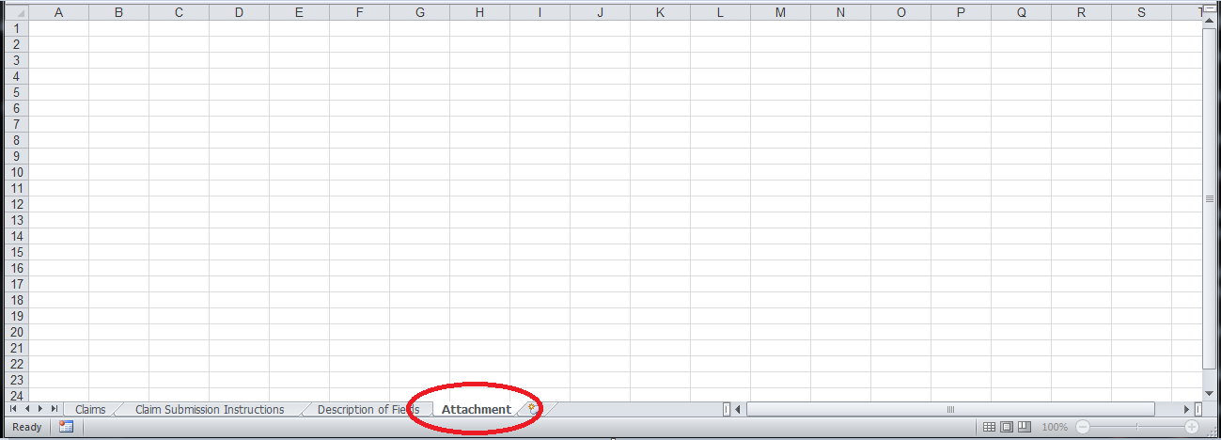
Go to the worksheet you have renamed and add any attachments related to the claim(s).

- Go to Insert Object
- Select Tab “Create from File”
- Select “Browse”
- Select the file you are needing to attached – Double Click
- Check box “Display as Icon”
- Click “OK”

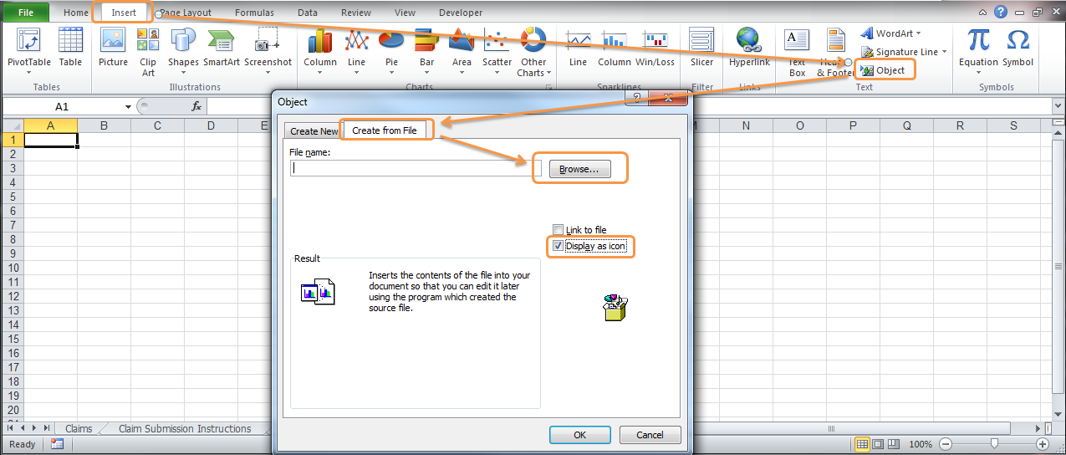
The document(s) will appear as an icon of the file.

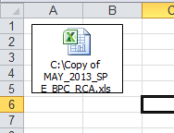

How to Upload the Billing Claims Spreadsheet:

When you have completed filling out the spreadsheet you will need to save the Wholesale Billing Claim spreadsheet to your PC desktop.

Select the “Browse” button
Locate your file
Once you locate you can double click on the file or select OPEN
Your file will be displayed in the text box and now you can select the “Upload Spreadsheet” button

Pending Validation Status - Spreadsheet uploaded and is awaiting processing

When your spreadsheet is over 120KB (over 3000 line items) the data submitted will be pending validation. An on-line confirmation will appear providing the Batch ID and the file name of the spreadsheet submitted. Verizon will complete its mechanized validation process ensuring that all the data supplied is valid and no information is missing. The status of the spreadsheet will appear in the Existing Billing Claims section. The status spreadsheet will be “Pending” for pending validation.

A Status of Pending on a Batch – Verizon is validating the submitted data for missing or invalid data.

Error Validation Status - Spreadsheet processed but NOT uploaded due to error conditions

Once Verizon has completed its mechanized validation process and errors are found, you will need to view the error message to correct your spreadsheet and resubmit the spreadsheet. The Existing Billing Claims section will indicate the status at the batch id level for the spreadsheet submitted.

To view the error message for correction of your spreadsheet click the “Error” status for the pop-up screen that will list the error message for correction of your spreadsheet.

Error Status Retention:
Error Unread: Display for 48 hours then deletes.
Error Read: Display until user reads the error conditions (same as today)

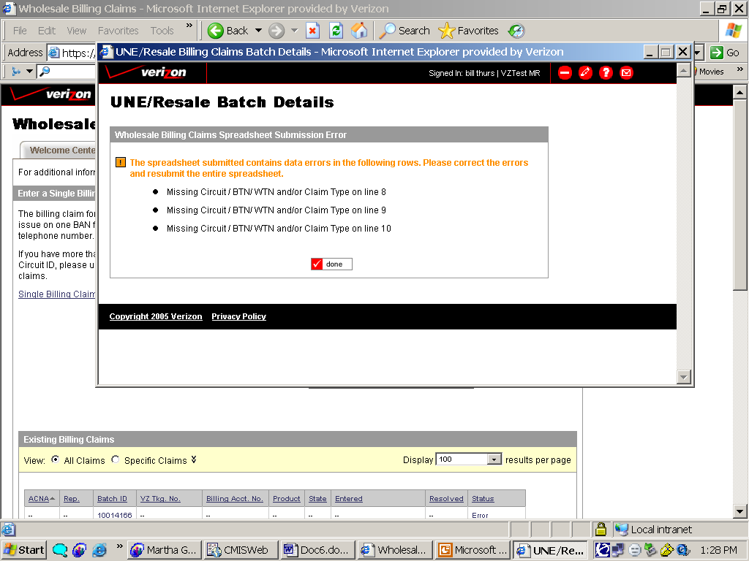

Acknowledged Status

When the validation process is completed and no errors are found; the status will be Acknowledged. The status can be view via the Existing Claims Section.

Common Errors and Issues
There are no applicable common errors and issues to the processes documented in this procedure.

SOX Control
There are no applicable SOX controls to the processes documented in this procedure.

Online Acknowledgement Display
Verizon will acknowledge receipt of your claim with an on-line splash acknowledgement screen and you will continue to receive you email Acknowledgement emails with attachment.

Spreadsheet Splash Acknowledgement – Access/Collocation:
After successful validation a Batch ID and the associated tracking numbers will be displayed.

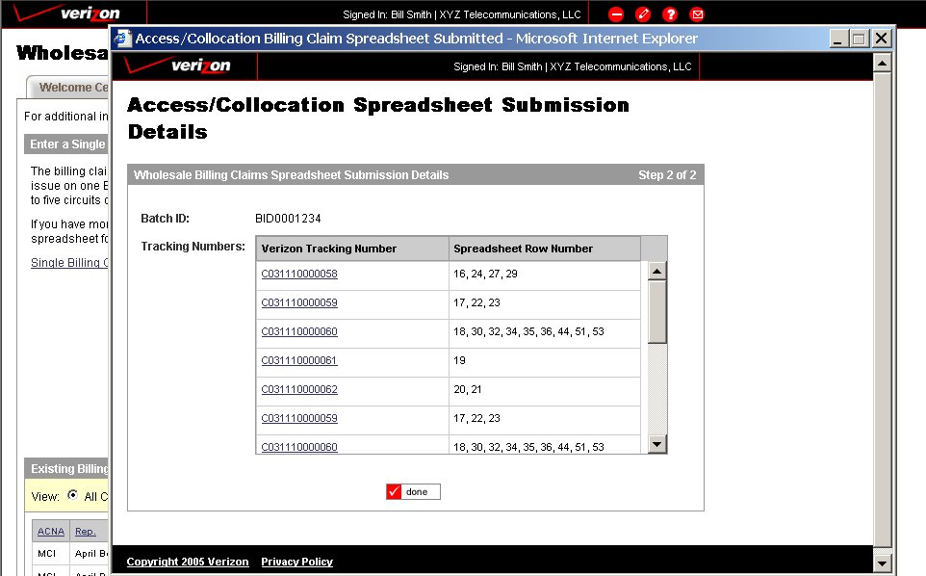

Spreadsheet Splash Acknowledgement – UNE/Resale:
After successful validation a Batch ID and the associated tracking numbers will be displayed

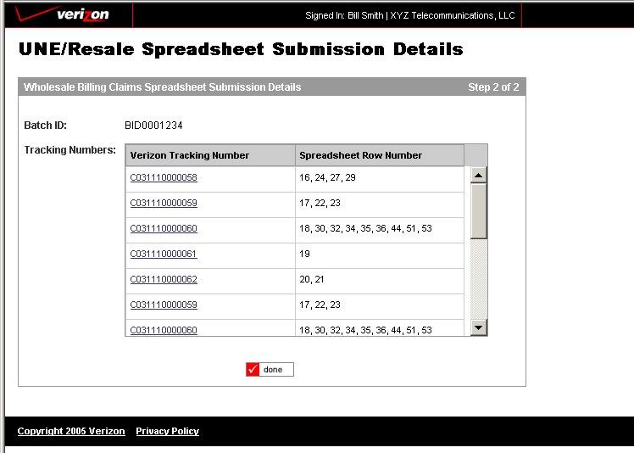

Common Errors and Issues
There are no applicable common errors and issues to the processes documented in this procedure.

SOX Control
There are no applicable SOX controls to the processes documented in this procedure.

Online View OF CLAIM Status
Wholesale Billing claim provides an on-line view of your claim status. By going to the “Existing Billing Claims” section you can select a claim, column sort by Status or search for a specific claim.
For claims that are in Resolved status, select the Batch or the Tracking Number hyperlink to view claim resolution. Along with viewing your claim status and resolution on-line Verizon will continue to email a Status Resolution letter.

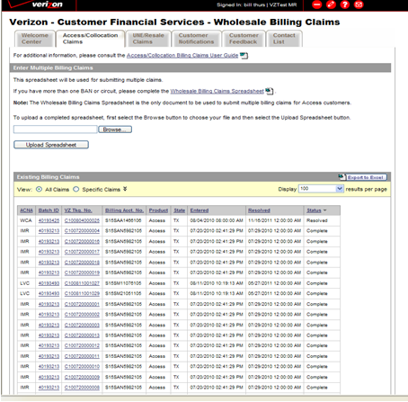

Existing Billing Claims - Search

By selecting “All Claims” a list of all of on-line submitted claims will appear in the section Existing Billing Claims’.

To view additional pages use the Page Number Designation to jump to specific page. The results per page will allow you to change the number of claims to be displayed per page.

The user has the ability to sort results information by using the column heading for ascending and descending sort

Existing Billing Claim - Advanced search options
Selecting “Specific Claims” allows user to search for a specific claim.

Advanced search options:
- ACNA
- BAN
- Subordinate/Component TN
- Circuit ID
- Batch ID
- VZ Tracking Number
- Customer Claim Number
- Billing Representative – Enter Last or First Name
- State
- Status
- Date Entered - mmddyyyy
- Date Resolved - mmddyyy

Status definitions:
New | Claims recently entered that are assigned but not yet acknowledged
Acknowledged | Claims under investigation
Cancelled | Claims cancelled due to internal Verizon Error
Resolved | Resolution letter has been e-mailed to initiator of claim
Complete | Claims pending adjustment/service order have processed. If payment is pending, claim has been referred to treatment .

Existing Billing Claims - Export to Excel Spreadsheet
By using the “Export to Excel” the user will be able to export to spreadsheet all claims submitted via the web portal. This will provide user the ease of sorting and view all claims.
Existing Billing Claims Results on spreadsheet
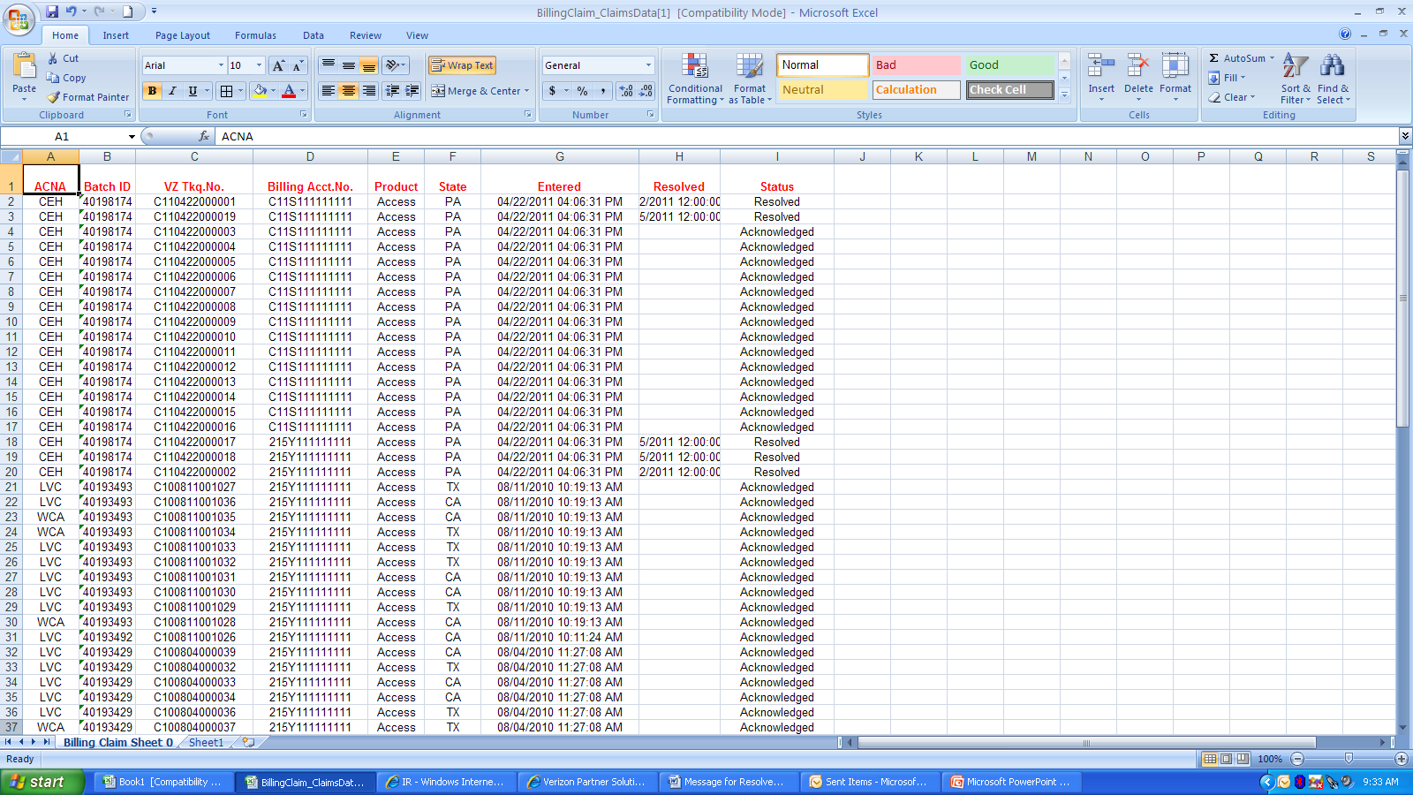

Retrieve Claims Status Spreadsheet –Using Batch ID
Select from Existing Billing Claims View to view the Batch ID (hyperlink). The batch details screen will be displayed, to retrieve the Acknowledged or Resolved Claims Status spreadsheet, select the hyperlink for that file.

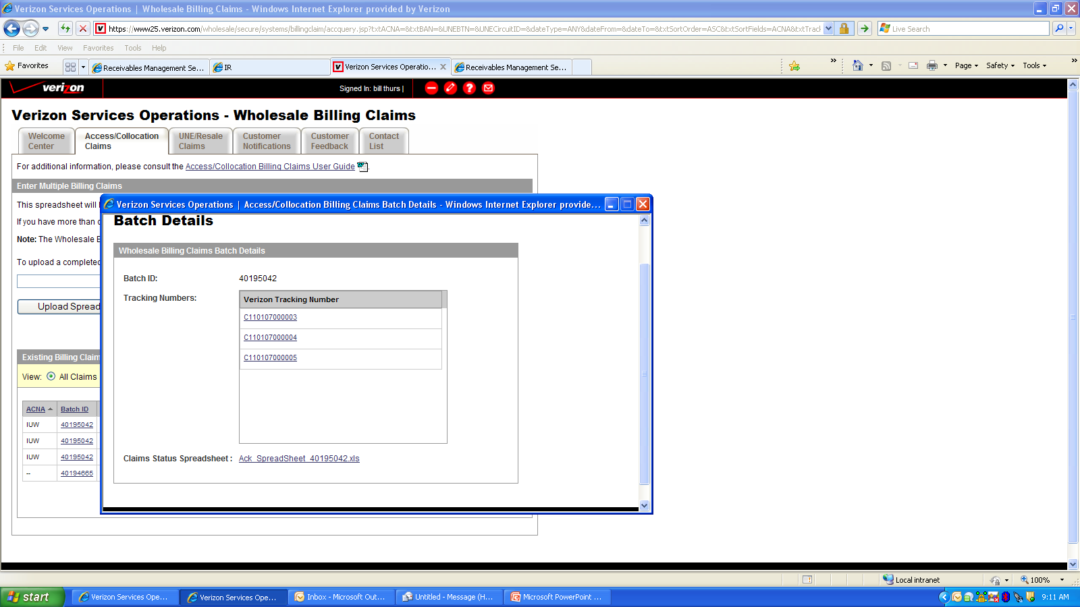
User will be able to open file and get the same Status Acknowledgement and Status Resolution attachment that they receive today via email.

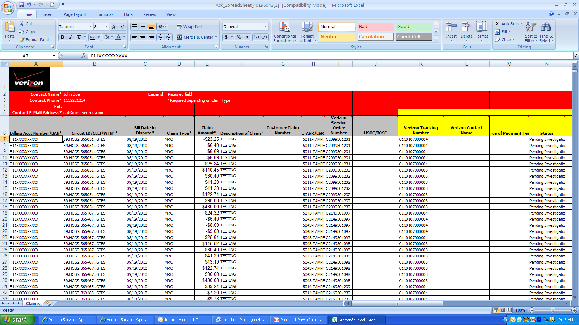

Claim Status Screen Sections:
The Status screen contains data entered by the user when the claim was entered and will contain data from Verizon regarding the status of the claim at the Batch ID/Verizon Tracking Number level and Item detail level. Clicking the Batch ID or Verizon Tracking Number will launch the Status Screen.
The following are the sections within the Status Screen and data that will be available under each section.
Resolution Summary
Batch ID | Assigned by Verizon
Verizon Tracking Number | Assigned by Verizon
Claim Type | Claim reason
Status | Status of the overall claim at the Batch ID level
Notes | Resolution notes at the Batch ID level
Dollar Value of Claim | Total claimed amount
Customer Resolved | Total Amount awarded to customer at the Batch ID Level
Verizon Resolved | Total Amount found in Verizon favor at the Batch ID Level and payment due back to Verizon.
Claim Resolution Details
Company Name | Derived from Billing System
State of Service | Derived from Billing System
Product Type | Derived from Billing System
Usage/None-Usage | Derived from Billing System
ACNA/CCNA/OCN/RSID | Derived from Billing System
Contact Name | Customer entered Information
Contact Phone | Customer entered Information
Email Address | Customer entered Information
Billing Number or BAN | Customer entered Information
Quantity of Circuits | Derived from customer entered information
Quantity of Circuit IDs/BTNs/Line Items | Customer entered Information
Dated Entered | Derived
Dated Resolved | Assigned by Verizon
Bill Date In Dispute | Customer entered Information
Invoice Number | Derived from Bill Date in Dispute
Circuit ID/BTN/Line Item Details - Details
Customer Claim Number | Customer entered Information
Description of Claim | Customer entered Information
Purchase Order Number | PON associated with specific line item in dispute. Customer entered Information
ASR/LSR Number | ASR/LSR number associated with specific line item in dispute. Customer entered Information
Verizon Service Order Number | Service Order Number associated with specific line item in dispute. Customer entered Information
Dollar Value of Claim | Claim amount for line item in dispute. Customer entered Information
Customer Resolved | Amount found in Customer favor for the specific line item in dispute. Verizon entered information.
Verizon Resolved | Amount found in Verizon favor for the specific line item in dispute. Verizon entered information
Resolution Notes | Notes specific to the resolution for the specific line item in dispute. Verizon entered information
Status | Status for specific line item in dispute. Resolve or Pending Investigation assigned by Verizon.

Line Item Detail Section – High item to view status of a specific Circuit ID/BTN/ Line item. The results will appear to the right of the red arrow for each of the line items in dispute

Common Errors and Issues
There are no applicable common errors and issues to the processes documented in this procedure.

SOX Control
There are no applicable SOX controls to the processes documented in this procedure.

Inquiries – If you have a zero-dollar claim or general questions about:
- Bill copy requests (handled by both claims and collections) or
- Bill explanation
Please contact your billing representative for assistance by locating the Customer Contact tab which provides a list of contact names and numbers.

Common Errors and Issues
There are no applicable common errors and issues to the processes documented in this procedure.

SOX Control
There are no applicable SOX controls to the processes documented in this procedure.

Troubleshooting
If you need assistance in submitting your claim via the Billing Claims Web Portal; send an e-mail to “wholesale.claims.access@verizon.com” with a detail description of your error.

Common Errors and Issues
There are no applicable common errors and issues to the processes documented in this procedure.

SOX Control
There are no applicable SOX controls to the processes documented in this procedure.

