

Order by Product
VzON/EPL Inquiry to Firm Order User Guide

Effective Date: July 21, 2012
Revised Date: NA

Notices

DISCLAIMER

This technical documentation is for general information purposes only. This documentation does not obligate Verizon to provide services in the manner described herein. Verizon reserves the right as its sole option to modify or revise the information contained in this technical documentation at any time without prior notice.

In addition to and without limitation of any other limitation of liability of Verizon or its affiliated companies set forth in an applicable contract or tariff, or elsewhere, in no event shall Verizon or its affiliated companies, or their agents, employees, directors, officers, representatives, or suppliers, be liable under contract, warranty, tort (including but not limited to the negligence of Verizon or its affiliates), or any other legal theory, for any incidental, consequential, special or indirect damages arising from or relating to this document or its contents, even if advised of the possibility of such damages.

© 2012 Verizon Corporation -All rights reserved.
Table of Contents
1 Overview 3
1.1 Benefits/Features 3
2 Getting Started with Order by Product 4
2.1 Order by Product Menu 6
2.2 Access Service Inquiry Activity Menu and associated Product Options 6
2.3 Ordering Menu – Routing and State Options 8
3 Account Information 12
4 Contact Information 13
4.1 Contact Information Section 13
5 Order Information 14
5.1 Wireless VzON Inquiry Order ACTL to PREM Request 14
5.1.1 ACTL to PREM Request – New Activity 14
5.2 Wireless VzON Inquiry Order PREM to PREM Request 24
5.2.1 PREM to PREM Request – New Activity 24
6 Service Address Section 33
7 Review and Submit Request 43
8 Order History and Status Section 47
9 Creating a Firm Order 50
10 Modify a Request (SUP) 53
10.1 Modify a Service Inquiry Request (SUP) 53
10.2 Modify a Firm Order Request (SUP) 55
10.3 Cancel a Request 57
11 View as ASR 58
11.1 “View as ASR” Prior to Submitting Request 58
11.2 “View as ASR” after Request has been Submitted 60
12 Billing/Account Profile 62
13 SOS Helpdesk 66

Overview

Order by Product is designed to simplify the ordering process for the most commonly ordered products. After populating the required fields and submitting the Request, Verizon will generate an ASR and send it to be processed. Certain ASR fields will be derived (ex: NC/NCI/SECNCI) based on selections made for the Routing, Configuration, and whether or not the Access Customer Terminating Location (ACTL) is collocated or not. Determining the appropriate Routing, Configuration, and ACTL considerations will be covered in greater detail in the sections below.

Benefits/Features
- Provides easy ordering of service inquiry products for new activity across Verizon's footprint.
- Determines the NC, NCI and SECNCI based on customer provided data and selections.
- Provides minimal number of fields to simplify ordering process; fields are displayed in full text rather than in ASOG Industry standard abbreviation.
- When the request is submitted, ASR is created and field values will be derived based on the entries and selections made by the User (ex. NC, NCI, SECNCI, REQTYP, PIU, SPEC etc).
- User Profile information containing Contact and Billing data is pre-populated on each request.
- Supports converting the service inquiry request to a firm order.
- Ability to modify and submit subsequent versions of the request (SUP).
- Provides option to convert request to ASR format.
- Functionality includes the option to: Save, Close, Copy, Delete (Draft) or Review/Submit.

Getting Started with Order by Product

“Order by Product” can be selected from one of three ways:

- The initial “Landing Page”

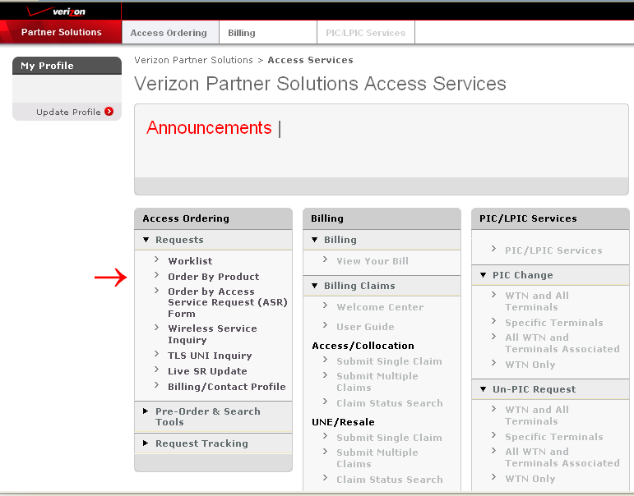

- The “Access Ordering” Tab

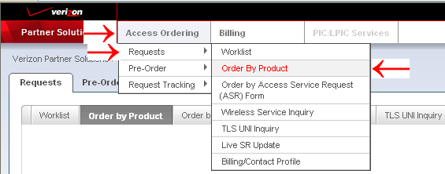

- The “Order by Product” Tab

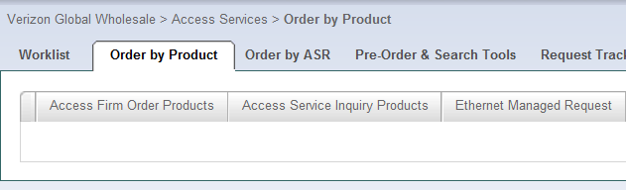

Order by Product Menu

After selecting “Order by Product”, product options are displayed in tab format and “Access Service Inquiry Products” should be selected:

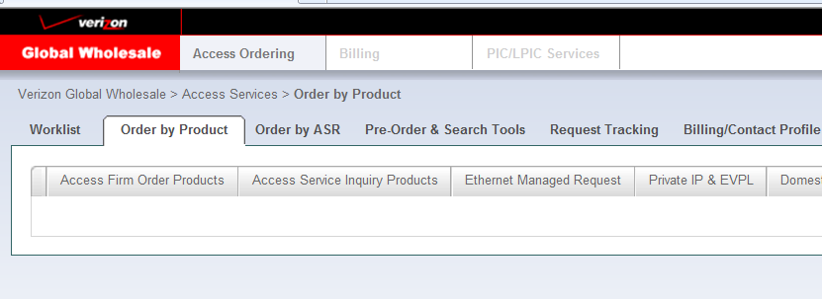

Access Service Inquiry Activity Menu and associated Product Options

After Selecting “Access Service Inquiry Products”, the Activity Menu is displayed:

“New” Activity will be auto selected by the system for inquiry products:

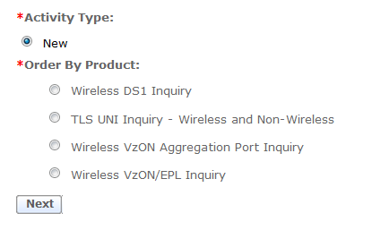

One “Order by Product” option must be selected, select “Wireless VzON/EPL Inquiry” and the “Next” Button:

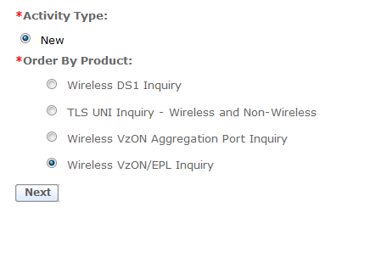

When “Wireless VzON/EPL Inquiry” is selected, additional menu fields are displayed:

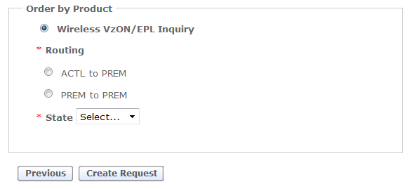

Ordering Menu – Routing and State Options
Regardless of Activity selected, the Routing and State options need to be selected.

Verizon Optical Networking Service (VzON), also known as Ethernet Private Line (EPL), provides for managed optical transport of Ethernet data signals of various speeds over Verizon’s shared network.

Select a Routing Option for Wireless VzON/EPL Inquiry Order:

- ACTL to PREM
Select this option when ordering the following type of service:
- POP location or collocation arrangement to End User location
- REQTYP derived as “SD”
- Serial Circuit ID format

- PREM to PREM
Select this option when ordering the following type of service:
- End user to End user
- REQTYP derived as “ED”
- Serial Circuit ID format

Select the State:
Choose the appropriate geographical state from the “State” drop-down option for the request.

Select “Create Request” button

After completing the “Order by Product” menu, select the “Create Request” button to continue.

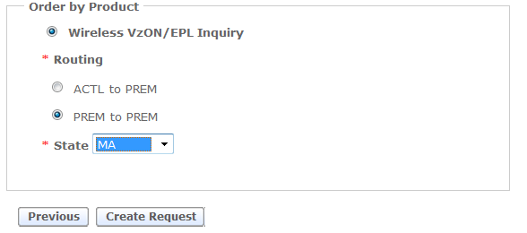

After the “Create Request” is selected, the order request form is presented:
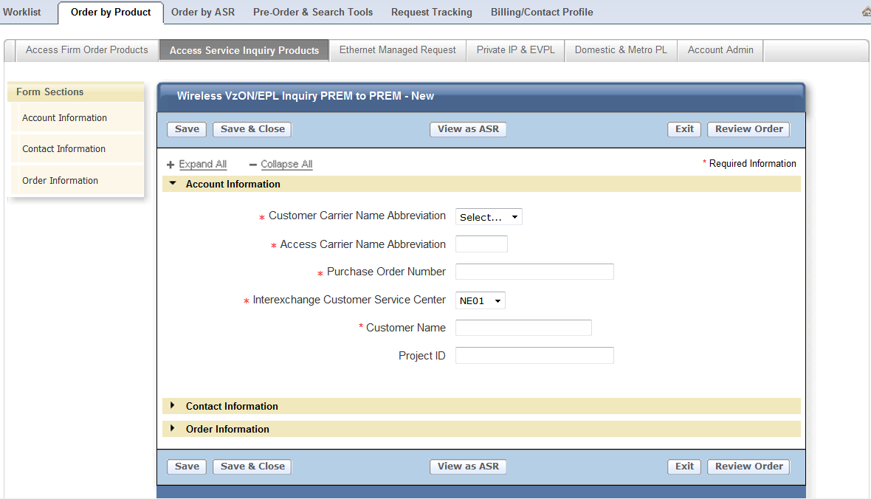

The layout of the form displayed is the same regardless of the “Routing Option” selected on the previous menu and includes:

Form Sections: A check mark “” will be displayed and indicate when the required fields of a section are complete.

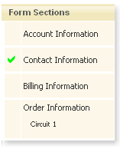

The Header will indicate the type of “Routing” and “Activity” selected from the menu:

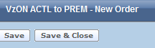

The Function Buttons are “Save”, “Save & Close”, “View as ASR”, “Exit” and “Review Order”:

The buttons perform the following functionality when selected:

- Save – Saves all the populated entries and remains on the current screen.
- Save & Close – Saves all the populated entries, closes the current screen, and returns to the “Worklist” page.

NOTE: The Customer Carrier Name (CCNA), Purchase Order Number (PON), Interexchange Customer Service Center (ICSC), and Response Type Requested (RTR) fields must be populated for the “Save” or the “Save & Close” option to engage.

- View as ASR – Permanently changes the request to ASR format. Review Section 11.1 for additional information.
- Exit – CHANGES WILL NOT BE SAVED, closes the current screen, and returns to the “Worklist” page.
- Review Order – Select this button once the request is completed. The completed request is displayed for final review prior to submitting.

Expand All and Collapse All Buttons will Open or Close the different sections contained within the request.

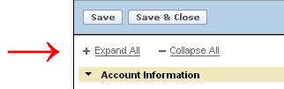

The next sections will provide the details for completing each Section of a request.

Account Information

The details provided in this section apply for creating a service inquiry request. The required fields will be designated with a red asterisk (*) on each type of request.

Populate the appropriate fields:
  - Customer Carrier Name Abbreviation (CCNA)
  - Access Carrier Name Abbreviation (ACNA)
  - Purchase Order Number (PON)
  - Interexchange Customer Service Center (ICSC) default value will be determined based on the geographical state selected on “Order by Product” Menu. Value can be changed if needed.
  - Customer Name – required
  - Project ID – optional
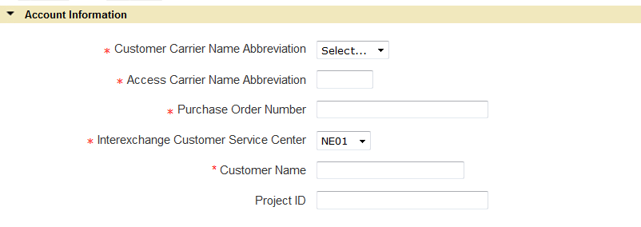

Contact Information

Contact Information Section
The details provided in this section apply for creating a service inquiry request. The required fields will be designated with a red asterisk (*) on each type of request.

Populate the appropriate fields:
  - Request by Name (INIT)
  - Request by Telephone (INIT TEL NO)
  - Request by E-mail (INIT EMAIL)
  - Design Contact Name (DSGCON)
  - Design Contact Telephone (DSGCON TEL NO)
  - Design Contact Fax (DSG FAX NO) – optional
  - Design Contact E-mail (DSG EMAIL) – optional

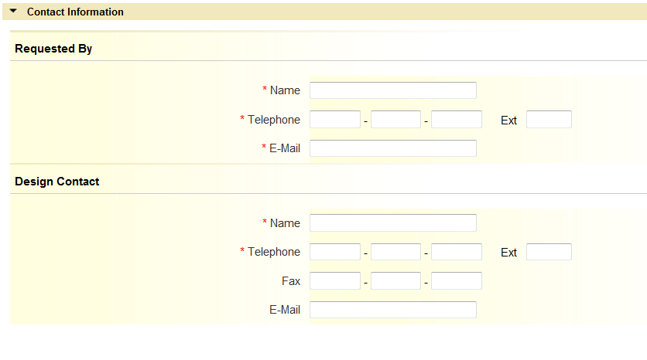

NOTE: The data for the Contact Section of each request can be system populated by completing and saving the Billing/Contact Profile. (See Section 12)

Order Information

Wireless VzON Inquiry Order ACTL to PREM Request
The details provided in this section apply for creating a service inquiry request with “New” Activity.

ACTL to PREM Request – New Activity
The details provided in this section apply for creating a request with “New” Activity. The required fields will be designated with a red asterisk (*). This section is broken down into subsections and contains the information needed for indentifying the connecting facility assignment (CFA/CCEA), the Primary location details, and the Secondary location details including the terminating service address fields.

    - Order Information Section

Populate the following Required Fields:
  - Are you collocated at the primary or secondary location? - the value selected for this field is part of the necessary information needed for determining the NCI/SECNCI values as well as determining allowable bandwidth options in the ‘What is the requested bandwidth?’ field.
      - Select “Primary Location”, “Secondary Location”, or “Collocation at both ends” only when the specific location is collocated within a Verizon Central Office otherwise select “No”.

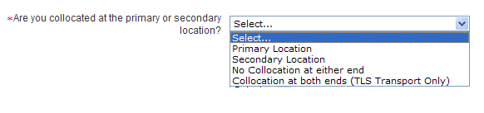
  - Are you riding a Connecting Facility Assignment (Aggregation Port)? – the value selected for this field is part of the necessary information needed for determining the NCI/SECNCI values as well as determining allowable bandwidth options in the ‘What is the requested bandwidth?’ field. Drop down options in this field will vary based on selection to field “Are you collocated at the primary or secondary location?” Note: If the requested circuit is riding another CFA type (such as a Ring) that is not an Aggregation Port Facility, you cannot use Order by Product for this request.
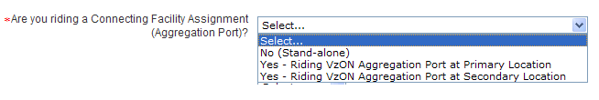
  - Do you want to be SONET Mapped at the primary location? – field is displayed when ‘No (stand-alone)’ is selected for “Are you riding a Connecting Facility Assignment (Aggregation Port)?” and ‘Secondary Location” is selected for “Are you collocated at the primary or secondary location?”. The value selected for this field is part of the necessary information needed for determining the NCI/SECNCI values as well as determining allowable bandwidth options in the ‘What is the requested bandwidth?’ field.
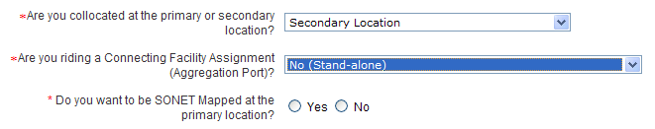
  - Do you want to be SONET Mapped at the secondary location? – field is displayed when ‘No (stand-alone)’ is selected for “Are you riding a Connecting Facility Assignment (Aggregation Port)?” and ‘Primary Location” is selected for “Are you collocated at the primary or secondary location?”. The value selected for this field is part of the necessary information needed for determining the NCI/SECNCI values as well as determining allowable bandwidth options in the ‘What is the requested bandwidth?’ field.
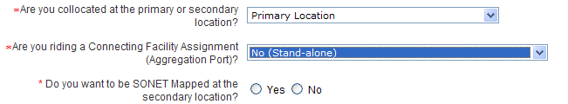
  - Do you want to be SONET Mapped at either the primary or secondary location? – field is displayed when ‘No (stand-alone)’ is selected for “Are you riding a Connecting Facility Assignment (Aggregation Port)?” and ‘No collocation at either end” is selected for “Are you collocated at the primary or secondary location”. The value selected for this field is part of the necessary information needed for determining the NCI/SECNCI values as well as determining allowable bandwidth options in the ‘What is the requested bandwidth?’ field.
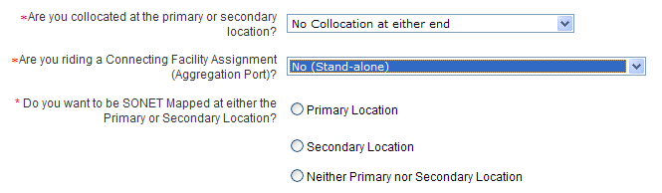
  - What is the requested bandwidth? – the value selected for this field is part of the necessary information needed for determining the NC/NCI/SECNCI values. Values displayed in the drop down will vary based on previously answered questions.

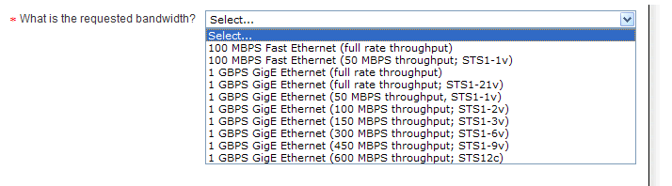

Conditional and Optional Field(s):

  - Do you require the Verizon Inter-Office Facility route to be protected? – the value selected for this field is part of the necessary information needed for determining the correct NC value. This field shall be displayed and required based upon specific bandwidth selections for field “What is the requested bandwidth?” Available options are ‘Yes’ and ‘No’. Certain collocation and bandwidth selections will cause this field to default to ‘Yes’.
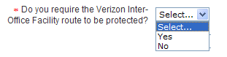
  - Fiber Network Identification (FNI) – this field is displayed and required when you are riding a connecting facility assignment at either the primary or secondary location.
  - Wireless Site Indicator (WSI) – System selected as “New Site”.
  - Customer Circuit ID (CKR) – field is optional
  - Cross Connect Equipment Assignment (CCEA) – Required when ‘No (Stand-alone)’ is selected to field “Are you riding a Connecting Facility Assignment (Aggregation Port)?” and “Primary Location” or “Collocation at both ends (TLS Transport Only)” is selected to field “Are you collocated at the primary or secondary location?”
  - Secondary Cross Connect Equipment Assignment (SCCEA) – Required when ‘No (Stand-alone)’ is selected to field “Are you riding a Connecting Facility Assignment (Aggregation Port)?” and “Secondary Location” or “Collocation at both ends (TLS Transport Only)” is selected to field “Are you collocated at the primary or secondary location?”
  - Remarks – field is optional

Example of Order Information section for ACTL to PREM:

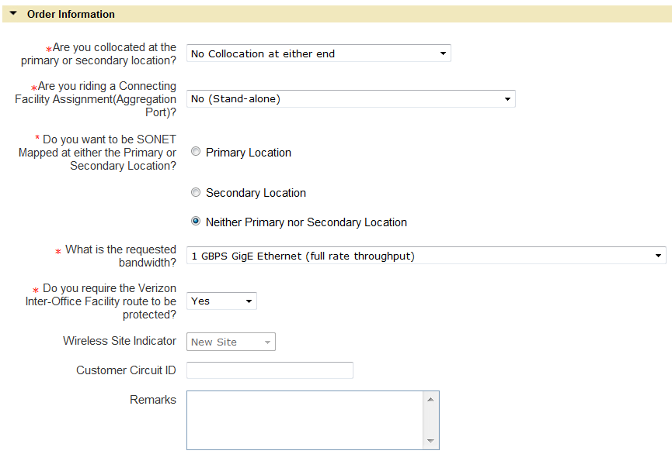

    - Primary Location Connecting Facility Assignment (CFA) Section
This Section is required when the circuit being ordered is to ride a higher level facility.
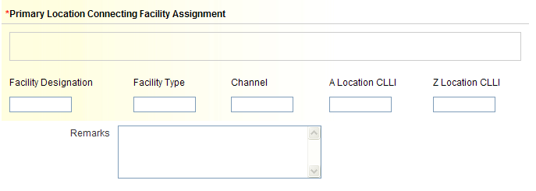

Available Fields:

  - Connecting Facility Assignment (CFA) – required when ‘Yes - Riding VzON Aggregation Port at Primary Location” is selected for field “Are you riding a Connecting Facility Assignment (Aggregation Port)?” and consists of the following elements:
      - Facility Designation
      - Facility Type
      - Channel
      - A Location CLLI
      - Z Location CLLI

Note: Must meet CFA format requirements and all elements must be populated.

- What is multiplexing location CLLI code for the CFA? (MUXLOC)– displayed and required when “Interexchange Customer Service Center” in Account Section is GT10 or GT11.
  - Does a lease arrangement apply to this CFA? Used to indicate if your Company is the owner of the facility named or if a lease arrangement applies.

- When “No” is selected, no further action is needed.

- When “Yes” is selected, population of additional fields is required:

Lease Authorization Name (LANM)
Date of Lease Arrangement (LADATED) Use the format of MM-DD-YYYY

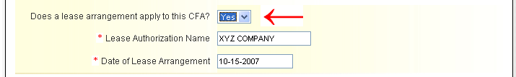

- Remarks - optional

    - Secondary Location Connecting Facility Assignment (SCFA) Section
This Section is required when the circuit being ordered is to ride a higher level facility.
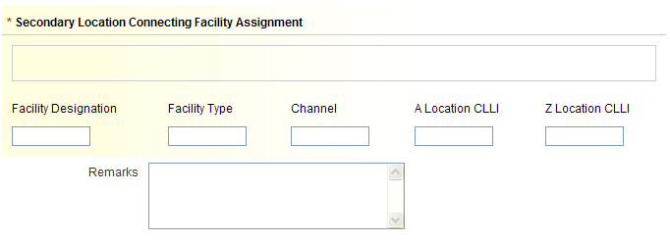

Available Fields:

  - Secondary Connecting Facility Assignment (SCFA) – required when ‘Yes - Riding VzON Aggregation Port at Secondary Location” is selected to field “Are you riding a Connecting Facility Assignment (Aggregation Port)?” and consists of the following elements:
      - Facility Designation
      - Facility Type
      - Channel
      - A Location CLLI
      - Z Location CLLI

Note: Must meet CFA format requirements and all elements must be populated.

- Remarks - optional

    - Service Installation – From
This Section provides information for population of the primary location of the service requested (ACTL).

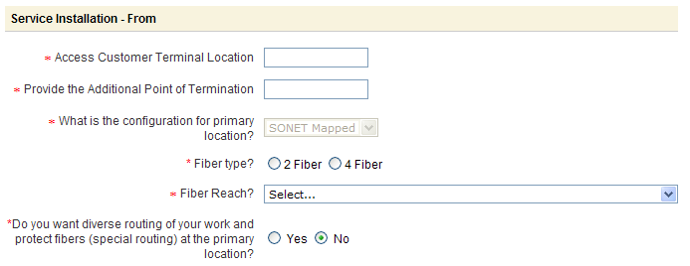

  - Access Customer Terminal Location (ACTL) – this field is required and must contain a valid 11 character CLLI code
  - Provide the Additional Point of Termination (APOT) – this field is required
  - What is the configuration for primary location? – required when displayed. Field will not be displayed when Primary Location is collocated or bandwidth is one of the following:

      - 1 GBPS Fibre Channel (full rate throughput; STS1-19v)
      - 1 GBPS FICON (full rate throughput; STS1-19v)

Note: This field may be defaulted to “SONET Mapped” or ‘Native Ethernet” based upon previous selections for SONET Mapped and/or riding a connecting facility assignment. If field is not defaulted, a selection will be required.

    - When Native Ethernet is selected or bandwidth is 1 GBPS Fibre Channel (full rate throughput; STS1-19v) or 1 GBPS FICON (full rate throughput; STS1-19v), the following additional fields may be displayed based upon previous selections:
      - What is the type of Ethernet Hand-off at primary location? –required when displayed and Native Ethernet is selected for configuration for primary location.
        - Select Electrical or Optical from drop down menu.
          - Some bandwidth selections will cause a default to either “Optical” or “Electrical” for this field.
      - Type? – required when displayed. This field will display when “Optical” is selected to “What is the type of Ethernet Hand-off at primary location?” or bandwidth is 1 GBPS Fibre Channel (full rate throughput; STS1-19v) or 1 GBPS FICON (full rate throughput; STS1-19v).

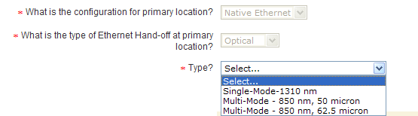

    - When SONET Mapped is selected, the following additional fields may be displayed based upon previous selections:

      - Fiber type? – required when displayed and SONET Mapped is selected for configuration at the primary location.
        - When riding a connecting facility assignment at the primary location, this field will default to “4 Fiber”.
      - Fiber Reach? – required when displayed and SONET Mapped is selected for configuration at the primary location.

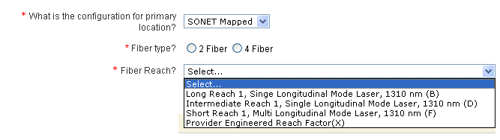

  - Is the circuit(s) being mapped to a standalone STS1 Facility? – this field may be displayed and required based upon previous configuration selections when location is ‘SONET Mapped’ and bandwidth selection is ‘100 MBPS Fast Ethernet (50 MBPS throughput) mapped to STS1 (STS1-1v)’. The value selected for this field is part of the necessary information needed for determining the NCI value.
  - Is Primary location Near-Out-Of-Franchise (NOOF)? - displayed and required when Interexchange Customer Service Center (ICSC) is GT10 or GT11. The value selected for this field is part of the necessary information needed for determining if a SPEC value is required.
  - Near-Out-Of-Franchise (NOOF) Contract Number (CNO) – displayed and required when “Yes” is selected for field “Is Primary location Near-Out-Of-Franchise”.
  - Does Near-Out-Of-Franchise (NOOF) have an ICB? – displayed and required when “Yes” is selected for field “Is Primary location Near-Out-Of-Franchise”. The value selected for this field is part of the necessary information needed for determining the correct SPEC value.
  - Do you want diverse routing of your work and protect fibers (special routing) at the primary location? (SR) – required for selection when displayed. Field is only displayed when primary location is not collocated.

    - Service Installation – To
This Section provides information for population of the secondary location of the service requested (SECLOC).

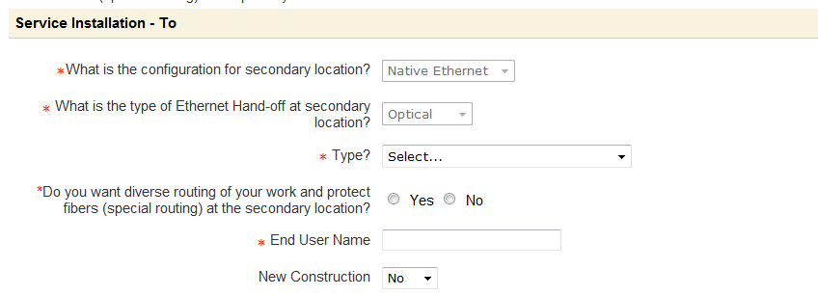

  - What is the configuration for secondary location? – required when displayed. Field will not be displayed when Secondary Location is collocated or bandwidth is one of the following:

      - 1 GBPS Fibre Channel (full rate throughput; STS1-19v)
      - 1 GBPS FICON (full rate throughput; STS1-19v)

Note: This field may be defaulted to “SONET Mapped” or ‘Native Ethernet” based upon previous selections for SONET Mapped and/or riding a connecting facility assignment. If field is not defaulted, a selection will be required.

    - When Native Ethernet is selected or bandwidth is 1 GBPS Fibre Channel (full rate throughput; STS1-19v) or 1 GBPS FICON (full rate throughput; STS1-19v), the following additional fields may be displayed based upon previous selections:
      - What is the type of Ethernet Hand-off at secondary location? –required when displayed and Native Ethernet is selected for configuration at secondary location.
        - Select Electrical or Optical from drop down menu.
          - Some bandwidth selections will cause a default to either “Optical” or “Electrical” for this field.
      - Type? – required when displayed. This field will display when “Optical” is selected to “What is the type of Ethernet Hand-off at secondary location?” or bandwidth is 1 GBPS Fibre Channel (full rate throughput; STS1-19v) or 1 GBPS FICON (full rate throughput; STS1-19v).
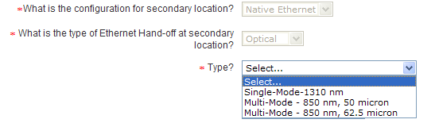

    - When SONET Mapped is selected, the following additional fields may be displayed based upon previous selections:

      - Fiber type? – required when displayed and SONET Mapped is selected for configuration at the secondary location.
        - When riding a connecting facility assignment at the secondary location, this field will default to “4 Fiber”.
      - Fiber Reach? – required when displayed and SONET Mapped is selected for configuration at the secondary location.

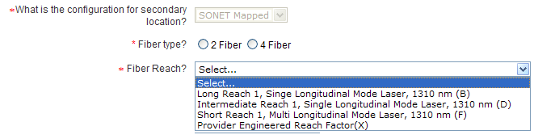
  - Is the circuit(s) being mapped to a standalone STS1 Facility? – this field may be displayed and required based upon previous configuration selections when location is ‘SONET Mapped’ and bandwidth selection is ‘100 MBPS Fast Ethernet (50 MBPS throughput) mapped to STS1 (STS1-1v)’. The value selected for this field is part of the necessary information needed for determining the SECNCI value.
  - Is Secondary location Near-Out-Of-Franchise (NOOF)? - displayed and required when Interexchange Customer Service Center (ICSC) is GT10 or GT11. The value selected for this field is part of the necessary information needed for determining if a SPEC value is required.
  - Near-Out-Of-Franchise (NOOF) Contract Number (CNO) – displayed and required when “No” is selected for field “Is Primary location Near-Out-Of-Franchise” and “Yes” is selected to “Is Secondary location Near-Out-Of-Franchise (NOOF).
  - Does Near-Out-Of-Franchise (NOOF) have an ICB? – displayed and required when “No” is selected for field “Is Secondary location Near-Out-Of-Franchise” and “Yes” is selected to “Is Secondary location Near-Out-Of-Franchise (NOOF). The value selected for this field is part of the necessary information needed for determining the correct SPEC value.
  - Do you want diverse routing of your work and protect fibers (special routing) at the secondary location? (SR) – required for selection when displayed. Field is only displayed when secondary location is not collocated.
  - End User Name (EUNAME) – field is required
  - New Construction (NCON) – field is optional. Value is set to default to “No”, change value to “Yes” when terminating address is new construction.

    - Service Address

Go to Section 6 for population information of the terminating service address and the local contact information.

Then Go to Section 7 (Review & Submit Request). Please note, for service inquiry requests, the quantity must be 1 so no additional circuit information can be provided.

Wireless VzON Inquiry Order PREM to PREM Request
The details provided in this section apply for creating a service inquiry request with “New” Activity. This section is broken down by Activity Type.

PREM to PREM Request – New Activity
The details provided in this section apply for creating a service inquiry request with “New” Activity. The required fields will be designated with a red asterisk (*). This section is broken down into subsections and contains the information needed for indentifying the connecting facility assignment (CFA/CCEA), the Primary locations details, and the Secondary location details including the originating and terminating service address fields.

    - Order Information Section

Populate the following Required Fields:
  - Are you collocated at the primary or secondary location? - the value selected for this field is part of the necessary information needed for determining the NCI/SECNCI values as well as determining allowable bandwidth options in the ‘What is the requested bandwidth?’ field.
  - Are you riding a Connecting Facility Assignment (Aggregation Port)? - the value selected for this field is part of the necessary information needed for determining the NCI/SECNCI values as well as determining allowable bandwidth options in the ‘What is the requested bandwidth?’ field. Drop down options in this field will vary based on selection to field “Are you collocated at the primary or secondary location?” Note: If the requested circuit is riding another CFA type (such as a Ring) that is not an Aggregation Port Facility, you cannot use Order by Product for this request.
  - Do you want to be SONET Mapped at the primary location? – this field is displayed when ‘No (stand-alone)’ is selected for “Are you riding a Connecting Facility Assignment (Aggregation Port)?” and ‘Secondary Location” is selected for “Are you collocated at the primary or secondary location?”. The value selected for this field is part of the necessary information needed for determining the NCI/SECNCI values as well as determining allowable bandwidth options in the ‘What is the requested bandwidth?’ field.

  - Do you want to be SONET Mapped at the secondary location? – this field is displayed when ‘No (stand-alone)’ is selected for “Are you riding a Connecting Facility Assignment (Aggregation Port)?” and ‘Primary Location” is selected for “Are you collocated at the primary or secondary location?”. The value selected for this field is part of the necessary information needed for determining the NCI/SECNCI values as well as determining allowable bandwidth options in the ‘What is the requested bandwidth?’ field.
  - Do you want to be SONET Mapped at either the primary or secondary location? – this field is displayed when ‘No (stand-alone)’ is selected for “Are you riding a Connecting Facility Assignment (Aggregation Port)?” and ‘No collocation at either end” is selected for “Are you collocated at the primary or secondary location”. The value selected for this field is part of the necessary information needed for determining the NCI/SECNCI values as well as determining allowable bandwidth options in the ‘What is the requested bandwidth?’ field.
  - What is the requested bandwidth? – the value selected for this field is part of the necessary information needed for determining the NC/NCI/SECNCI values. Values displayed in the drop down will vary based on previously answered questions.

Conditional and Optional Field(s):

  - Do you require the Verizon Inter-Office Facility route to be protected? – the value selected for this field is part of the necessary information needed for determining the correct NC value. This field shall be displayed and required based upon specific bandwidth selections for field “What is the requested bandwidth?” Available options are ‘Yes’ and ‘No’. Certain collocation and bandwidth selections will cause this field to default to ‘Yes’.
  - Fiber Network Identification (FNI) – this field is displayed and required when you are riding a connecting facility assignment at either the primary or secondary location.
  - Wireless Site Indicator (WSI) – System populated as “New Site”.
  - Customer Circuit ID (CKR)
  - Cross Connect Equipment Assignment (CCEA) – Required when ‘No (Stand-alone)’ is selected to field “Are you riding a Connecting Facility Assignment (Aggregation Port)?” and “Primary Location” or “Collocation at both ends (TLS Transport Only)” is selected to field “Are you collocated at the primary or secondary location?”
  - Secondary Cross Connect Equipment Assignment (SCCEA) – Required when ‘No (Stand-alone)’ is selected to field “Are you riding a Connecting Facility Assignment (Aggregation Port)?” and “Secondary Location” or “Collocation at both ends (TLS Transport Only)” is selected to field “Are you collocated at the primary or secondary location?”
  - Remarks - optional

Example of Order Information section for Prem to Prem:
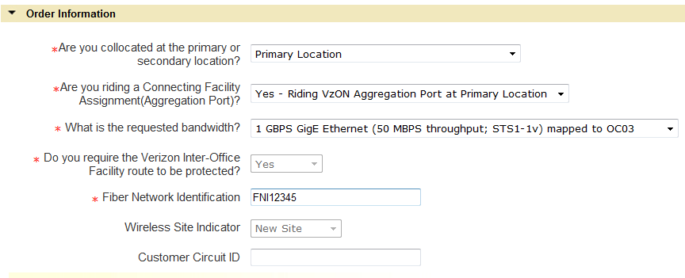

    - Primary Location Connecting Facility Assignment (CFA) Section

This Section is required when the circuit being ordered is to ride a higher level facility at the primary location.
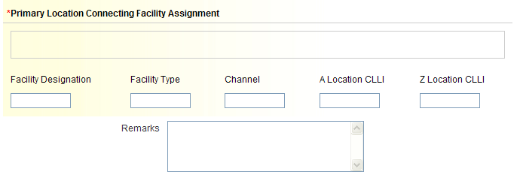

Available Fields:

  - Connecting Facility Assignment (CFA) – required when ‘Yes - Riding VzON Aggregation Port at Primary Location” is selected to field “Are you riding a Connecting Facility Assignment (Aggregation Port)?” and consists of the following elements:
      - Facility Designation
      - Facility Type
      - Channel
      - A Location CLLI
      - Z Location CLLI

Note: Must meet CFA format requirements and all elements must be populated.

- What is multiplexing location CLLI code for the CFA? (MUXLOC)– displayed and required when “Interexchange Customer Service Center” in Account Section is GT10 or GT11.
  - Does a lease arrangement apply to this CFA? Used to indicate if your Company is the owner of the facility named or if a lease arrangement applies.

- When “No” is selected, no further action is needed.

- When “Yes” is selected, population of additional fields is required:

Lease Authorization Name (LANM)
Date of Lease Arrangement (LADATED) Use the format of MM-DD-YYYY

    - Secondary Location Connecting Facility Assignment (SCFA) Section
This Section is required when the circuit being ordered is to ride a higher level facility at the secondary location.

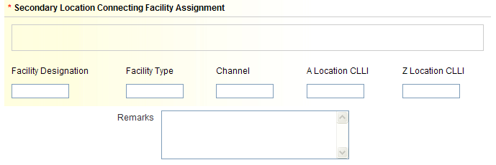

Available Fields:

  - Secondary Connecting Facility Assignment (SCFA) – required when ‘Yes - Riding VzON Aggregation Port at Secondary Location” is selected to field “Are you riding a Connecting Facility Assignment (Aggregation Port)?” and consists of the following elements:
      - Facility Designation
      - Facility Type
      - Channel
      - A Location CLLI
      - Z Location CLLI

Note: Must meet CFA format requirements and all elements must be populated.

- Remarks - optional

    - Service Installation – From
This Section provides information for population of the primary location of the service requested.
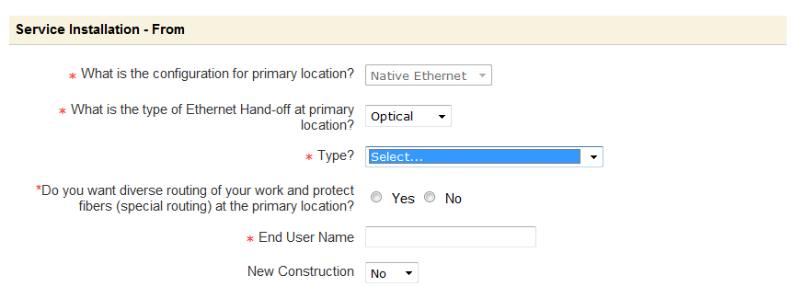

  - What is the configuration for primary location? – required when displayed. Field will not be displayed when Primary Location is collocated or bandwidth is one of the following:

      - 1 GBPS Fibre Channel (full rate throughput; STS1-19v)
      - 1 GBPS FICON (full rate throughput; STS1-19v)

Note: This field may be defaulted to “SONET Mapped” or ‘Native Ethernet” based upon previous selections for SONET Mapped and/or riding a connecting facility assignment. If field is not defaulted, a selection will be required.

    - When Native Ethernet is selected or bandwidth is 1 GBPS Fibre Channel (full rate throughput; STS1-19v) or 1 GBPS FICON (full rate throughput; STS1-19v), the following additional fields may be displayed based upon previous selections:
      - What is the type of Ethernet Hand-off at primary location? –required when displayed and Native Ethernet is selected for configuration at primary location.
        - Select Electrical or Optical from drop down menu.
          - Some bandwidth selections will cause a default to either “Optical” or “Electrical” for this field.
      - Type? – required when displayed. This field will display when “Optical” is selected to “What is the type of Ethernet Hand-off at primary location?” or bandwidth is 1 GBPS Fibre Channel (full rate throughput; STS1-19v) or 1 GBPS FICON (full rate throughput; STS1-19v).

    - When SONET Mapped is selected, the following additional fields may be displayed based upon previous selections:

      - Fiber type? – required when displayed and SONET Mapped is selected for configuration at the primary location.
        - When riding a connecting facility assignment at the primary location, this field will default to “4 Fiber”.
      - Fiber Reach? – required when displayed and SONET Mapped is selected for configuration at the primary location.

  - Is the circuit(s) being mapped to a standalone STS1 Facility? – this field may be displayed and required based upon previous configuration selections when location is ‘SONET Mapped’ and bandwidth selection is ‘100 MBPS Fast Ethernet (50 MBPS throughput) mapped to STS1 (STS1-1v)’. The value selected for this field is part of the necessary information needed for determining the NCI value.
  - Is Primary location Near-Out-Of-Franchise (NOOF)? - displayed and required when Interexchange Customer Service Center (ICSC) is GT10 or GT11. The value selected for this field is part of the necessary information needed for determining if a SPEC value is required.
  - Near-Out-Of-Franchise (NOOF) Contract Number (CNO) – displayed and required when “Yes” is selected for field “Is Primary location Near-Out-Of-Franchise”.
  - Does Near-Out-Of-Franchise (NOOF) have an ICB? – displayed and required when “Yes” is selected for field “Is Primary location Near-Out-Of-Franchise”. The value selected for this field is part of the necessary information needed for determining the correct SPEC value.
  - Do you want diverse routing of your work and protect fibers (special routing) at the primary location? (SR) – required for selection when displayed. Field is only displayed when primary location is not collocated.
  - End User Name (EUNAME) – field is required
  - New Construction (NCON) – field is optional

    - Service Address

GO TO Section 6 for information on population of the originating service address and the local contact information.

    - Service Installation – To
This Section provides information for population of the secondary location of the service requested (SECLOC).

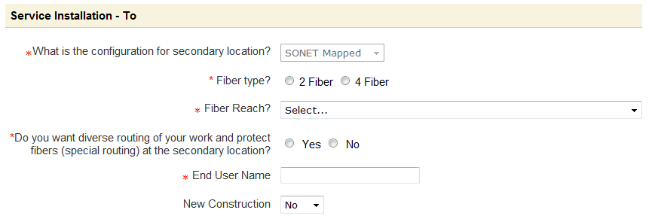

  - What is the configuration for secondary location? – required when displayed. Field will not be displayed when Secondary Location is collocated or bandwidth is one of the following:

      - 1 GBPS Fibre Channel (full rate throughput; STS1-19v)
      - 1 GBPS FICON (full rate throughput; STS1-19v)

Note: This field may be defaulted to “SONET Mapped” or ‘Native Ethernet” based upon previous selections for SONET Mapped and/or riding a connecting facility assignment. If field is not defaulted, a selection will be required.

    - When Native Ethernet is selected or bandwidth is 1 GBPS Fibre Channel (full rate throughput; STS1-19v) or 1 GBPS FICON (full rate throughput; STS1-19v), the following additional fields may be displayed based upon previous selections:
      - What is the type of Ethernet Hand-off at secondary location? –required when displayed and Native Ethernet is selected for configuration at secondary location.
        - Select Electrical or Optical from drop down menu.
          - Some bandwidth selections will cause a default to either “Optical” or “Electrical” for this field.
      - Type? – required when displayed. This field will display when “Optical” is selected to “What is the type of Ethernet Hand-off at secondary location?” or bandwidth is 1 GBPS Fibre Channel (full rate throughput; STS1-19v) or 1 GBPS FICON (full rate throughput; STS1-19v).

    - When SONET Mapped is selected, the following additional fields may be displayed based upon previous selections:

      - Fiber type? – required when displayed and SONET Mapped is selected for configuration at the secondary location.
        - When riding a connecting facility assignment at the secondary location, this field will default to “4 Fiber”.
      - Fiber Reach? – required when displayed and SONET Mapped is selected for configuration at the secondary location.

  - Is the circuit(s) being mapped to a standalone STS1 Facility? – this field may be displayed and required based upon previous configuration selections when location is ‘SONET Mapped’ and bandwidth selection is ‘100 MBPS Fast Ethernet (50 MBPS throughput) mapped to STS1 (STS1-1v)’. The value selected for this field is part of the necessary information needed for determining the SECNCI value.
  - Is Secondary location Near-Out-Of-Franchise (NOOF)? - displayed and required when Interexchange Customer Service Center (ICSC) is GT10 or GT11. The value selected for this field is part of the necessary information needed for determining if a SPEC value is required.
  - Near-Out-Of-Franchise (NOOF) Contract Number (CNO) – displayed and required when “No” is selected for field “Is Primary location Near-Out-Of-Franchise” and “Yes” is selected to “Is Secondary location Near-Out-Of-Franchise (NOOF).
  - Does Near-Out-Of-Franchise (NOOF) have an ICB? – displayed and required when “No” is selected for field “Is Secondary location Near-Out-Of-Franchise” and “Yes” is selected to “Is Secondary location Near-Out-Of-Franchise (NOOF). The value selected for this field is part of the necessary information needed for determining the correct SPEC value.
  - Do you want diverse routing of your work and protect fibers (special routing) at the secondary location? (SR) – required for selection when displayed. Field is only displayed when secondary location is not collocated.
  - End User Name (EUNAME)
  - New Construction (NCON) – Value is set to default to “No”, change value to “Yes” when terminating address is new construction.

    - Service Address

GO TO Section 6 for population information of the terminating service address and the local contact information.

Then Go to Section 7 (Review & Submit Request). Please note, for service inquiry requests, the quantity must be 1 so no additional circuit information can be provided.

Service Address Section
This section provides information for population of the originating and/or terminating service address and the local contact information. The required, conditional, and optional fields vary depending on the Verizon Region and address type (AFT) selected.

  - Select Address Type (AFT) – Value is set to default at “Official Numbered Address”. When desired value is not “Official Numbered Address”, the supported values to choose from will vary depending on the Verizon Region.

Verizon North and South Regions allowable entries:

Official Numbered Address (AFT = “blank”)
Rural Route & Box (AFT = “A”)
Assigned House Number (AFT = “C”)
Remote Location with Assigned CLLI (AFT = “E”)

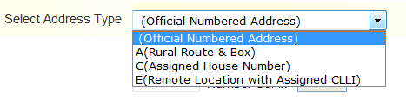
Note: Remote Location with assigned CLLI is not applicable when the associated Location is collocated.

Verizon West Region allowable entries:

Official Numbered Address (AFT = “blank”)
Rural Route & Box (AFT = A)
Unnumbered Address (AFT = B)
Remote Location with Assigned CLLI (AFT = “E”)

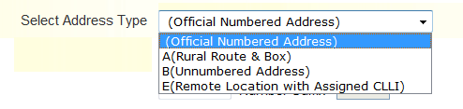

Note: Remote Location with assigned CLLI is not applicable when the associated Location is collocated.

Required Fields for “Official Number Address” (all Verizon regions) and “Assigned House” Number (Verizon East Only):

  - Select Address Type – “Official Numbered Address” or
“C (Assigned House Number)”
  - Address Number (SANO)
  - Street Name (SASN)
  - City (CITY)
  - State (STATE)
  - Zip Code (ZIP CODE)

Note: The fields named above are the minimal required fields. However, additional service address fields may be required to receive a successful address validation.

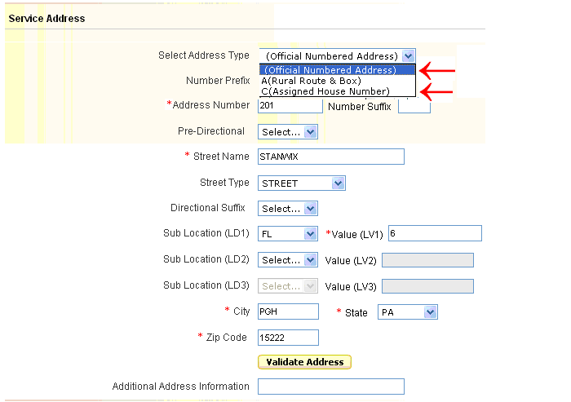

Optional Fields:
  - Number Prefix (SAPR)
  - Number Suffix (SASF)
  - Pre-Directional (SASD)
  - Street Type (SATH)
  - Directional Suffix (SASS)
  - Sub Location (LD1)
  - Value (LV1)
  - Sub Location (LD2)
  - Value (LV2)
  - Sub Location (LD3)
  - Value (LV3)

Populate the address where service is to terminate and select the “Validate Address” button.

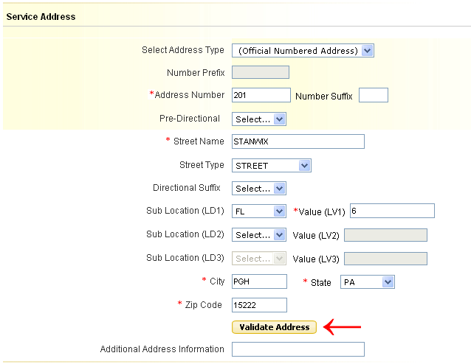

A “Pop Up” box will display the result of the Search. Slide the Scroll bar on the bottom of the box to see all the information returned:

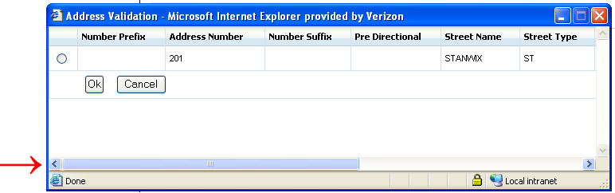

Select the radio button next to the address, and then select “OK”.

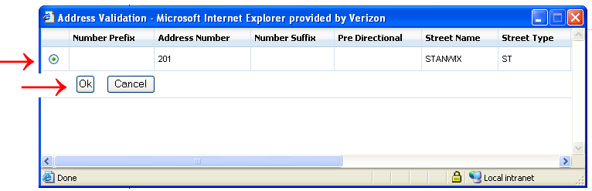

Required Fields for “Rural Route and Box”:

  - Select Address Type – A (Rural Route & Box)
  - Address Number – Verizon East Only (SANO)
  - Rural Route (SASN) – Select the appropriate entry
  - Route # (SASN)
  - City (CITY)
  - State (STATE)
  - Zip Code (ZIP CODE)

Note: The fields named above are the minimal required fields. However, additional service address fields may be required to receive a successful address validation.

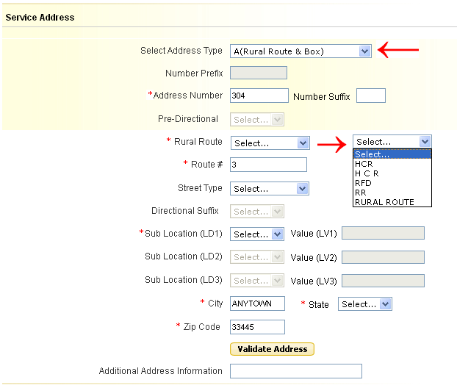

Optional Fields:
  - Number Suffix (SASF)
  - Street Type (SATH)
  - Sub Location (LD1)
  - Value (LV1)
  - Sub Location (LD2)
  - Value (LV2)
  - Sub Location (LD3)
  - Value (LV3)

Populate the address where service is to terminate and select the “Validate Address” button.

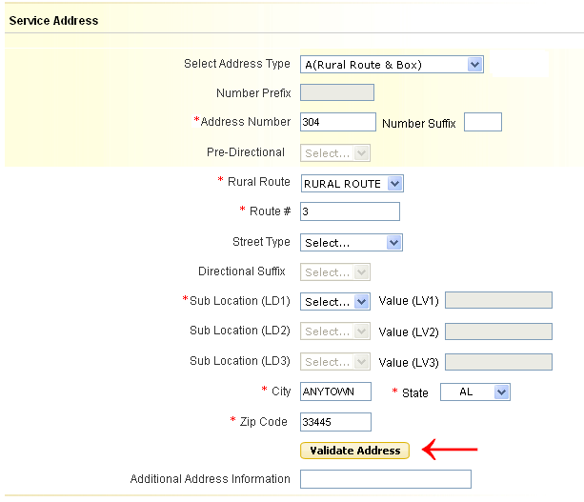

Required Fields for “Unnumbered Address” (Verizon West Only):
  - Street Name (SASN)
  - City (CITY)
  - State (STATE)
  - Zip Code (ZIP CODE)

Note: The fields named above are the minimal required fields. However, additional service address fields may be required to receive a successful address validation.
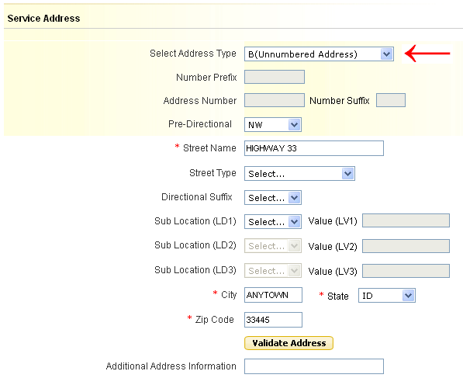

Optional Fields:
  - Pre-Directional (SASD)
  - Street Type (SATH)
  - Directional Suffix (SASS)
  - Sub Location (LD1)
  - Value (LV1)
  - Sub Location (LD2)
  - Value (LV2)
  - Sub Location (LD3)
  - Value (LV3)

Populate the address where service is to terminate and select the “Validate Address” button.

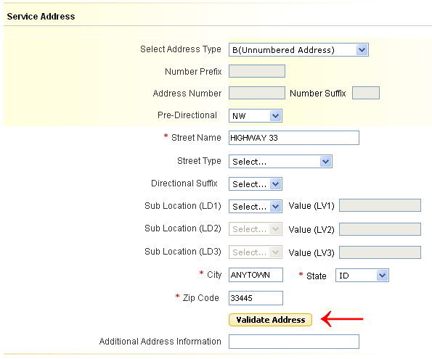

Required Fields for “Remote Location with Assigned CLLI”:

  - Remote Location CLLI – 8 or 11 character CLLI code
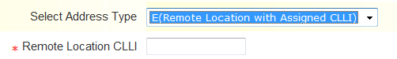

    - Local Contact Information

Populate the following Required Fields:

- Local Contact Name (LCON)
- Local Contact Telephone (ACTEL)
- Local Contact E-Mail (LCON EMAIL)
- Alternate Local Contact Name (ALCON) – must be different than the Local Contact Name
- Alternate Local Contact Telephone (ALCON TEL) – must be different than the Local Contact Telephone
- Alternate Local Contact E-Mail (ALCON EMAIL) – must be different than the Local Contact E-Mail

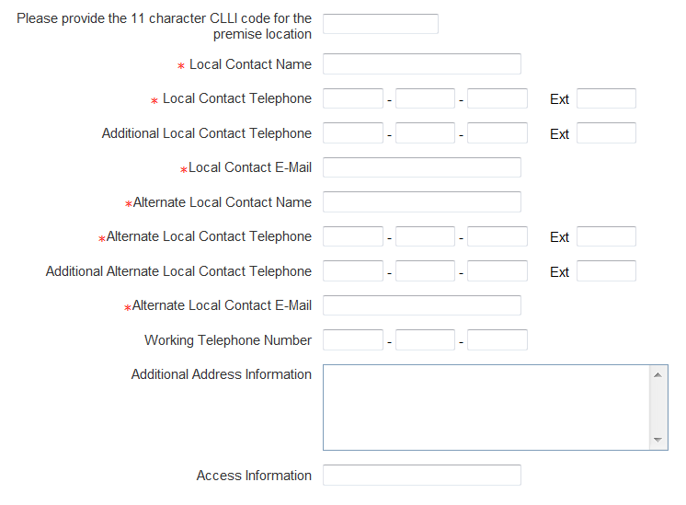

Optional Fields:

  - Please provide the 11 character CLLI code for the premise location (SPOT) – required when Interexchange Customer Service Center field 1st two positions are GT, else optional.
  - Additional Local Contact Telephone (AACTEL)
  - Additional Alternate Local Contact Telephone (AALCON TEL)
  - Working Telephone Number (WKTEL) - Required for population when 'Existing Site' is selected for field "Wireless Site Indicator", else optional.
  - Additional Address Information (AAI) – required only when “Remote Location with assigned CLLI” is selected in the “Select Address Type” field otherwise optional.
  - Access Information (ACC)

Review and Submit Request
The details provided in this section provide the necessary steps for reviewing and submitting a completed request.

Select “Review Order” button:

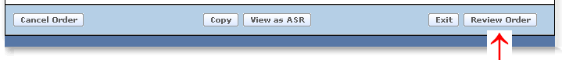

Select “Submit” after reviewing the order details:

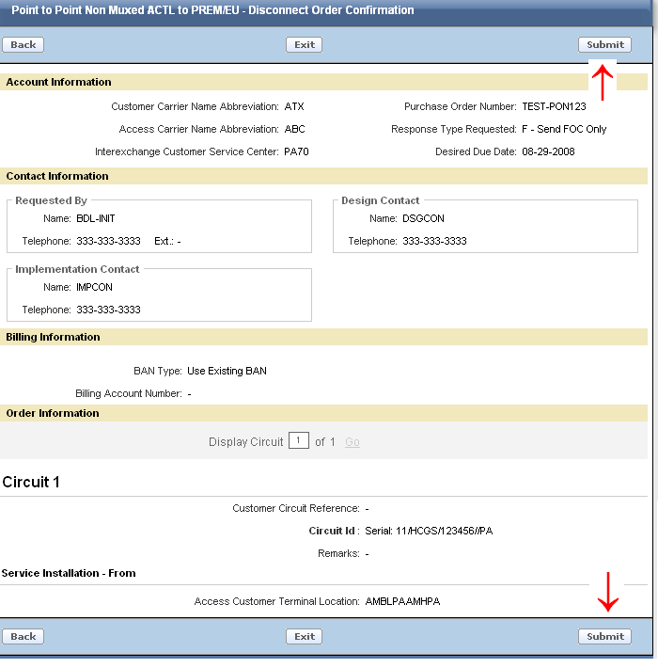

Select the “Back” button to return to the order entry screen.
Select the “EXIT” button to return to the Worklist page. The current request will not be “Saved” or “Submitted” when “EXIT” is selected.

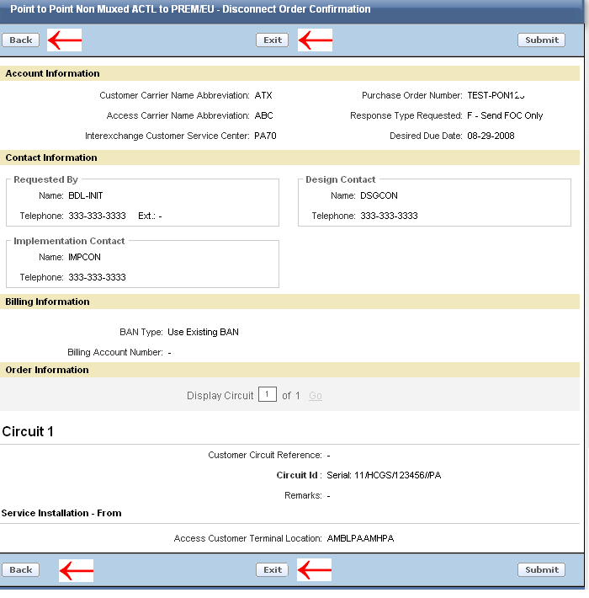

After Submit is selected, you will receive a pop up message asking “Are you sure you want to submit the request?”

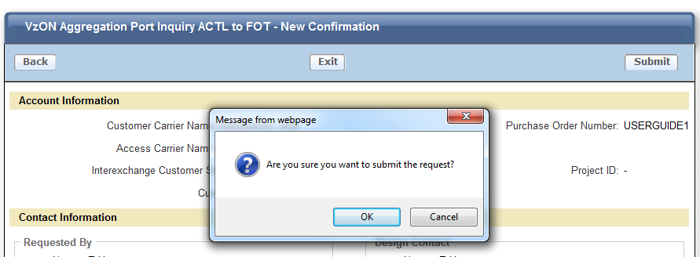

Click “OK” to submit
Click “Cancel” to return to the Review Order Page.

After “OK” is selected, you will receive a confirmation that your order has been submitted successfully:

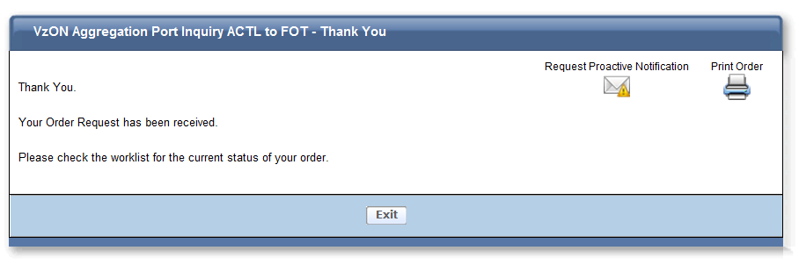

If you would like to receive proactive email notification of status changes on your order, then select “Request Proactive Notifications” otherwise you may print and/or exit the order.

If “Request Proactive Notifications” was selected, you will see the following screen and you can then select which notifications you would like to receive and hit the “Subscribe” button:
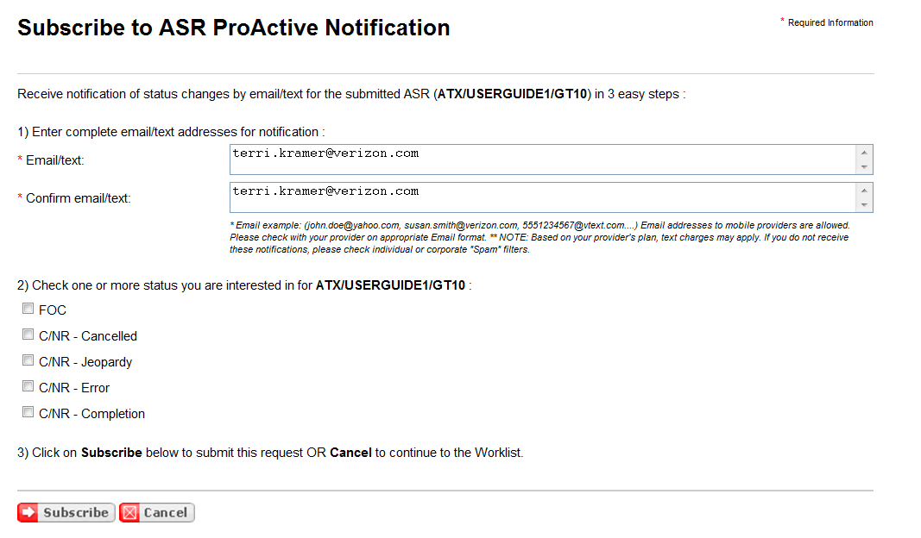

Order History and Status Section
To check the history and/or Status, select the PON from the Worklist.

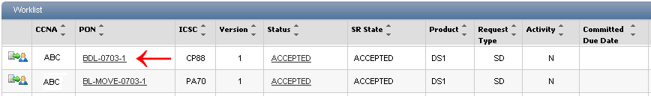

The Order History and Status section provides the history of a PON from submission to completion.

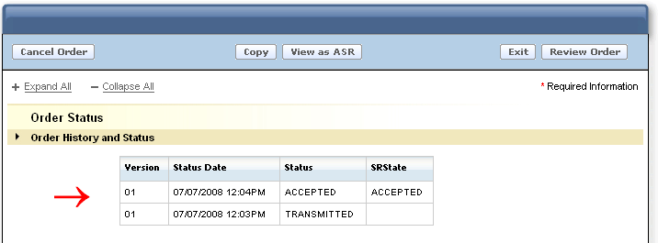

When the Status column indicates “Rejected”, the word “Rejected” is displayed as a link. Select the link to view the rejection response:

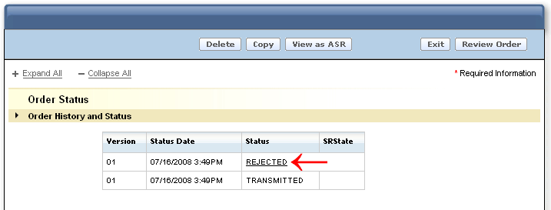

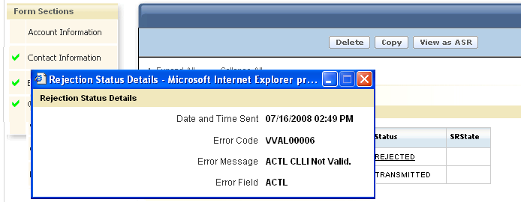

When the SRState column indicates “Error C/NR Pending”, the words “Error C/NR Pending” are displayed as a link. Select the link to view the C/NR response:

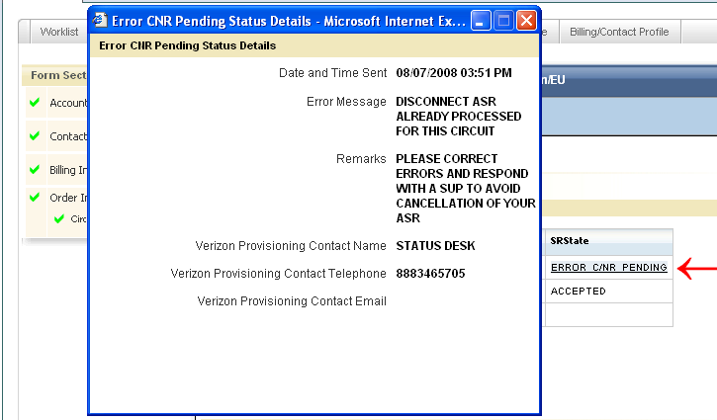

When the SRState column indicates “Confirmed”, the word “Confirmed” is displayed as a link. Select the link to view the Confirmation response:

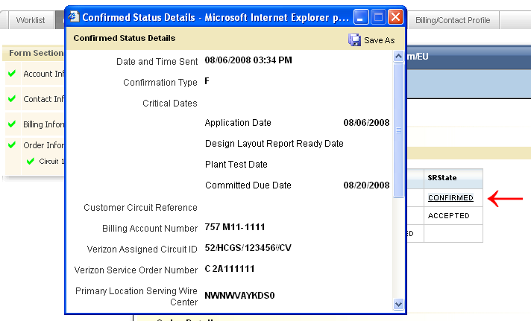

Creating a Firm Order
This section will provide the necessary steps to create and submit a firm order after receiving a confirmation on the Service Inquiry.

A Confirmation must be received on a Service Inquiry before the firm order is allowed. When a Confirmation is sent, the SRState in the Order History and Status Section is updated to “Confirmed”.

Select the “Create Firm Order” button

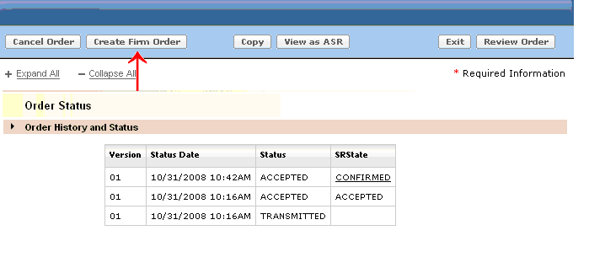

The Order will convert to a Firm Order request and will include the original data provided on the Service Inquiry.
- The Firm Order request will contain new fields for population (required and optional) along with the fields converted from the Service Inquiry.
- Most of the fields converted from the Service Inquiry will not have the ability to be changed.
  - Please note that most fields in the Service Address section are editable when converted but must match the address that was returned on the inquiry. The address shall be returned to the initiator via email as well as on an informational C/NR.
- If an update is necessary to a field that cannot be changed, the request will need to be cancelled and a new Service Inquiry will need to be issued.

Populate the additional required fields designated with a red asterisk (*) and any other desired optional fields.

Detailed instructions for completing a Firm Order request can be found in the Order by Product VzON/EPL Firm Order User Guide. Once a Service Inquiry Request is converted to Firm Order, the same rules apply to the request as outlined in the Firm Order User Guide.

For Example: In the Order Information Section, populate the Response Type Requested (RTR) and Desired Due Date (DDD)

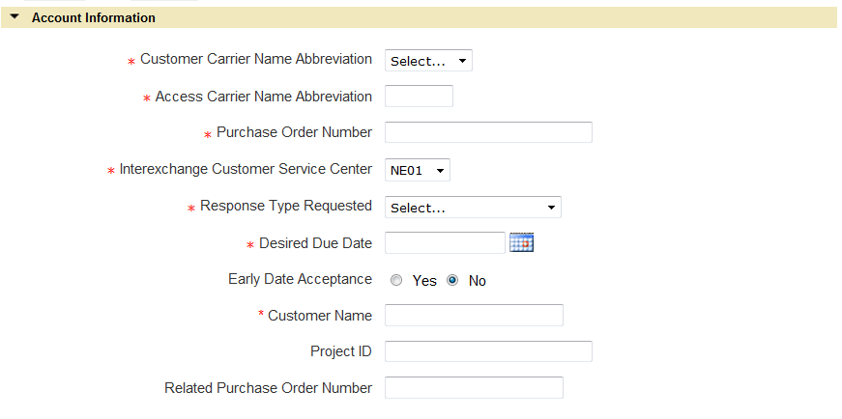

After populating the necessary fields to complete the Firm Order Request, select the “Review Order” button.

After reviewing the Firm Order request, select the “Submit” button.

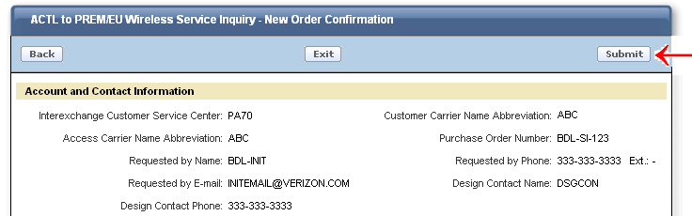

After Submit is selected, you will receive a pop up message asking “Are you sure you want to submit the request?”

Click “OK” to submit
Click “Cancel” to return to the Review Order Page.

After “OK” is selected, you will receive a confirmation that your order has been submitted successfully:

If you would like to receive proactive email notification of status changes on your order, then select “Request Proactive Notifications” otherwise you may print and/or exist the order.

Modify a Request (SUP)
This section will provide the necessary steps to submit a supplement (SUP) version of a Service Inquiry and a Firm Order request that has been submitted and received by Verizon, but prior to the confirmation.

Modify a Service Inquiry Request (SUP)
There are situations that may occur which require the submission of a supplement (SUP) on a previously Accepted Service Inquiry PON prior to it being confirmed. A few examples are: To update entries previously provided on specific fields or to provide a respond to a Customer Notification Record (C/NR).

To issue a supplement, retrieve the PON from the Worklist. Note: The PON must be associated with your own worklist in order to issue a supplement.

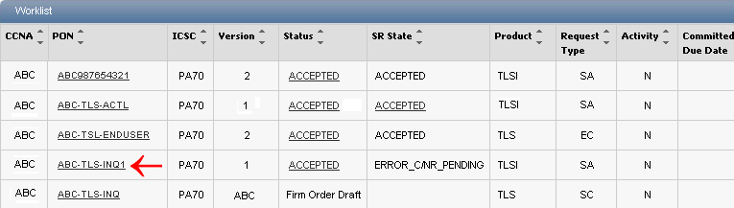

If you need to move a PON to your worklist in order to issue a supplement, you must search for the PON in another user’s worklist. Once PON is located:

- To the left of the CCNA column on the list of PONs displayed will be the following icon:

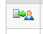

- Press the icon to assume responsibility of the order. The following text box will appear:
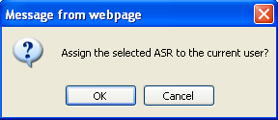
- Select ‘OK’ to transfer the PON to your own worklist in order to issue the SUP or ‘Cancel’ to leave the PON on the current worklist.

Enter the necessary changes (ex: updating the Service Address), then…

Select the “Review Order” button:

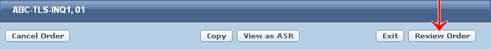

Then Select the “Submit” button:

Verizon will assign a SUP value of “4” to the request.

Modify a Firm Order Request (SUP)
There are several situations that may occur which require the submission of a supplement (SUP) on a previously Accepted PON. A few examples are: Change the original Desired Due Date (DDD), update entries previously provided on specific fields, or to respond to a Clarification (C/NR).

To issue a supplement, retrieve the PON from the Worklist. Note: The PON must be associated with your own worklist in order to issue a supplement.

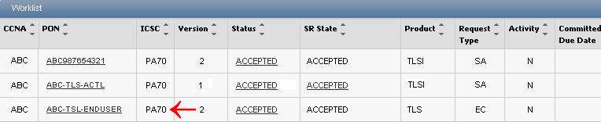

If you need to move a PON to your worklist in order to issue a supplement, you must search for the PON in another user’s worklist. Once PON is located:

- To the left of the CCNA column on the list of PONs displayed will be the following icon:

- Press the icon to assume responsibility of the order. The following text box will appear:
- Select ‘OK’ to transfer the PON to your own worklist or ‘Cancel’ to leave the PON on the current worklist.

To change the Desired Due Date, Select the Calendar Icon and select the appropriate date:

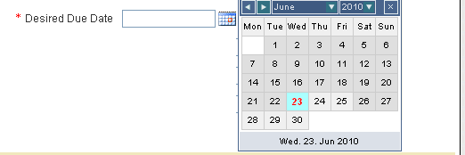

Select “Review Order” button:

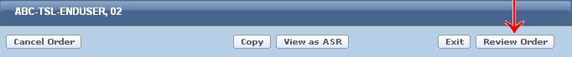

Then Select “Submit”.

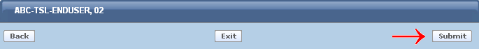

Verizon will compare the new version to the previous version. If the Desired Due Date is the only change, the SUP value of “2” will be named on the ASR created and submitted to the provisioning center.

When making other changes make the appropriate update, then…

Select “Review Order” button:

Then Select “Submit”.

Verizon will compare the new version to the previous version and assign a SUP value of “3” or “4” depending on whether or not a Confirmation has been issued for the PON.

Cancel a Request
This section will provide the necessary steps to cancel (SUP 1) a PON previously submitted and Accepted by Verizon.

To submit a cancellation, retrieve the PON from the Worklist.

Select “Cancel Order” button

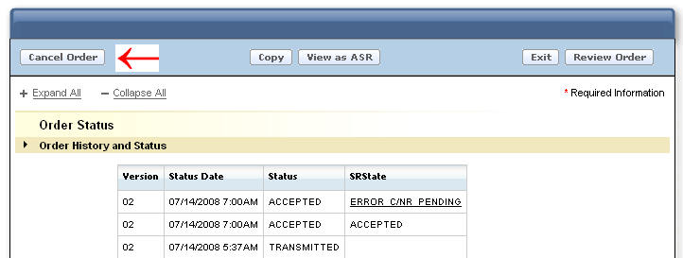

The display will automatically change to a “review” status and the description in the Header will show “Request Cancellation”.

Select “Submit”
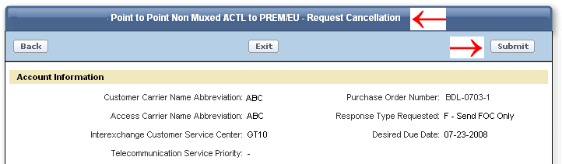

Verizon will assign the SUP value of “1” on the ASR created and submitted to the provisioning center.

View as ASR

When the “View as ASR” button is selected, the request is permanently moved to ASR format. All entries populated prior to moving the request to ASR format will be retained. When using “Order by Product”, there are several fields that are derived by Verizon (ex: REQTYP, PIU, NC, NCI, SECNCI). Determination of what “derived” fields are populated on the ASR will depend upon when the “View as ASR” button is selected during the process.

“View as ASR” Prior to Submitting Request

All required fields must be populated before the “View as ASR” button may be selected. All entered data will be retained and populated on the ASR formatted request, as well as the following “derived” fields”:

ASR field | = | Derived Value
REQTYP | = | SA or EA (Assigned based on original routing option selected from the ordering menu- ACTL to PREM/PREM to PREM)- Service Inquiry Values only
REQTYP | = | SC or EC- Firm Order values when converted from Inquiry
ACT | = | N
QTY | = | 1

NOTE: Because the request was not “submitted” through the “Order by Product” feature, additional derived fields are not available to be calculated (ex: PIU, NC, NCI, SECNCI) and will NOT be present on the ASR request when the “View as ASR” button is selected.

To view a request in ASR format, select “View as ASR” button.

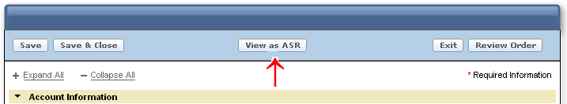

A warning message will display stating the action will permanently convert the request to ASR format.

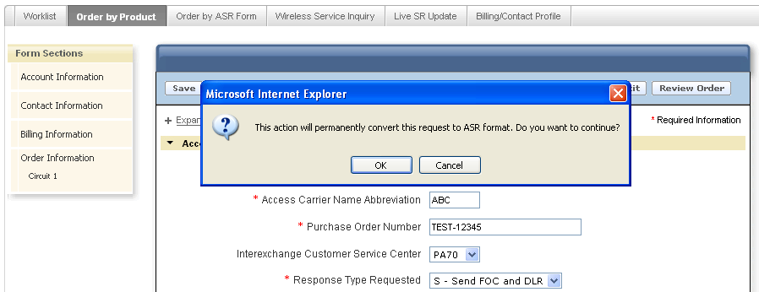

Select “OK” to continue or “Cancel” to stop the process. A selection of “OK’ will move this request to Order by ASR. A selection of “Cancel” will retain the request in Order by Product.

NOTE: When “View as ASR” button is selected, the action may take a few moments to process.

When “OK” is selected, the request will convert to ASR format.

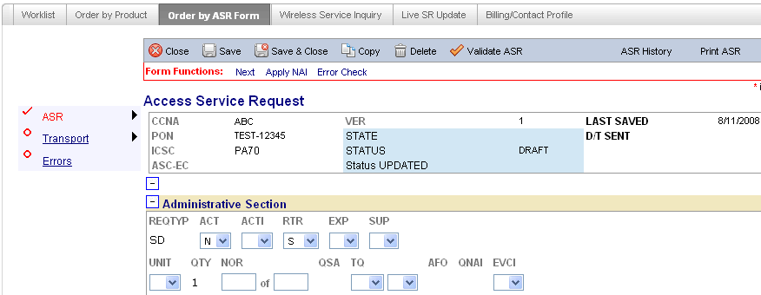

Complete, validate, and submit the request.

“View as ASR” after Request has been Submitted
“View as ASR” can be selected at anytime after a request has been submitted except when the current status is “Transmitted”.

All entries entered by the user and the entries derived by Verizon will be populated on the ASR formatted request.

To view the request in ASR format:

Retrieve the desired PON from the Worklist:

Select the “View as ASR” button:

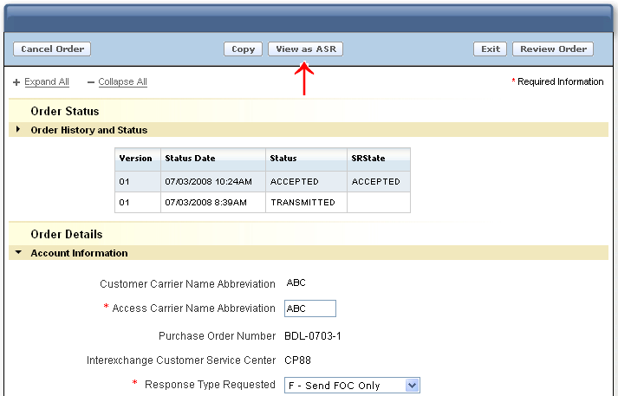

A warning message will display stating the action will permanently convert the request to ASR format.

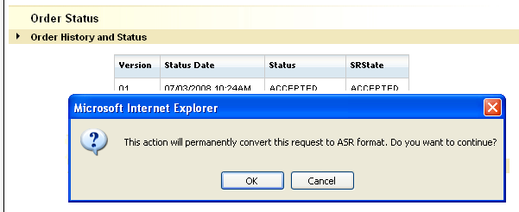

Select “OK” to continue or “Cancel” to stop the process.

When “OK” is selected, the process will begin to convert the request to ASR format. While the conversion is taking place the following screen will display. The process may take a few moments:

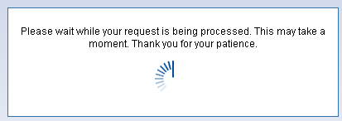

Once the conversion process is completed, the PON will display in ASR format. All fields and forms (entered by user or derived by Verizon) will be included.

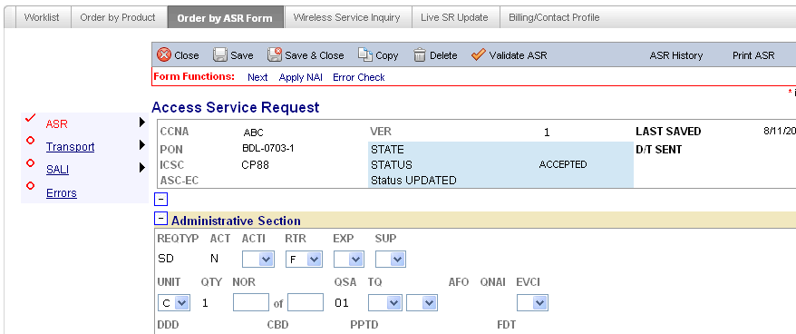

Billing/Account Profile

The Billing and Contact Profile provides a Default Profile for pre-population of the Billing and Contact Information Sections when the request is created.

The Billing and Contact Profile can be selected from:

The initial “Landing Page”
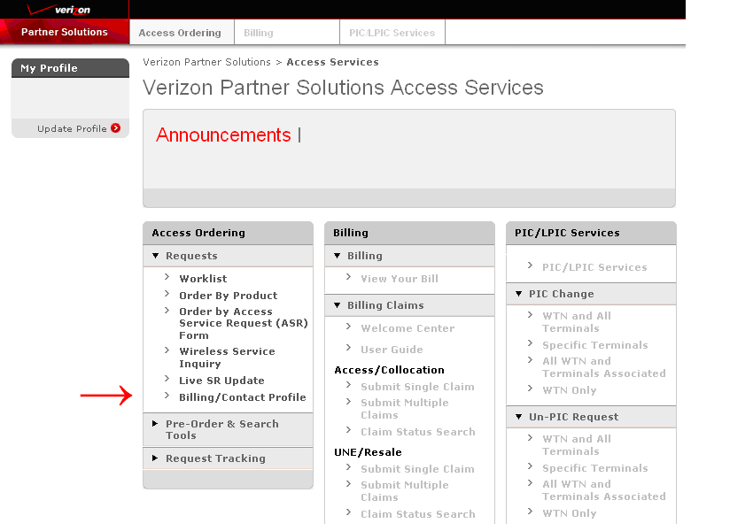

The “Access Ordering” Tab

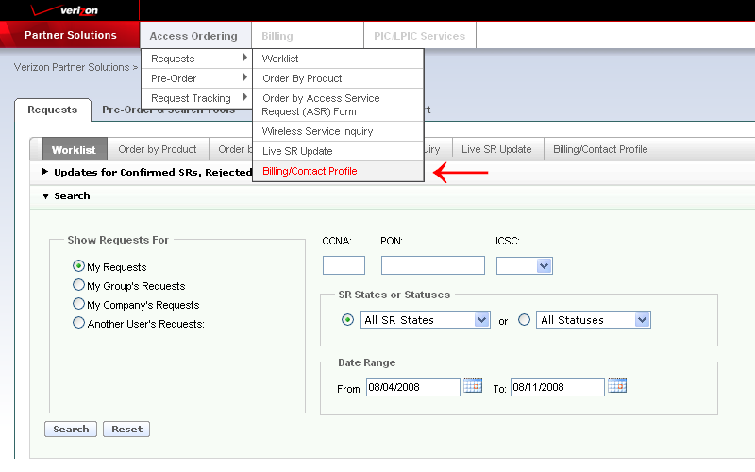

Or…The “Billing/Contact Profile” Tab

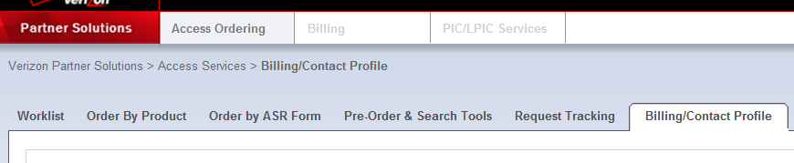

Create a default profile by populating the appropriate fields:

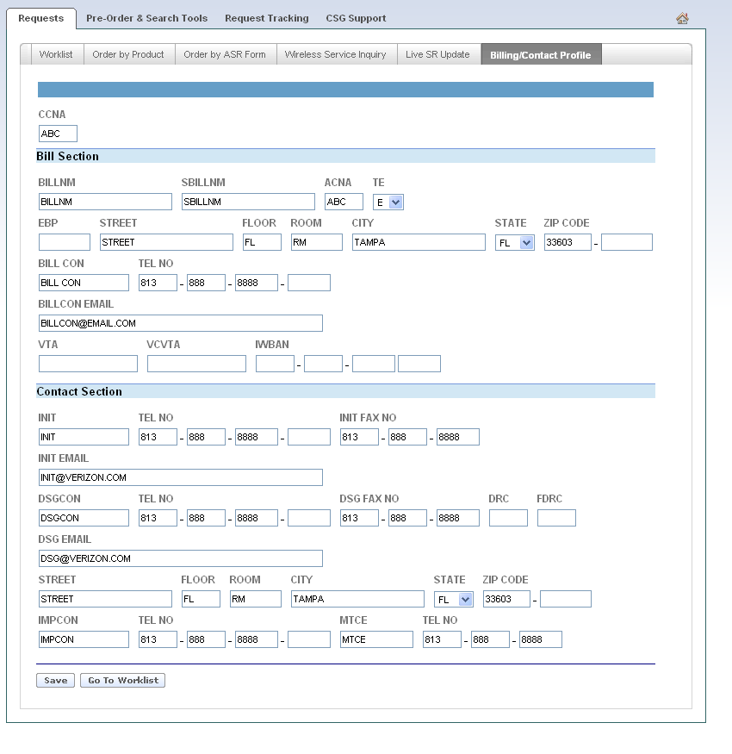

Select “Save” to save the Profile:

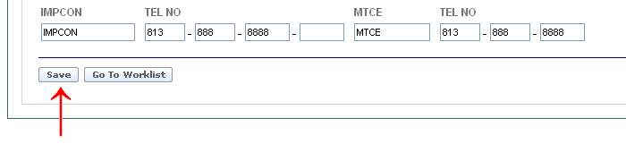

Select “Go to Worklist” to return to Worklist:

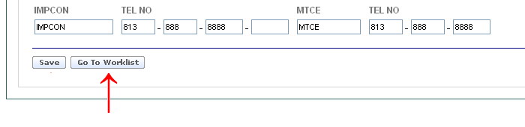

SOS Helpdesk
Each provisioning center within Verizon contains an Access Ordering Helpdesk. To obtain the correct telephone number go to the following url:

http://www22.verizon.com/wholesale/

Select “Contact Us”

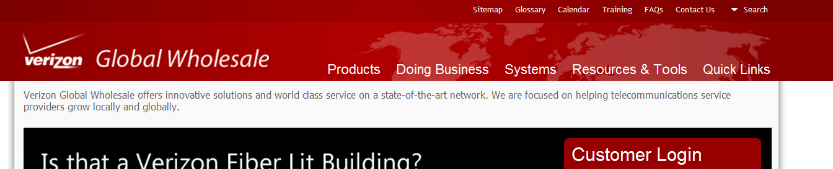

Select “Local and Access Services” and the “Next” Icon:

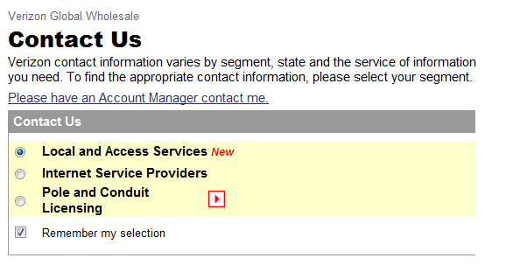

Select “Access Services” under Segment drop down:
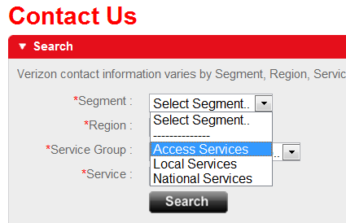

Select the appropriate “Region” using the drop down:
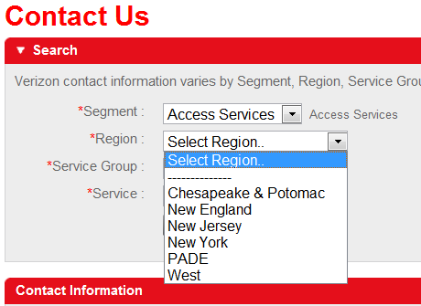

Select “Help Desk” from the “Service Group” menu drop down:
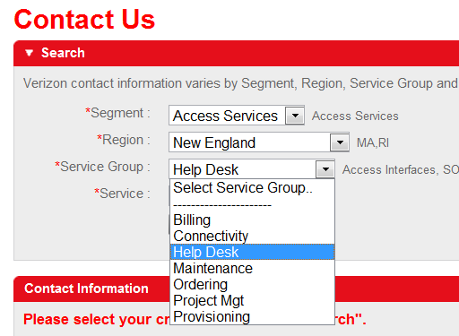

Select “SOS Help Desk” from the “Service” menu drop down:

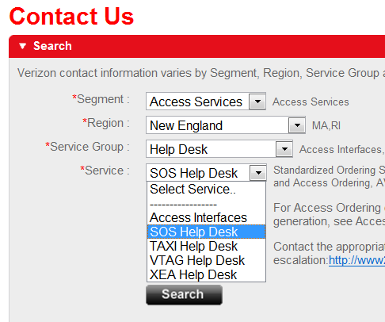

Select “Search”:

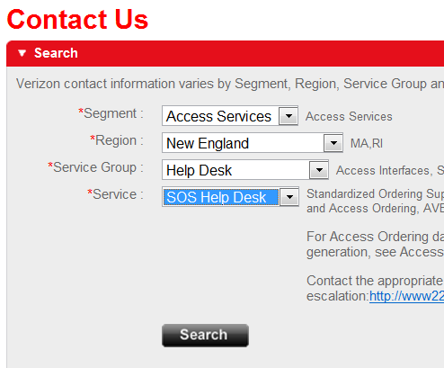

The Contact Information is displayed:



